Oluwatobiloba Greensides

Candidate number: 0578

Centre Name: Greenhead College

Centre Number: 37490

OCR H446-03 Computer science project

tasksphere– the Student Task Manager

Tobi Greensides

# Project Contents

Project Contents 2

A. Analysis 3

Problem Identification 3

Stakeholders 4

Research 9

Essential Features 11

Limitations 13

System Requirements 15

Success Criteria 16

computational methods 19

B. Design 21

System diagram 21

Decomposition table 22

Algorithm Design 23

Usability features 41

Key Variables 53

database table design 60

SQL Queries 61

Class diagrams 65

Validation 70

Post-development Test plan 71

C. Iterative Development 79

Prototyping 79

Prototype 1 - development 80

Prototype 1 - review 150

Prototype 2 - development 159

Prototype 2 review 206

D. Evaluation 207

Post development testing - functionality 207

Post development testing – usability 217

Usability Features Evaluation 222

Success criteria evaluation 224

Limitations & Improvements 226

Maintenance 227

GUI Evidence 228

Complete code evidence 233

# A. Analysis

## Problem Identification

Students struggle managing their time because the demands of work, school, family, and friends can make it difficult to stay organised. This often results in stress, missed deadlines and, in some cases, lower than expected achievement. Pen and paper planners and to-do lists are not adaptive enough to meet the demands of student life, and therefore I have made it my aim to combat the inefficiency of these time-management solutions while increasing the simplicity for the user by using a computational solution.

My solution is a mobile application with everything that a student might require for organising their personal and academic activities. At first, I decided to create a desktop application, however after interfacing with my target audience it became obvious that a mobile app is much better suited to the needs of students due to portability and ease of use. My application will consist of a task management system made up of categories, created by the user, to which the user can add tasks relevant to that category. For example, the user might create a category called Maths for their maths schoolwork, to which they can add any homework or revision tasks they want to complete. Each task will consist of a title, a due date, a priority and a category.

This problem is solvable by a computational approach because:

* It eliminates all physical elements of task management such as pens, planners, lists etc., reducing the amount of paper the user has to focus on, on top of their actual schoolwork.
* It uses due dates in combination with notifications to effectively remind users of upcoming deadlines, such as 3 days or 1 day before the deadline.
* It separates the user’s thoughts up into different spaces, allowing them to focus on one task or subject/category at a time.

My main goal when approaching this project is simplicity for the user. In a fast-paced environment such as school, the last thing a student needs is extra complexity, especially when their success is based on the ability to organise and prioritise their tasks. My app will help with both areas without the user having to waste time on learning to use it.

This computational solution will have the scalability to easily make pen and paper planners redundant because of the waste of resources that they involve – my app will only need a mobile phone, which most college students already have.

## Stakeholders

### Who are my stakeholders

My application is to be designed for GCSE students all the way through to undergraduate students, so I have decided to use college students for my stakeholder research. This is because college students have a balance of self-directed vs teacher directed learning, which is perfect because my solution should be able to help with both areas. College students are a good halfway between high school and university students, meaning they should be able to comment on features that would be useful for both groups. My method of research is through a Microsoft Forms questionnaire (see image) from which I will use the results to help design my program.

### Questionnaire

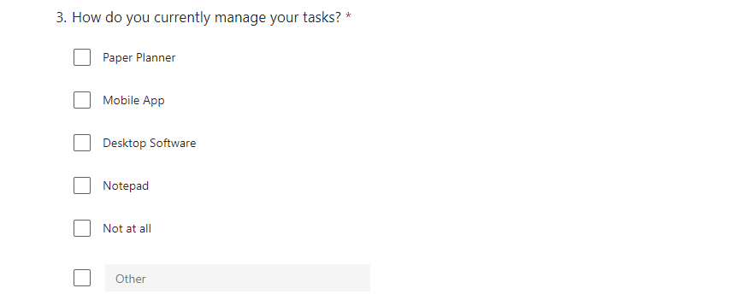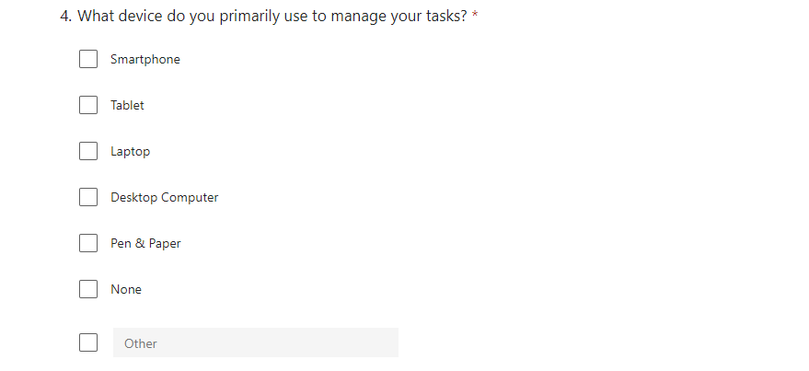

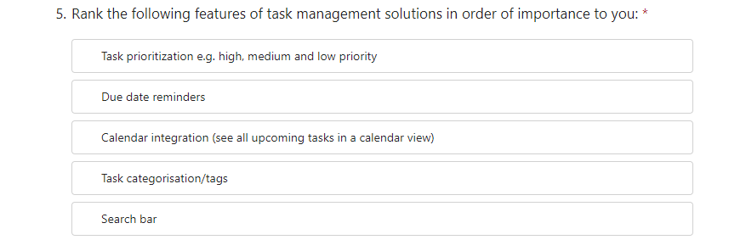

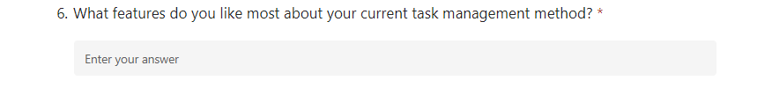

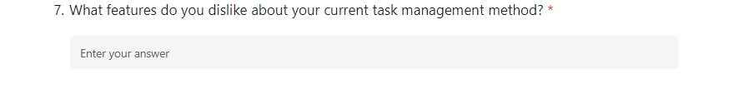

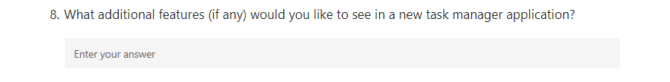

### Results

After collecting the results from my Form, a few things have been brought to light about what students really want – and need – from a task management application.

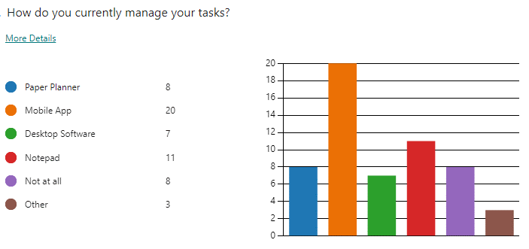Firstly, the most unsurprising result of the questionnaire is that users require a mobile app. My data shows that 20 out of the 37 participants (54%) use a mobile app to manage their college tasks (see **figure 1**). The next highest medium is a notepad, used by 11 of the participants. This shows that it is only fair that I develop a mobile app, because it is obvious that portability and ease of use are a necessity for my stakeholders. A desktop application would not be useful for the majority of my stakeholders, because, as teenagers, they naturally use their phones for most of their computer-based needs.

Figure 1

Another thing brought to light by my questionnaire is the importance of due date reminders/notifications, which was ranked as the most important feature by 65% of the participants (see **figure 3**), as well as second most important by another 16%. Additionally, deadlines/reminders were common themes when participants were asked what features they like about their current solution (see **figure 4**), as well as what they would like to see in a new task management application (see **figure 5**). For these reasons I have decided to make notifications when tasks are e.g. 1 day away from the due date so that students always know what is due soon.

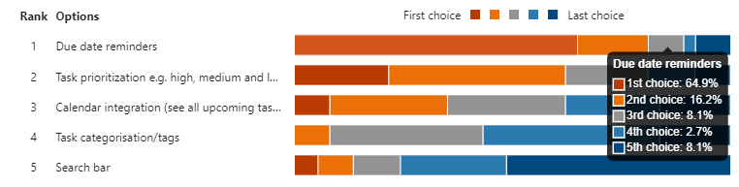

Figure 3 (Rank the following features in order of importance to you)

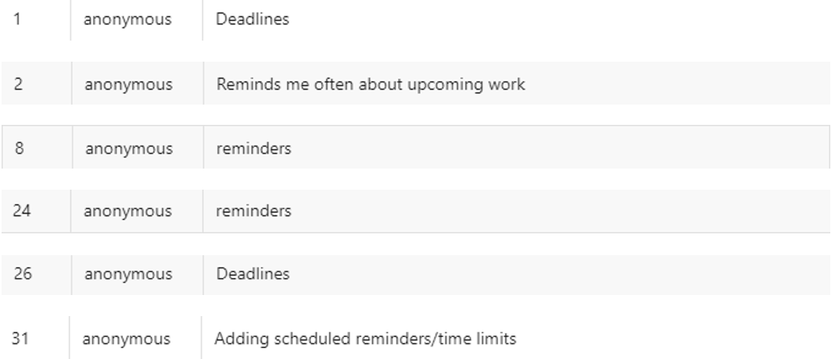

Figure 4 (What features do you like about your current task management application)

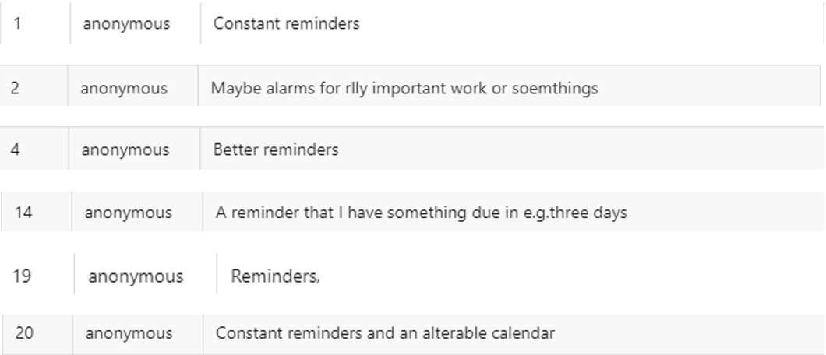

Figure 5 (What features would you like to see in a new task management application)

I believe a feature that allows students to prioritise tasks in order of importance is necessary for my solution. The reason for this is that when asked what they dislike about their current task management solution, some students stated that they found it difficult to organise their tasks in terms of priority (see **figure 6**). This creates a problem, because tasks that may be of high importance to the user could easily get lost beneath tasks that are of lower significance. Furthermore, Task Prioritisation ranked second highest in the “importance” question (see **figure 7**). Therefore, it is necessary to create a system that allows users to assign each task an importance weighting, for example High, Medium and Low. This way, students will be able to focus on the tasks that are important to them.

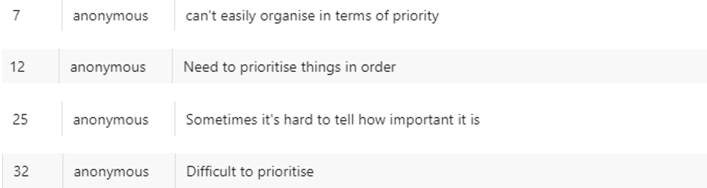

Figure 6

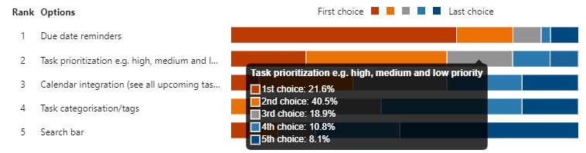

Figure 7

I would briefly like to touch on the proposition of a calendar-based view for my application, which was ranked third in the importance question (see **figure 8**). While at first, I thought it to be a good idea (hence why I put it in the question), I have since concluded that it would take too long to program, therefore adding too much to the scope of my project.

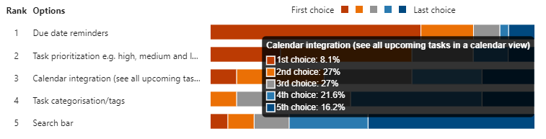

Figure 8

Another thing students complained about is the lack of space for task description provided by their solution (see **figure 9**). While this is important, I believe there must be a limit on the number of characters a user can use for their description. This is because characters take up a lot of storage, and if every task has a long description, the amount of storage taken up by the application would get very large very quickly. For this reason, I have decided to give each task description a cap of 100~ characters, so that students can get down their thoughts while at the same time not filling up their storage.

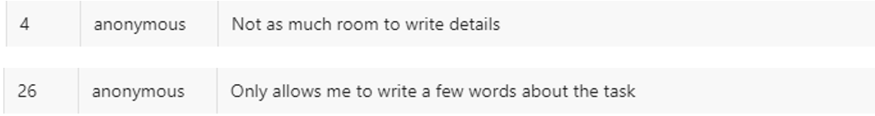

Figure 9

## Research

To help me pinpoint features that will make my solution fully functional, I will be carrying out research on 2 existing solutions to similar problems: Microsoft To-do and Todoist I have selected these because they all boast a variety of features that I could take and adapt for my own solution, aligning them to the requirements of my stakeholders. I will be using the Memu android emulator, which will allow me to access the mobile versions of these applications from my computer. This way, I can screenshot the features I like and drop them straight into this document.

### Microsoft to do

One example of a solution to my problem is Microsoft To-Do, a task management application that allows users to organise all of their tasks. I believe that To Do’s simple interface allows users to focus on their tasks, with everything positioned in an easy-to-access manner.

#### navigation menu

To Do’s menu (see **figure 10**) is sleek and straightforward, with a minimal number of pages. I plan to use a menu for navigation in my program, however there are a few features I would like to change.

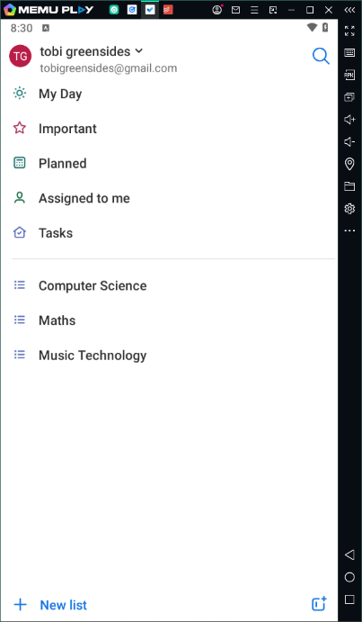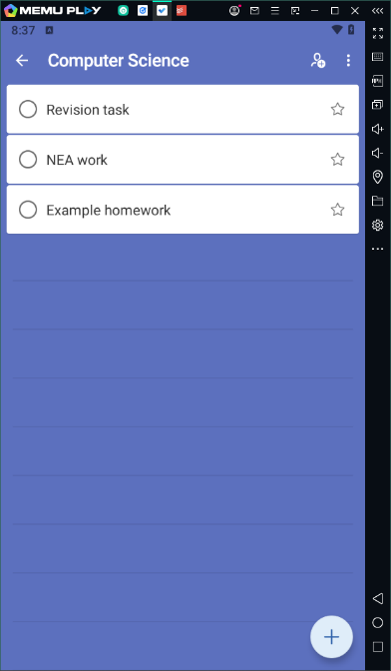My menu would have the following main pages: Today, All Tasks and Completed view, as well as a page for each of the user’s created categories. To-do’s “Important” view only shows tasks that are starred. In my application, each task will have its own priority, with levels Low, Medium and High. Tasks will be able to be sorted by priority within their respective lists.

Figure 10

#### Lists

To-do’s “Lists” allow users to categorise their tasks and separate them into different projects/sections. I want to integrate this in my program because it aligns perfectly with my stakeholder demographic – students will be able to separate their tasks up into different subjects, as I have demonstrated **figure 11**. This feature would allow students to separate the personal from the academic, simply by adding their tasks to different sections.

In my solution, students will be able to enter their subject names upon creating an account. This will automatically create sections for each subject they have entered. From there, users will be able to create their own sections for other areas of life that are not school related. However, these will be stored under another divider in the navigation menu. Instead of naming them lists, I will name them categories.

I believe that a feature like this is necessary because it is aligned with my idea that students should be able to easily organise their tasks in a simple way. Without categories all of the students’ tasks would be jumbled up, with no separation between them. This would prevent students from focusing on exactly what they want to focus on at one time.

Figure 11

### todoist

Another example of a solution to a similar problem is Todoist. This application has an extremely clean and user-friendly interface, offering simple navigation (which is one of my stakeholders’ required features) and a reward system that encourages users to complete their tasks.

#### Add tasks pop-up

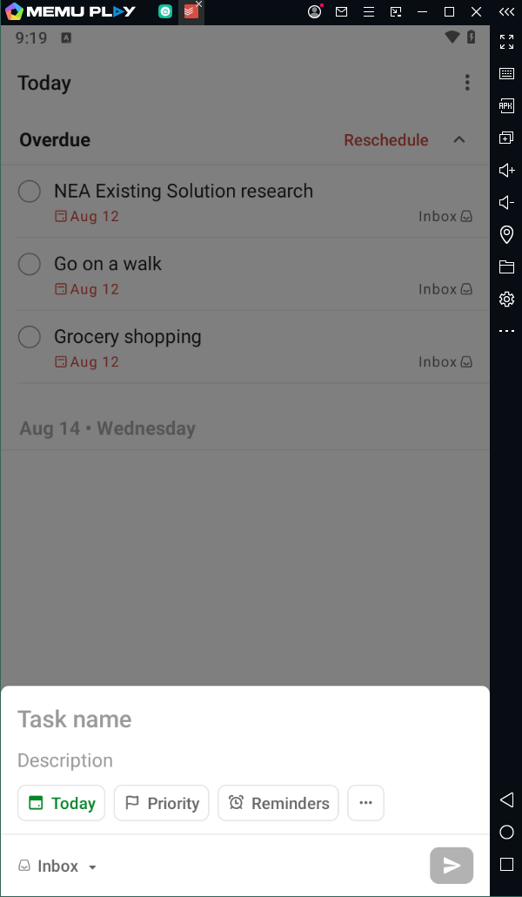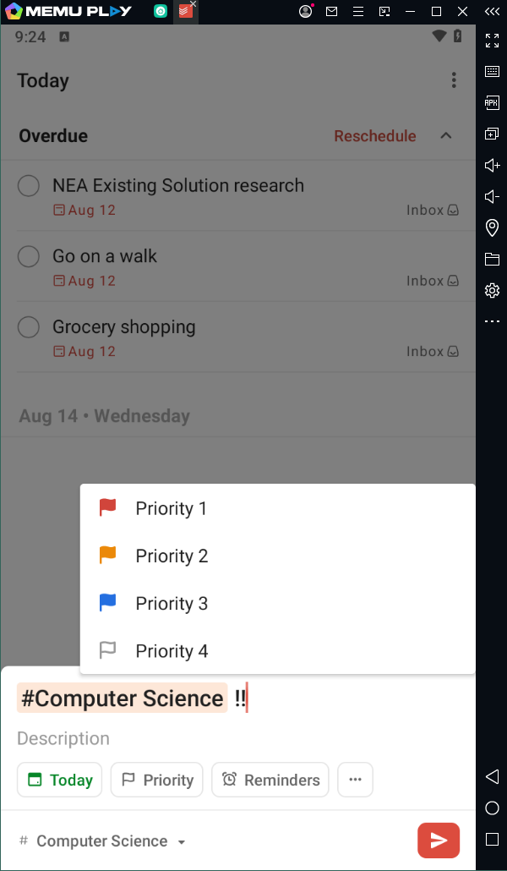When a user wants to add tasks in Todoist, a small window pops up at the bottom of the screen (see **figure 12**) with a simple design that allows users to add a name, due date, reminders, labels and projects to their task. I like this feature because it is not cluttered at all – it contains only the necessary detail required for a task.

Figure 12

Figure 13

In my application, I plan to use a similar design, with the option to add tasks with similar fields – especially the “Priority” feature (see **figure 13**), which is an improvement on To-do’s “important” page. This way, users will have a greater range of priorities for their tasks. However, instead of being a popup window, my application will have a new screen come up when adding a task to simplify the programming.

There will also be an option to add a task to a specific subject, or to a personal project, so that students can keep everything separate. This will greatly help them to focus on one thing at a time.

#### Reward system

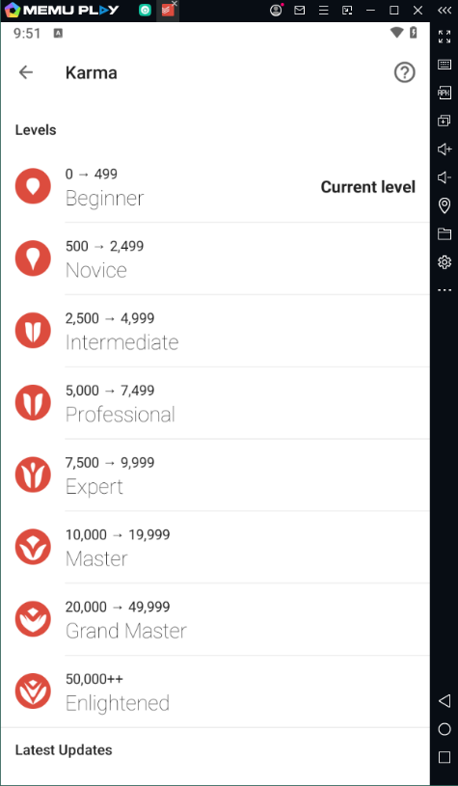Todoist rewards its users for creating and completing tasks, which acts as an incentive for them to keep doing so. Users gain “Karma” every time they complete one of these actions, and as they gain karma, they progress through the levels that can be seen in **figure 14**. This idea would be perfect for my target demographic as it is a sort of gamification of what is in reality quite a mundane thing. I would love to include this in my program if I have the time. However, this would be a low priority thing for me, because other features are of greater importance to my project.

Figure 14

If I were to incorporate this in my application, I would use a similar points system. For each high priority task completed, 30 points would be awarded, then 20 for medium priority, and finally 10 for low priority points. Any task that does not have an assigned priority will automatically add 10 points when completed, just like a low priority task. If I decide to use this in my project, I will then define what each level will be, but for now it is only an idea.

## Essential Features

### Introduction

The following features are necessary towards my solution if I want it to be fully functional, and meet as many of the stakeholders’ needs in the time frame that I have:

* User authentication
* Effective data storage
* Task management system, which also includes:
  + Task categorisation system
  + Task priority system
* Notification system
* Simple and accessible UI/UX

Please find below my justification of the choices that I have made.

### User authentication

The first essential feature of my program is a login/signup system. Students will be able to create accounts each with a username and password, with which they can log in and out. If a user attempts to create an account with a username that is already in use, the app will display a message that the selected username has already been take. Account data will be stored locally on the user’s device, as I have no way of setting up a server. This feature is essential because it ensures security of all the user’s data.

### Data storage

The second feature of my program is a data storage system that will use an SQL database which will allow each user to have their own tasks, as well as their user information, stored locally on their device. An SQL database is the best method of data storage for my program as I can easily integrate it with python. Well thought out data storage is essential because I need my program to be efficient.

### task management

The third – and most important – feature of my program is task management. Users will be able to do the following: create, edit, view and delete tasks. When viewing a task list, the tasks will be displayed with title, due date and priority level. Students will be able to select tasks individually to view more detailed info. Each task will have several attributes available to it: title, description, due date, priority level and subject/category. These will all be able to be changed after the creation of the task through an “edit task” button, which will show up when an individual task is viewed. Task management is crucial because it is the core purpose of the application and is the reason a user would choose my solution in the first place.

### Task categorisation

When creating tasks, students must be able to organise them into their own separate categories, personal to the user. Students should be able to add their own categories for both schoolwork, and for other areas of their life that are unrelated to school.

The ability to categorise tasks is necessary to my stakeholders because using the mental capacity it requires to separate thoughts should be used for study and focus – this can be achieved if their tasks are all already separated out. This is essential because my users need to be able to open the application and see exactly what needs to be done for each subject/area of life, and focus particularly on one of these, without the bombardment of everything else.

### Task priority rating

Both my stakeholder and similar system research confirm that the ability to assign tasks a priority rating is necessary to my application. Therefore, students will be able to give each task a priority of either high, medium or low depending on the importance of the task to themselves. This is essential because it allows the user to abstract the necessary from the unnecessary and focus on only what is truly important at a given time.

### Due date notifications

Notifications is a feature that is highly requested by my stakeholders. Therefore, they are essential to my program. My app will display notifications that remind users of tasks with upcoming due dates. This will be done using the Plyer python notification library. This feature is essential because it will keep users on track with their tasks and – especially – their school assignments, helping to improve their productivity.

### Simple UI/UX

A simple, clean user interface is something I think is necessary for my project. Everything will be positioned in an easy to access manner, with additional pages hidden under menus. This will be done using Kivy, a mobile application library for python. This is essential because the user will be able to focus on upcoming deadlines and completing work, without being hindered by a clumsy, complex experience.

## Limitations

### Introduction

In order to keep my project manageable, I have opted to not include certain features that are common in task management applications. This will help me narrow down the scope of my project so that I can more easily complete everything in the essential features in the time allotted, while also saving time for study of my other A level subjects.

### Cross platform support and collaboration

The first limitation of my application is cross platform support. Users will not be able to access their tasks when logging in on different devices. This is because I have no way of creating a server that would house all the users’ tasks, so they must be stored locally to the users’ devices. While this is a pretty big limitation, it is necessary that I identify it because it is something that users would generally expect from an application such as this. I just have no way of making it happen without paying for server space.

Another limitation that links to this is the idea of teams working collaboratively, and assigning tasks to each other etc. This is, again, made impossible by the fact that I cannot create or maintain a server, which would be required in order for users to be able to share data with each other within the application. Furthermore, the complexity of having everything synchronized in real-time would be beyond my programming abilities and would take up too much time for my project.

### Custom prioritisation

Some task management applications, like Todoist, allow users to create custom priority ratings for tasks, each colour coded and personalised to the user’s taste. On the other hand, some applications have only two priority ratings: starred and not starred. While it would be great for my program to have all the priority functionality of Todoist, it would be a waste for me to spend the time programming that. Instead, tasks will have one of 3 priority ratings: high, medium and low. This allows me to improve upon the priority features of some programs, while saving time and effort programming it with all the bells and whistles.

### Sub tasks

One feature I had originally planned to include in my program is the ability for students to add sub-tasks, or tasks within tasks. Similar features can be found in many task management applications, but this exceeds the scope of my project. Furthermore, with tasks being stored locally to users’ devices, this would cause the application to take up tremendous amounts of space, should the user decide to create many tasks, each with many sub tasks. For this reason, I have decided not to include it in my project.

### Recurring tasks

A feature I would have loved to include in my project is the ability to add recurring tasks, which repeat daily, weekly, monthly, etc. This would require lots of logic to handle the recurrence patterns, which adds a lot of complexity to my program. This could end up taking a lot more time than I have available to me. Furthermore, I would have to manage edge case scenarios, such as leap years, weekends, or holidays, which would prove even more difficult and time consuming to program. It is therefore necessary for me to exclude this feature from my project.

### Calendar integration

A common feature between task management solutions is the ability to integrate the user's tasks with an external calendar such as Google or iCloud calendar. This would require real time synchronization between the user’s application and the external calendar, as well as a complex use of APIs (which vary between different calendar systems). Therefore, this feature would massively increase the complexity of my project to the point where it would be impossible to complete in the given time.

### Customisation

From the beginning I have made it one of my main objectives for the program that it should have a clean, simple design that lends itself to being an atmosphere of focus and concentration. For some users, this means being able to customize the application with theme and colour to create a more comfortable experience for the user. However, this is secondary in my opinion to the other features that make the application what it is – users can live without customization capabilities in a task management application, because it does not affect the core functionality of the program. For this reason, I have decided to exclude them from my application because they add unnecessary detail to an already complex solution.

### Reward system

Originally, I had planned to use a reward system, similar to that of Todoist, so that I could motivate students using my application. After some consideration, I have decided that why my program is in its infancy, it would be best to leave out extra features that do not actually benefit the core purpose of my project as a whole. A reward system is one of these features, and as much as I would love to include it, it is just not a realistic goal.

## System Requirements

In order for the experience of my program to be smooth, users must have a mobile phone that holds the following specifications:

### Android 2.2 or newer

In order to run my application, devices must use at a minimum Android 2.2. This is because it is the lowest version of Android that Kivy, my chosen user interface library, is able to run on. Having this as my minimum OS requirement ensures that the application will be able to run on a range of devices, not just those with the newest android versions. This makes the app accessible to a broader audience, as not every student will definitely have the newest version of android installed on their phone.

### 1ghz dual core or higher processor

A processor fast enough to deal with everything that the program has going on is necessary. I want the user to experience minimal delay when completing tasks, so they are not hindered simply because of performance. Kivy requires 1GHz clock speed to run on android devices, and I believe dual core at least would be necessary for it to run smoothly. However, I would recommend quad core or octa core if the user wants a truly seamless experience, so that multiple instructions will be able to be completed at once if necessary. Kivy applications can be quite demanding because all of the screen widgets are rendered, rather than using androids UI packages, so for this reason, my users will need a processor that can handle this.

### minimum 2gb ram

When dealing with larger task lists, sufficient RAM is required because those lists must be accessed in order for them to be loaded and manipulated. With 2GB of RAM, most devices are able to handle normal applications, and as mine will not be too intensive, they should be able to handle that as well. 2GB is quite low for today’s standards, so if the minimum is 2GB, it will ensure that the application is available to most modern devices.

### 50mb available storage

My solution uses SQlite3 (which is designed to be lightweight) and tasks only store basic information, with no media information – the task will be mostly text based. However, because I am writing the application in Python, the file size will be a bit larger because a full python runtime environment must be bundled into the app through Kivy. Furthermore, if the user would like to add loads of tasks, and loads of different task lists, I would recommend a higher available storage, just to ensure that all the tasks can be accommodated. Kivy apps are usually 10-20MB, so to make sure there is plenty of space, I will recommend 50MB.

### 1280*720 minimum screen resolution

In order to ensure that the app’s interface is clear, the device will require a minimum resolution of 720p. This resolution is common on many older phones, so it makes sense that this be the minimum resolution in order to accommodate these. Furthermore, devices with a resolution of 720p are generally able to run most mobile apps smoothly, so this helps ensure that the user’s device is actually up to date enough to run my app.

## Success Criteria

### User account management

|  |  |  |  |
| --- | --- | --- | --- |
| **#** | Feature | Description | Justification |
| **1** | Signup/login form | When signing up, the user will be given the option to enter a username and a password into the given fields. The username will be stored as it is, and the passwords will be stored as hashes. Similar to the signup form, the login form will give the user the option to enter a username and password into the given fields. | Without a signup/login page, users will not be able to keep their own task data specific to themselves and their personal account. |
| **2** | Signup validation | When creating a username and password, each of these will be subject to a set of rules such as minimum length, necessary characters, etc. If a username has already been chosen, the user will have to create a different one. | If passwords are too simple, they may be easily guessed, which compromises the user’s security. Password requirements help to combat this. |
| **3** | Login validation | Once the user has entered their details, and clicked the login button, the username will be located in the database and checked against the corresponding password. If both are correct, the user will be granted access. If incorrect, an error message will be displayed prompting the user to try again. | If the user’s login details were not checked, anyone would be able to access the user’s account. This brings up obvious security problems. |
| **4** | Password hashing | When the user’s password is created and validated, it will be converted into a hash for storage. | This ensures that passwords will not be able to be stolen. If anyone managed to gain access to the database, they would be able to do nothing with what they find. |

### Task management system

|  |  |  |  |
| --- | --- | --- | --- |
| **#** | Feature | Description | Justification |
| **1** | Relational database | This database will be an SQL database composed, of three tables: “users”, “categories” and “tasks”. The users table will store user account details and will contain the fields “user_id”, “username” and “password_hash”. “user_id” the primary key of the Users table. The tasks table will then store vital information about each task created, with the following fields: “task_id”, “user_id”, “category_id”, “title”, “description”, “due_date”, “priority”, “category” and “status”. “user_id” will be the foreign key that connects the task to a user, and “category_id” will be the foreign key that connects the task to a category. I will be using the SQLite3 python library for database management. | I am using a relational database because it is a much more efficient system than a flat file database, which would take up a lot more space and be more clunky to navigate. I am using SQLite3 because it is a relatively lightweight database management system, which will be easy to incorporate into my project. |
| **2** | Task creation system | When creating tasks, users will be greeted with a screen that will allow them to add the following details to their task: title, description, due date, priority level and subject/category, which will all be stored in the “tasks” database. | It is obvious why this is a necessary feature for my project because without it users would not be able to add tasks, and therefore would not be able to use the app for what it is. |
| **3** | Task edit system | When the user opens a task to view it, there will be a button in the corner that says “edit”. This will bring up a window similar to the task creation window, where the user will be able to alter any of the task’s fields. | I want my program to be dynamic so that it can fit the needs of my stakeholders – therefore it is necessary that they are able to edit their tasks after they have been created. |
| **4** | Task sorting functionality | When viewing lists of tasks, users will be able to sort these lists by all of the fields that the tasks contain, e.g. by priority. To sort the items, I will use the “ORDER BY” clause. | One thing that my stakeholders said they would love to see in a new solution is the ability to order tasks by priority, so this feature would allow them to do that, and allow them to sort their tasks by other parameters as well.  Furthermore, it would be extremely limiting for users to only be able to view tasks in an order that has been decided by me. Instead, being able to order tasks by priority, due date etc would provide users with the ability to focus on what they deem to be the most important factor. |
| **5** | Task viewing | If a user wants to view a specific task with all of its details, they will be able to do that with the task viewing feature. This will open as a full page, with the title of the task at the top, and all the task’s details below that. This is where **3. Task edit system** will be able to be accessed. | It is essential that the user is able to view a specific task, separate from any other tasks they have created, because they need to be able to focus on one thing at a time. A task viewing system will also allow users to view any descriptions they might have created for their tasks, as this would be too much information to display on the main page. |
| **6** | Navigation menu | My interface will have a navigation menu with links to view different lists of tasks, such as a list of all the tasks related to a specific subject, or project. There will also be an “All tasks” page as well as a “Today” page for tasks due today. To display these tasks, I will use a simple SQL query that only displays items related to a specific parameter. | Users must be able to separate their tasks into different categories, and view those different categories, so that they do not become overwhelmed with tasks that have no significance to what they are currently focusing on. |

### Other success criteria

|  |  |  |  |
| --- | --- | --- | --- |
| **#** | Feature | Description | Justification |
| **1** | Notifications | I will use the plyer python library to send notifications to users’ devices when tasks are due in 3 days, 1 day and today. | My stakeholders said that they dislike how they end up forgetting about tasks because their chosen app does not remind them. Having a notification functionality would solve this issue, which is why it would be great to include it in my program. |
| **2** | Simple and intuitive UI | My application will have a clean design, with any extra details hidden under menus, pages etc. The interface will be simple and easy to navigate. |  |

## computational methods

Below are the computational methods I will be using when developing my app. They are necessary to ensure that my application is a justifiable solution to the problem that I described, and without these methods I would be unable to undertake this task.

|  |  |  |
| --- | --- | --- |
| Computational method | Justification | Incorporation |
| Abstraction | Abstraction involves simplifying complex problems by focusing only on necessary detail, discarding anything unnecessary. This makes things easier for developers as it makes everything easier to implement. It also reduces strain on hardware resources. | Information hiding – Each task will be simplified down to their most important parts: Title, description, due date, priority, category, and status. This allows the user to focus on only the key elements. Furthermore, my UI will present only the most important features to the user, hiding any advanced features in menus. Using information hiding is necessary for my solution as I aim to make task organisation as streamlined as possible for the user, and this is only achievable if they are unhindered by unnecessary detail. |
| Functional abstraction – I plan to use libraries in python to speed up the development process. Some libraries I might need to use for my project are Kivy, so I can build a user interface for my app, (possibly) KivyMD so that I can make my app visually appealing for my users, SQLite for database management, Plyer so that I can access mobile features such as notifications, and Time so that the program can check e.g. every hour if there are any tasks due soon. This is not an exhaustive list – while developing my application I may decide to use other libraries as well. These are just some that I believe I will need pre-development. It is evident that functional abstraction and the use of libraries is necessary as without it the development of my program would take far too long; these libraries allow my solution to be programmable within a reasonable amount of time. |
| Decomposition | Decomposition involves breaking down a complex problem into smaller, more manageable parts, making it easier to develop, test and maintain the application. This is crucial for both me as the developer, and the students who are my intended users. | Modular development – I will program each section of the application in modules. This will allow me to break down the problem into smaller parts so that I am not overloaded by the scope of the entire project. |
| Selection | Selection is integral for any computational solution, as it is used to make decisions within a program – certain paths/actions are taken based on certain conditions. This is necessary for user interactivity as it creates a more dynamic environment that responds uniquely to user inputs. | The first thing that selection is necessary for is user authentication – when a user attempts to log in, their details must be checked in order to ensure that they are a legitimate user. As there are two main possible outcomes (granting access or displaying an error message), authentication would be impossible without selection as one of these two pathways would not be able to be selected. |
| Secondly, selection is required for sending notifications to the user’s mobile phone, as it allows the application to check e.g. if a task is due soon so that it can remind the user. Without selection, this would be impossible as the check would not be able to be done. As reminders are one of my stakeholders’ most important desired features for my solution, this shows that my problem is solvable through selection. |
| Iteration | Iteration involves repeatedly executing a block of code until a condition is met. This is essential for performing repetitive tasks – for things as simple as displaying the task list from the database. | Any process that involves displaying tasks will require iteration, whether this is a list of tasks, or an individual task. This is because the database must be looped through in order to display them. This shows that my problem is amenable to being solved through iteration as it is necessary for efficiency when displaying tasks to users. |
| Data Storage | Effective data storage is an integral feature of any program as users must be able to access any of their stored data easily. It is also important because the way data is stored determines the operations that can be performed on said data e.g. searching and sorting algorithms. | I plan to use a relational database management system (SQLite) due to its simplicity and how easily it integrates with python. Furthermore, it does not require a server, which is perfect for a local application, and also it makes it easier to use SQL queries in python. |
| Object orientated programming | OOP involves creating classes of objects that can be created and reiterated to create different versions of the same object. | Because I plan to use the Kivy library for my UI, it is best that I use OOP because Kivy is essentially made up of objects – if I did not have objects that I could easily recreate for each section of my program, when it came to connecting it to Kivy I would struggle. |

# B. Design

## System diagram

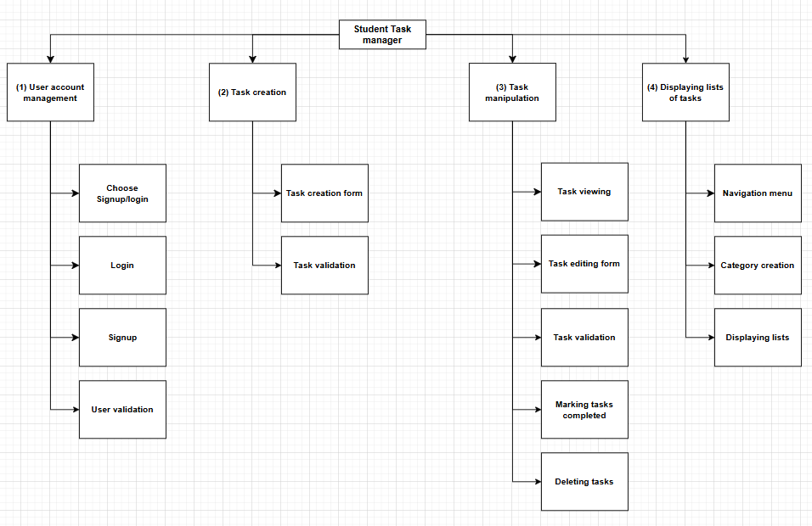

### Justification

The reason I have decided to draw a system diagram for my design is that when I come to programming it will help me immensely with breaking the problem down into what each section requires at its core. This technique is called decomposition, and it is imperative that I use it when designing and developing my program. Without decomposition, I would become overwhelmed by the entire task, and unable to focus on one thing at a time. I have therefore decided to develop my program in a modular fashion, with each of the main sections of the diagram (Login & signup, Task creation, Task manipulation, and List Display) being a module that I will develop separately, with the rest of the project in mind. I have then decomposed each of these modules into even smaller sub-problems. This should provide me with some sort of “step-by-step” methodical process that I can follow while programming. It should also help me track my progress more easily while developing.

## Decomposition table

In order to effectively decompose my problem, it is important that I first explain my module choices and how each module is separate from each other. This decomposition table outlines the features of each module, displaying the algorithms that are associated with it.

|  |  |  |
| --- | --- | --- |
| Module | Justification of decomposition | Relevant algorithms |
| (1) User Account Management | This is an important module because it ensures the security of user data, especially for future scaling of the solution, which might involve the introduction of a server to store data on a server for access across multiple devices. For now, it provides security to users who might be sharing a device with others who seek to use the app as well. | **Choose signup or login**  **Login form**  **Login validation**  **Signup form**  **Password hashing**  **Signup validation**  **Log out** |
| (2) Task Creation | This allows users to create tasks with their relevant details, providing a structured, consistent way to do so. This is essential for the functionality of my program as tasks must be created before they can be managed. | **Task creation**  **Created task validation**  **Category creation** |
| (3) Task Manipulation | This feature allows users to view the full details of a task that they have selected, update, delete or mark tasks as completed. This ensures that the user can keep their tasks up to date and relevant and also allows users to be flexible about tasks that might need to change. | **View task**  **Edit task**  **Delete task**  **Mark task as completed** |
| (4) List Display | This improves navigation by allowing users to view tasks that fit a specific criterion that they are looking for and preventing the users screen from becoming too cluttered with irrelevant tasks. | **Navigation menu**  **View task lists**  **View completed**  **Category creation**  **Created category validation** |

Note – the **Send Reminder Notification** algorithm is not included under any of these modules because it does not fit under any of them, but I will still be developing it.

## Algorithm Design

### Applicability to solution

Find below the list of algorithms and how they fit into my success criteria for a complete solution. This proves how these algorithms for a complete solution to the problem.

UAM – User Account Management

TMS – Task Management System

OSC – Other Success Criteria

|  |  |  |
| --- | --- | --- |
| Algorithm | Success criteria | Justification |
| Choose signup or login | UAM (1) | This is necessary for the user to be able to access the signup and login forms that are specified in criteria (1). |
| Login form | UAM (1) | This is necessary to allow my users to log in and access the program, as described in success criteria (1) |
| Signup form | UAM (1) | This is necessary for the user to be able to keep their own task data private, as described in success criteria (1). |
| Login validation | UAM (3) | This algorithm is necessary because it is what will, when returned TRUE, grant the user access to the application. Without this, unauthorised users would be able to access accounts that are not theirs. |
| Signup validation | UAM (2) | This algorithm is important because it provides security to user accounts, ensuring that passwords are of acceptable strength, and usernames are not already taken. |
| Password hashing | UAM (4) | This ensures that all passwords are stored in the same format with the same length, and also adds an extra layer of security as any attempt to steal passwords would fail because all an attacker would find would be hashes. |
| Log out | UAM (none) | While not specified under success criteria, this is an important algorithm that comes underneath User Account Management. It ensures that multiple users can access the apps functionality while keeping accounts separate. |
| Task creation | TMS (2) | This algorithm is one of the most important for my solution because without the ability to create tasks users would not be able to actually use my program. |
| Created task validation | TMS (2) | This is necessary for criteria (2) because it will ensure that all created tasks follow a similar structure and follow the same set of rules. This is important for database handling because all of my tasks’ attributes must have similar data to that which is stored in every task to increase data integrity. |
| View task | TMS (5) | This is necessary so that task data can be retrieved from the database and shown to the user, separate from all of the other tasks. |
| Edit task | TMS (3) | This prevents tasks from becoming static, where once created their data cannot change. Without this algorithm, if a user wanted to alter a tasks data, they would have to delete the task and create a whole new task. |
| Navigation menu | TMS (6), OSC (2) | TMS (6) – the navigation menu is where the user will be able to access all of their different task lists/categories, so the algorithm is essential to my program.  OSC (2) – This aligns with my goal to have a simple and intuitive UI as it hides all other task lists under a menu, so they do not clutter the screen. |
| View task lists | TMS (6) | This comes under the navigation menu success criterion because it is from there that this algorithm will be called – when a user selects a list. |
| Delete task | TMS (3) | This is important for TMS (3) because as well as editing tasks, users need to have control over all of their tasks and whether or not they want them to still be there. Deleting tasks is necessary because if a user just marks it as completed to delete it, then the “View completed” page will become extremely cluttered/. |
| Mark task as completed | TMS (3) | This algorithm is necessary for my task edit system as it allows completed tasks to be abstracted from the main list of tasks. When completed they will only be able to be viewed separately, preventing the user from becoming overwhelmed with both current tasks, and tasks they have already completed. |
| Send reminder notification | OSC (1) | This algorithm is necessary because it is the most important feature to my stakeholders of a computational solution to the problem. |

### User account management

#### Choose signup or login

Aligning with User Account Management #1 from my success criteria, the first set of algorithms I will work are the ones that allow the user to sign up and log in. This will allow for multiple user accounts on each device, and will also provide scalability for the future, when I might want to expand the service to allow people to have accounts across devices. First, the user will be given the option to either sign up or login upon opening the application for the first time.

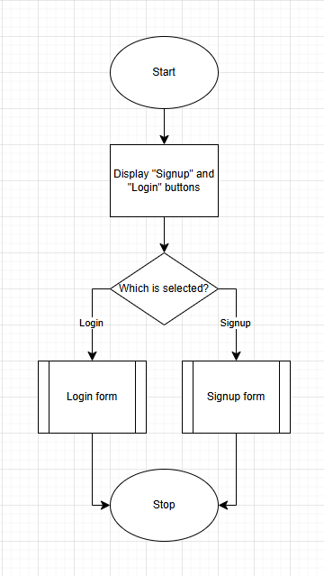

#### Login form

The goal of this form is to allow the user to access all the tasks related to their account. This will be displayed if the user selects “Login” from the above algorithm. The input will be passed into the Login validation function. If this returns true, access is granted to the main page of the application.

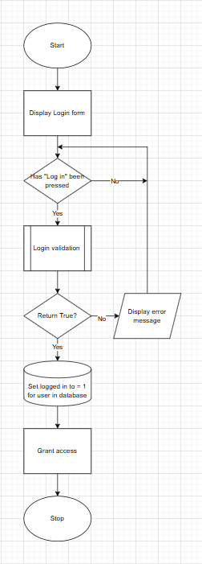

#### Login validation

Once the user has entered their login details, they must be checked against the values in the Users table. Because I will be storing my passwords as hashes, they must be hashed during validation as well.

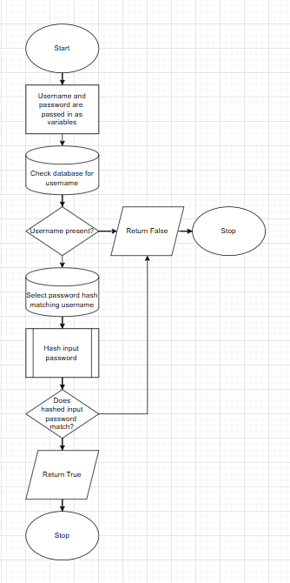

#### Signup form

If the user has never used the application on the current device they are using, they will need to sign up in order for their personal data and tasks to be related to an account. To ensure the security of user data, I have opted to hash all passwords using a hashing algorithm from a python library. Once details have been validated, and the password has been hashed, the data will be stored to the database and the user will be prompted to log in for the first time.

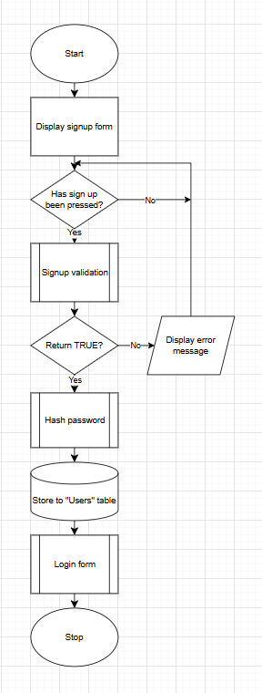

#### Signup validation

Instead of drawing a flow diagram for the signup validation, I am simply going to describe it because all the different options would make it messy to do in flow diagram format. In order to make sure that users create passwords that are as secure as possible, there will be a number of criteria that they must follow for their details to be valid. These are as follows:

* Username length must be 4 or more characters
* Password length must be 8 or more characters
* Passwords must contain at least one of the following special characters: !£$%^&*()
* Password must contain at least one number
* Passwords must contain at least one capital letter

Once the password has been validated, and it meets all these criteria, the function will return true and the rest of the events in **Signup form** will be carried out. If the

#### Log out

The last algorithm from the User Account Management section is the Log out algorithm, which is necessary for if a user wants to access a different account on their device. Once the user has logged out, they will be directed to the **Choose signup or login** page again.

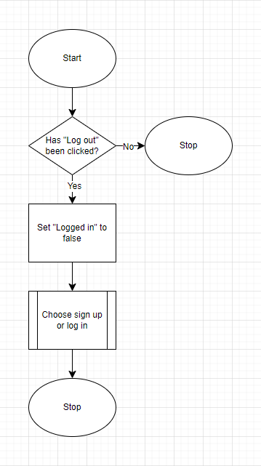

### Task creation

#### Create task

This is one of the most important algorithms for my program. Upon the click of the “create task” button, the user will be directed to a page with a form for filling in all the details of the task they want to create. The form will consist of the following:

* Task name
* Task description
* Task due date (not required)
* Task priority (not required)
* Subject/category

Once the user has entered all of the details, they will be passed into the “created task validation” method to ensure they fit the rules that I will specify later. If this method returns True, the task will be added to the database and the user will be shown a confirmation message. If it returns false, the user will be shown an error message and then will be directed to fill out the task creation form again.

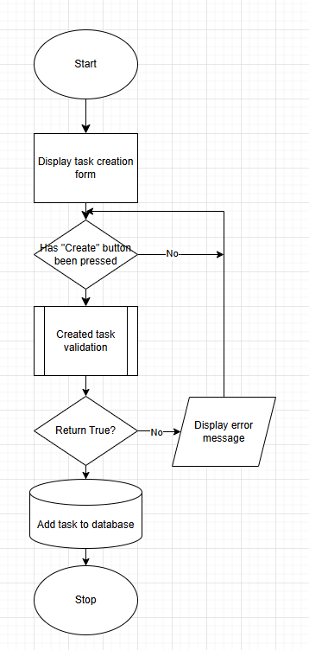

#### Created task validation

In order to make sure that users’ tasks are all standardised and in the same format, created task validation is necessary. This will ensure that no task name or description will be too long (these would make the database very large) and will also check that any due date added to the task is a valid date e.g. is not in the past.

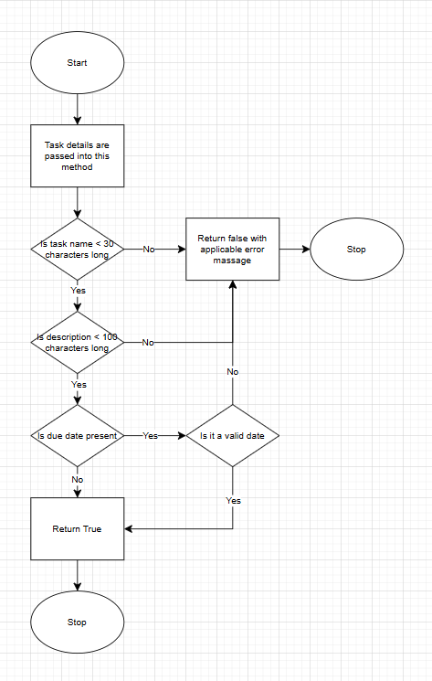

### Task manipulation

#### View task

If a user wants to view a specific task with all of its details, they will be able to do that with the task viewing feature. This will open as a full page, with the title of the task at the top, and all the task’s details below that. This is where **3. Task edit system** will be able to be accessed, as well as where the user will be able to delete a task.

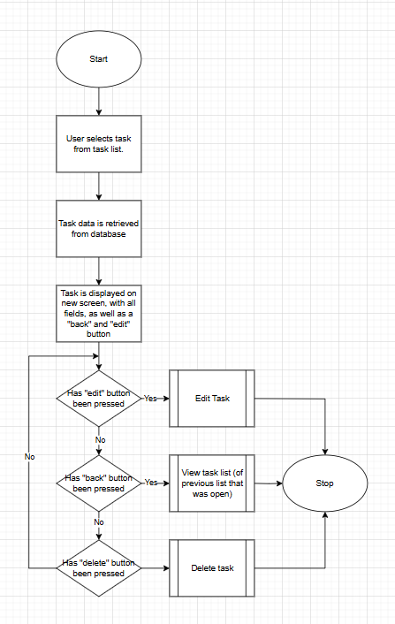

#### Edit task

If the user clicks the “edit” button from a “view task” page, a new screen will open called the “edit task” screen. This will display all task data in an editable format, where the user will be able to alter any of the task’s fields.

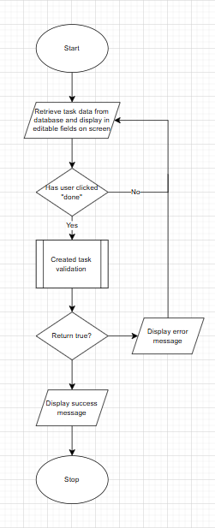

#### Navigation menu

The navigation menu will be where users will be able to access all their different lists as well as the stock lists that will be available to every user (“Today”, “All tasks” and “Completed”). Every time the menu button is pressed, the titles of these lists will be displayed on screen, and the pressing of one of these titles will prompt the **View Task Lists** function to be called. Furthermore, the user will be able to access the **Log out** button from here as well.

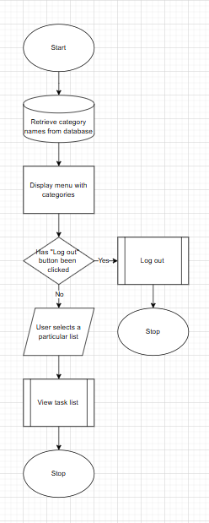

#### Delete task

When a user wants to delete a task, they will do so by clicking the “delete” button on the View Task page. This will cause the delete task function to be called, which will make sure that the user definitely wants to delete the task by displaying a message with the option to accept or decline. From there, if the user wants to delete it, an SQL query will be created that will remove the task from the database.

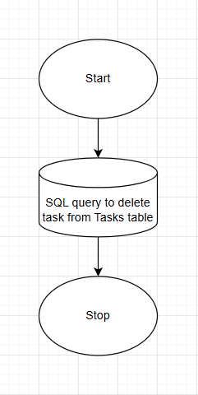

#### Mark task as completed

This is a very simple algorithm that will do one thing – change the status of the task to completed. This can be done from either the “view task list” page or from the “edit task” page, and it will cause an SQL query to change the task to completed. Once a task is marked completed, it will not be viewable in the main task lists. Instead, completed tasks will be able to be viewed from the “Completed” list, that can be found in the navigation menu.

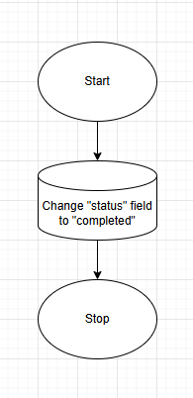

### List display

#### Displaying lists of tasks

Once a list has been selected from the navigation menu, an SQL query will be created to select all tasks that match the criteria of that list. All of these tasks will then be displayed on screen for the user to view, open and edit.

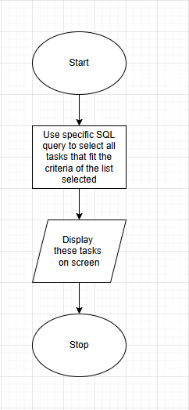

#### Category creation

This algorithm will handle the creation of categories by the user. It involves the “Create category” form, into which the category name is entered. Once the “Create” button is pressed, the Created Category Validation algorithm will be called, which I will define next.

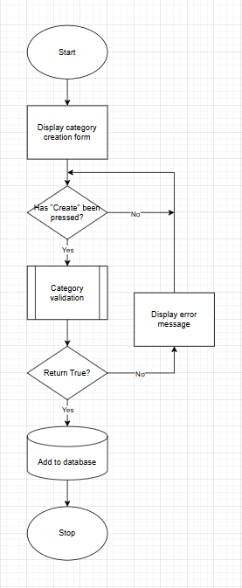

#### Created category validation

This algorithm checks if the title is blank, or longer than 20 characters, and displays an error message and returns false if it is, and returns true if it is valid.

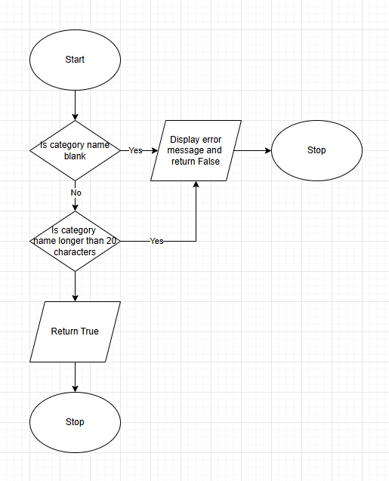

### Send reminder notification

Due date reminders are, according to my stakeholders, the most important feature that they want to see from a task management application. For this reason, it is important that I specify an algorithm that will be able to send notifications to users’ devices. The algorithm will send a notification if there is a task due:

* 3 days from today
* Tomorrow
* Today

In future, I may be able to scale this feature so that the user can choose when a notification is sent to their phone, for example, if they want a reminder 1 week before the due date, or 1 month before.

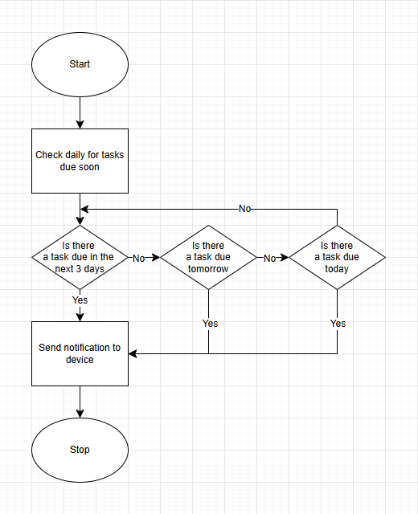

## Usability features

In order to have an idea of what I want my interface to look and feel like, it is imperative that I create a rough design of each screen beforehand and describe how users will be directed through these screens. This is important because I want the user experience to be streamlined and simple. Furthermore, designing each screen beforehand will help me when it comes to programming because I will know exactly what inputs, outputs and processes will need to be in place at each point.

Every usability feature that is described for my screens is justified fully with reasons for their use.

I want my interface to be scalable for future updates, and this is extremely possible using Kivy’s interface tools. In future, my users could be able to switch between light and dark modes, as well as possibly modify the colour of their interface to better suit their preferences.

### Usability features consistent throughout the program

There are some features that I will make sure to include throughout the program for consistency. This is because I want the program to be easy to use and uncomplicated, as well as be stylish and intuitive. These features will include:

* **Title at the top of every screen** – This is so that the user will always know where they are and what can be done on the screen they are on.
* **Back buttons on every screen that is not the main screen** – My users will always need the option to return to the main screen if they accidentally pressed somewhere that directed them away.
* **Consistent colour scheme** – all my screens will have a white background, all text will be black, and all buttons will be a dark grey colour with white text.
* **All form entry points will have the same format** – they will all be a white box with a black outline, and light grey text inside directing the user to input text. This light grey text will disappear once the user begins to type.

### consistent Usability features justification

The reason that it is important to keep usability features in mind is that they provide the user with consistency, and the ability to navigate their way throughout the program in a familiar way. If every new feature in my program had a different style, and different ways of interacting with it, my users would quickly become confused and be discouraged from using my program. I want to prevent this from happening because the whole idea behind my program is to be a streamlined, simple way solution for my stakeholders to organise their everyday life.

### Choose signup and login

**This screen will include**:

* Welcome text message
* Labelled Login button
* Labelled Signup button

**The usability features of this screen will include**:

* The buttons will have both names (login, signup) and text above them directing the user to which one they should click.
  + This is so that there is no debate over which button users should press.

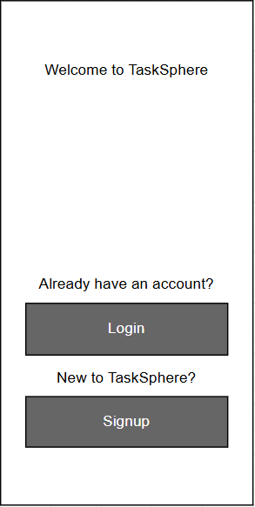

### Signup screen

**The sign-up screen will include:**

* Username field
* Password field
* Submit button
* Back button

**The usability features of this screen will include:**

* **Labelled fields, with the words “username” and “password” inside the field into which the user inputs text. These will disappear once the user starts typing.**
  + This saves space on the screen, making the interface look cleaner and simpler, while also directing the user to where they have to input text.
* **Clearly labelled back button so that the user can get back to choose to login instead**, in case they clicked the wrong button.
  + This is important because it will stop the user from getting stuck on the signup screen by accident.

**Scalability for the future includes:**

* **Adding an email to the account -** this would allow users to recover their accounts in case they forgot their password. An email would be sent to the user with a link to create a new password, therefore preventing users from being locked out of their accounts permanently.
* **Adding the users’ subjects upon signup –** because this program is developed for students, in future I could create a feature that would allow users to input their subjects and these would be stored alongside their other account data. Categories would be created for each subject, so the user wouldn’t have to add all of their subjects to different task lists, they would all already be created.

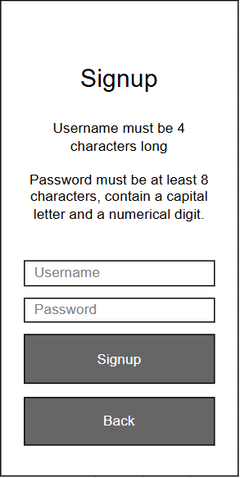

### Login screen

**The login screen will include:**

* Username field
* Password field
* Submit button
* Back button

**The usability features of this screen will include:**

* Labelled fields, with the words “username” and “password” inside the field into which the user inputs text. These will disappear once the user starts typing.
  + This saves space on the screen, making the interface look cleaner and more simple, while also directing the user to where they have to input text.
* Clearly labelled back button so that the user can get back to choose to signup instead, in case they clicked the wrong button.
  + This is important because it will stop the user from getting stuck on the login screen by accident.
* Once the user has logged in, the app will store them as “logged in” and they will not have to log in next time they open it.
  + This saves the user time because they will not have to log in every time they open the app.

**Scalability for the future includes:**

* **Forgot password button –** this would allow users to recover their accounts in case they forgot their password. In future, users will add their email address to the account, and an email would be sent to the user with a link to create a new password, therefore preventing users from being locked out of their accounts permanently.

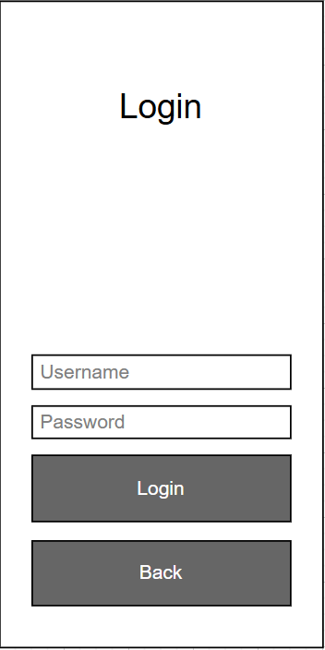

### Create task screen

**The create task screen will include:**

* Title field
* Due date field
* Priority radio button
* Category selection drop down
* Create button
* Cancel button

**The usability features of this screen will include:**

* Radio buttons for priority – the user will select one of these, and that will determine its level in the view task screen when the user sorts their tasks by priority.
  + This means less text input from the user, reducing confusion and opportunity for error.
* Drop down menu from which the user can select a category for their task. There will be an automatic category called “none”, in case the user does not want this task to go in any specific category.
  + This allows the user to separate their tasks easily, for future viewing within separate lists.
* “Create” button which will cause the task info that the user has inputted to be validated using the **Created task validation** algorithm and then added to the tasks database if it meets the correct criteria.
  + This makes it easy for the user to see where they can commit their changes.
* “Cancel” button – if a user has decided they do not want to create a task, or they accidentally clicked to create one, a cancel button is necessary so that they can return without having to create a task then delete it.
  + This ensures that the user does not get stuck on the create task screen if they opened it accidentally.

**Scalability for the future includes:**

* **Tags for categorisation within categories** – This would be extremely useful for example if the user wants to separate homework tasks from revision tasks, or if they want to split a personal project up into different tags. These tags could then be used for filters when viewing lists of tasks.
* **Custom priority levels** – A user might want to different types of priority levels that are personal to them, and more specific than just high, medium and low.
* **Recurring tasks** – users would be able to create tasks that repeat themselves e.g. every day, week or month. This would be useful for things that they know they will have to do regularly in a scheduled way.
* **Add collaborator** – In future, if I had the application linked up to a server, multiple users would be able to collaborate on tasks and projects together. When creating a task, users might be able to add collaborators that they want to be part of the task as well.

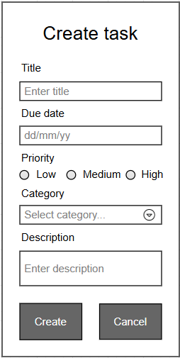

### Edit task screen

My Edit screen will be virtually the same as the Create task screen, with a few minor changes:

* The fields will already be filled in with the information currently saved for that task, and the user will be able to edit these.
  + This ensures that users can edit the data that is already there, rather than having to re-enter everything, which would essentially be creating a new task.
* The “Create” button will be replaced by a “Save Changes” button.
  + Thie ensures that the user knows they are manipulating an existing task.

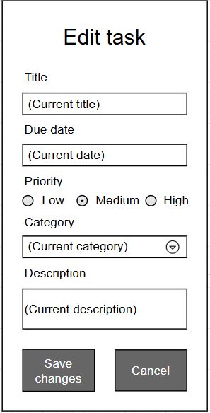

### View task screen

**The View Task screen will include:**

* All task information
* Edit button
* Delete button
* Mark completed button
* Back button

**The usability features of this screen will include:**

* Coloured Edit and Delete buttons – blue for edit and red for delete.
  + These make them stand out to the users, differentiating the functions of the buttons as two very different actions.
* The Mark completed and Back buttons are both the standard dark grey,
  + This highlighting them as two of the standard buttons that are most likely to be pressed by the user.
* When the user presses delete, a message will pop up asking them to confirm
  + This makes sure that users do not delete tasks by accident.

**Scalability for the future includes:**

* **Estimated completion time** – this would display an estimated time to complete based on similar tasks from the past.

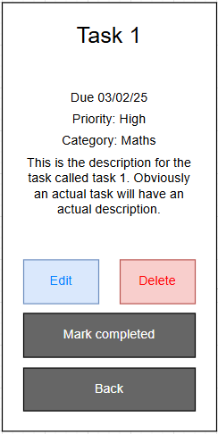

### Task list Screen

**The Task List screen will include:**

* Hamburger menu button to access navigation menu
* Category title
* List of tasks that match the category, with the following information about each:
  + Title
  + Due date
  + Priority with exclamation marks – 3 for high, 2 for medium, 1 for low
* Sort by drop down menu with the options:
  + A-Z
  + Priority
  + Due date
* Create task button

**The usability features of this screen will include:**

* Priorities are displayed using exclamation marks
  + This creates an easy way for students to view what priority level they placed a task, reducing clutter on screen.
* Pressing on a task brings up the View Task screen for that specific task
  + This allows users to view all of the details for a task so that they can focus on that task specifically.
* Drop down menu for sorting tasks
  + This provides users with the opportunity to choose what takes priority when it comes to task details.
* If there are more tasks than can fit on the screen, the user will be able to scroll to view the rest.
  + This ensures that if the user has lots of tasks, they are able to view all of them.

**Scalability for the future includes:**

* **Sorting tasks by multiple criteria** – this would allow users to sort their tasks with more than more choice, e.g. priority first, then due date, or vice versa.
* **Manual reordering of tasks** – this would allow users to sort tasks in a custom order by dragging and dropping them into place in the list wherever they see fit.
* **Filtering tasks** – this would allow users to filter tasks by different criteria, so they only have to look at tasks that fit their current focus – this would tie into the “tags” scalability feature that I mentioned in the **Create Task screen** section, as these tags could be one of the filter criteria.
* **Subtasks** – this would allow a “tasks within tasks” approach, where larger tasks could be subdivided into smaller ones. In terms of the View Tasks List screen, tasks could be expandable to view all of their subtasks.
* **Search bar** – this would allow users to quickly find tasks by using keyword searches.

In this example I have used the “Due Today” category.

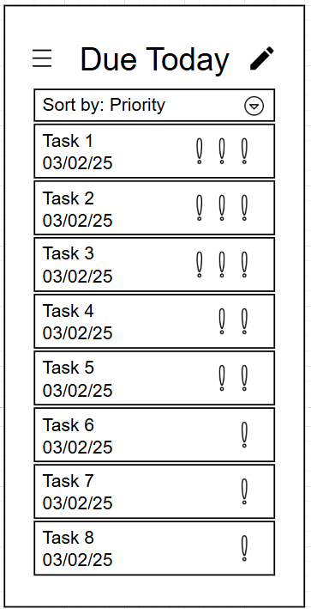

### Navigation menu screen

**The Navigation Menu screen will include:**

* Predetermined categories (Today, All Tasks, Completed)
* User created categories
* New Category button
* Back button
* Log Out button

**The usability features of this screen will include:**

* There is a separator line between the categories that are automatically there and the categories that the user has created.
  + This helps the user to differentiate between general and specific.
* New Category and Back buttons are the standard dark grey colour, whereas the Log Out is red to differentiate it as a more uncommon button.
  + I justified the user of coloured buttons in the last chapter.
* When logout is pressed, a message will pop up saying “Are you sure you want to log out?” with buttons Yes and No.
  + This will prevent users from accidentally logging out.

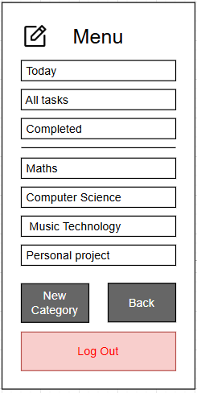[1]

### Create category screen

**The Create Category screen will include:**

* Title field
* Create button
* Cancel button

**The usability features of this screen will include:**

* All of the usability features in this screen have been covered for other screens, as it follows the basic structure of any of my forms.

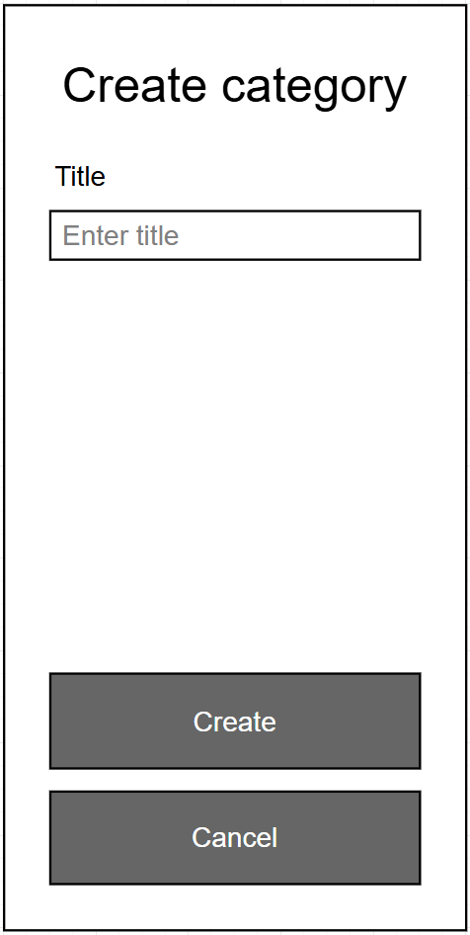

## Key Variables

These are some examples of key variables that I will use in my program. I have used majority local variables, however the initialisation of the database and the tables within the database use global variables that are not used again in the program. I have not included every single variable in this table because that would be a waste of time, instead I have included the variables crucial to the core functionality of my program.

### User account management

|  |  |  |
| --- | --- | --- |
| Variable name | Type | Description |
| login_username | String | Used within the login_validation and check_db functions to check if the user exists. |
| login_password | String | Used within the login_validation and check_db functions to check if the inputted password matches the username. |
| input_password_hash | String | Used to store the inputted password that has been converted into a hash so it can be compared against the hash stored in the database. |
| signup_username | String | Used within a few functions relating to signing up, to represent the username inputted by the user. |
| signup_password | String | Used within a few functions relating to signing up, to represent the password inputted by the user. |
| special_characters | String | Contains the string “!£$%^&*()” which is used to check if any of those characters are in the password entered by the user. |
| user_id | Integer | Contains the user id of the user that is logged in/has just signed up. |
| feedback_label | Kivy label widget | Connects to the ID of a label inside of my .kv file, so that that label’s text can be changed to display an error message if necessary. |
| conn | SQLite database connection | Connection to my task management database. |
| cur | SQLite database cursor | Cursor that can be used to execute SQL queries on the database that has bee connected through “conn”. |

### Task creation

|  |  |  |
| --- | --- | --- |
| Variable name | Type | Description |
| categories | Kivy List Property | Stores all of the categories related to the user that is logged in. |
| inp_title | String | Stores the title that has been inputted by the user. |
| inp_date | String | Stores the due date that has been inputted by the user. |
| inp_descr | String | Stores the description that has been inputted by the user. |
| inp_category | String | Stores the category that has been selected by the user. |
| inp_priority | String | Stores the priority that has been selected by the user. |
| user_id | Integer | Contains the user id of the user that is logged in. |
| category_name | String | Contains the name of the category to which the user is trying to add a task. |
| category_id | Integer | Contains the ID of the category to which the user is trying to add a task. |
| feedback_label | Kivy label widget | Connects to the ID of a label inside of my .kv file, so that that label’s text can be changed to display an error message if necessary. |
| conn | SQLite database connection | Connection to my task management database. |
| cur | SQLite database cursor | Cursor that can be used to execute SQL queries on the database that has bee connected through “conn”. |
| view_task_screen | Kivy screen widget | Used to connect to the View Task screen so that its properties can be changed to match those of the created task. |
| task_id | Integer | Contains the ID of the newly created task. |
| user_categories | List | Contains all of the logged-in user’s categories that have been fetched from the database. |
| valid | Boolean | True if task validation was successful, false if task validation was unsuccessful. |
| error_message | String | Used in conjunction with the feedback_label to display an error message to the user if task validation was unsuccessful. |

### Task manipulation

|  |  |  |
| --- | --- | --- |
| Variable name | Type | Description |
| task_title | Kivy string property | Stores title of task to be displayed on screen (View Task screen) or in the title field (Edit Task screen). |
| task_description | Kivy string property | Stores description of task to be displayed on screen (View Task screen) or in the description field (Edit Task screen). |
| task_due_date | Kivy string property | Stores due date of task to be displayed on screen (View Task screen) and in the due date field (Edit Task screen). |
| task_priority | Kivy string property | Stores priority of task to be displayed on screen (View Task screen) or in the priority button (Edit Task screen). |
| task_status | Kivy string property | Stores status of task to be displayed on screen (View Task screen) or in the title field (Edit Task screen). |
| task_category_id | Kivy string property | Stores category ID of task that will be displayed on screen (View task screen) or the task that is being edited (Edit Task screen). |
| task_category_name | Kivy string property | Stores category name of task to be displayed on screen (View Task screen) or the task that is being edited (Edit Task screen) |
| task_id | Kivy string property | Stores task ID of task to be displayed on screen (View Task screen) or the task that is being edited (Edit Taks screen). |
| conn | SQLite database connection | Connection to my task management database. |
| cur | SQLite database cursor | Cursor that can be used to execute SQL queries on the database that has bee connected through “conn”. |
| inp_title | String | Stores the new title that has been inputted by the user in the edit screen. |
| inp_date | String | Stores the new due date that has been inputted by the user in the edit screen. |
| inp_descr | String | Stores the new description that has been inputted by the user in the edit screen. |
| inp_category | String | Stores the new category that has been selected by the user in the edit screen. |
| inp_priority | String | Stores the new priority that has been selected by the user in the edit screen. |
| feedback_label | Kivy label widget | Connects to the ID of a label inside of my .kv file, so that that label’s text can be changed to display an error message if necessary. |
| valid | Boolean | True if task/category validation was successful, false if task/category validation was unsuccessful. |
| error_message | String | Used in conjunction with the feedback_label to display an error message to the user if task/category validation was unsuccessful. |
| view_task_screen | Kivy screen widget | Used to connect to the View Task screen so that its properties can be changed to match those of the edited task. |
| cat_field | Kivy text input widget | Used to connect to the “category_name_input” text input field via its ID. |
| category_name | String | Contains the name of the category user wants to create. |

### List Display

|  |  |  |
| --- | --- | --- |
| Variable name | Type | Description |
| user_id | Integer | Contains the user id of the user that is logged in. |
| category_name | String | Contains the name of an individual category that has been fetched from the database. |
| conn | SQLite database connection | Connection to my task management database. |
| cur | SQLite database cursor | Cursor that can be used to execute SQL queries on the database that has bee connected through “conn”. |
| btn | Kivy button widget | Button created for each category that must be displayed in the navigation menu. |
| filter_type (string) | String | Used to determine what type of filtering is going to be used to query tasks when a particular task list is selected. |
| user_categories | List | Contains all of the logged-in user’s categories that have been fetched from the database. |
| filter_type (property) | Kivy String Property | Contains the filter type used to display tasks, which is dependant |
| selected_category | Kivy String Property | Contains the selected category of the list that has been selected, given that that list’s filter type is “category”. |
| query | String | Contains the SQL query used to select tasks based on the filter type and selected category. |
| params | List | List of parameters used in the query, that is updated depending on what list has been selected. |
| task_list_layout | Kivy layout widget | This is a connection to the task_list_layout ID that is in my .kv file, to which individual tasks can be added. |
| task_button | Kivy button widget | Button created for each task that has been fetched from the database. |
| tasks | List | Contains all the tasks that have been selected from the database through the query and parameters. |
| view_task_screen | Kivy screen widget | Used to connect to the View Task screen so that its properties can be changed to match those of the selected task. |
| task_id, title, description, due_date, priority, status, category_id | Variables (from task variable) | Task details fetched from database, separated out from the “tasks” list variable, so that they can be used for each task button. |

### Notifications

|  |  |  |
| --- | --- | --- |
| Variable name | Type | Description |
| today | String | Stores today’s date as a string |
| tomorrow | String | Stores tomorrow’s date as a string. |
| three_days | String | Stores the date in 3 days as a string. |
| tasks | String | Stores tasks that have a due date matching today, tomorrow or three_days. |
| conn | SQLite database connection | Connection to my task management database. |
| cur | SQLite database cursor | Cursor that can be used to execute SQL queries on the database that has bee connected through “conn”. |
| due_date_obj | Date object | Stores the due date of a task as a date object rather than a string. |
| today_obj | Date object | Stores the today’s date as a date object rather than a string. |
| message | String | Stores a due date message if there is a task due today, tomorrow or in three days. |
| conn | SQLite database connection | Connection to my task management database. |
| cur | SQLite database cursor | Cursor that can be used to execute SQL queries on the database that has bee connected through “conn”. |

### Other variables

|  |  |  |
| --- | --- | --- |
| Variable name | Type | Description |
| theme | Theme object | Instance of the theme class that can be used for objects in my app. |
| colors | Kivy dictionary property | Stores all of the colors used in my app’s theme. |
| sm_instance | Screen manager object | Instance of the screen_manager which allows my app to switch between screens. |
| initcon | SQLite database connection | Very first connection to my task management database, which handles table creation if the tables are not already present in my database file. |
| initcur | SQLite database cursor | Very first cursor that is used to execute the table creation queries if the tables are not already present in my database file. |

## database table design

### Users table

This table will store all user information required for them to access and use my program. This data will be collected during the users’ first signup and will be necessary for users to log in as well.

|  |  |  |  |
| --- | --- | --- | --- |
| Column name | Data type | Purpose | Primary/foreign key? |
| user_id | Integer | Unique identifier for each user | Primary key |
| username | String | Stores the username, which must be unique | None |
| password_hash | String | Stores hashed password for authentication | None |
| logged_in | Integer | Stores 0 if user is not logged in, 1 if user is logged in. | None |

### Categories table

|  |  |  |  |
| --- | --- | --- | --- |
| Column name | Data type | Purpose | Primary/foreign key? |
| category_id | Integer | Unique identifier for each category | Primary key |
| user_id | Integer | Links category to a specific user | Foreign key, referencing user_id in the Users table |
| category_name | String | Stores name of category | None |

This table stores user-specific categories, linked to each user through the user_id field.

### Tasks table

This table stores all tasks created by users. Each task is linked to both a user and a category, allowing users to separate their tasks into different categories.

|  |  |  |  |
| --- | --- | --- | --- |
| Column name | Data type | Purpose | Primary/foreign key? |
| task_id | Integer | Unique identifier for each task | Primary key |
| user_id | Integer | Links the task to a specific user | Foreign key |
| category_id | Integer | Links the task to a specific category | Foreign key |
| title | String | Stores user given title of the task. | None |
| description | String | Stored description of the task | None |
| due_date | String | Stores task’s due date | None |
| priority | Integer | Stores task’s priority, 1, 2 or 3 | None |
| status | String | Indicates if the task is completed or not: “completed” or “pending”. | None |

## SQL Queries

This table shows and describes some of the SQL queries that will be used in my program alongside the databases specified in the previous chapter. This is not a comprehensive list, as I may require more when I program my solution.

#### Database initialisation

|  |  |  |
| --- | --- | --- |
| SQL | Description | Justification |
| CREATE TABLE IF NOT EXISTS Users (  user_id INTEGER PRIMARY KEY AUTOINCREMENT,  username TEXT NOT NULL UNIQUE,  password_hash TEXT NOT NULL,  logged_in INTEGER DEFAULT 0  ) | This initialises the Users table. | This is needed so that my users can log in and sign up to the program. |
| CREATE TABLE IF NOT EXISTS Categories (  category_id INTEGER PRIMARY KEY AUTOINCREMENT,  user_id INTEGER NOT NULL,  category_name TEXT NOT NULL,  FOREIGN KEY (user_id) REFERENCES Users (user_id) ) | This initialises the categories table. | This is needed so that my users can create categories that are unique to their account. |
| CREATE TABLE IF NOT EXISTS Tasks (  task_id INTEGER PRIMARY KEY AUTOINCREMENT,  user_id INTEGER NOT NULL,  category_id INTEGER,  title TEXT NOT NULL,  description TEXT,  due_date TEXT,  status TEXT DEFAULT 'pending',  FOREIGN KEY (user_id) REFERENCES Users (user_id),  FOREIGN KEY (category_id) REFERENCES Categories (category_id) ) | This initialises the Tasks table with references to both user_id and category_id. | This is needed so that users can create tasks that are unique to their account. |

#### Recurring queries

These are queries that are used consistently throughout my program.

|  |  |  |
| --- | --- | --- |
| SQL | Description | Justification |
| conn = sqlite3.connect("task_manager.db")  cur = conn.cursor | This is not actually SQL, it is python, but it connects to the database and is used throughout my code. | This is necessary because it will be used a lot in my code so that my database can be interacted with. |
| "SELECT user_id FROM Users WHERE logged_in = 1 LIMIT 1" | Selects the user_id of the logged in user. | This query will be used used throughout my code to ensure that operations happen only to the tasks and categories relating to the logged in user. |
| ("SELECT category_id FROM categories… ) | Selects the category_id of a category. Relevant parameters will replace the elipses. | This will be used often for many reasons involving categories. |
| ("SELECT category_name FROM categories… ) | Selects all categories from the category table. Relevant parameters will replace the elipses. | This will be used for multiple reasons, that I will describe in more detail during development. |

#### User account management

|  |  |  |
| --- | --- | --- |
| SQL | Description | Justification |
| ("SELECT password_hash FROM Users WHERE username = ?", (username,)) | This attempts to fetch a password that relates to the inputted username. | This is necessary to check if there is a password that matches the username that the user inputted, in order to grant or deny the user access to the program. |
| ("UPDATE Users SET logged_in = 1 WHERE username = ?", (username,)) | This updates the logged_in value to be 1 so that the user is saved as logged in, and the app will open on the main screen when it is next opened. | This is necessary because without it my users would have to log in every time they opened the app, which would waste time. |
| ("INSERT INTO Users (username, password_hash) VALUES (?, ?)", (username, password_hash)) | When signing up, if the username and password are valid, this query will add the user data to the Users table. | This is necessary to make sure that the user has an account on the database, so they can log in and out. |
| ("SELECT username FROM Users WHERE logged_in = 1 LIMIT 1") | This selects a username of a user that is logged in so that the user can be granted access when the app is opened. | This is necessary because it provides logged in users access without them having to waste time logging in. |
| (INSERT INTO Users (username, password_hash) VALUES (?, ?)", (username, password_hash)) | Inserts user details of user that has just signed up into the Users table. | This is necessary because it means user details are stored and can retrieved again when the user wants to log in. |
| ("INSERT INTO Categories (category_name, user_id) VALUES ('None', ?)", (user_id,)) | Creates a category called “None” in the Categories table for the user that has just signed up. | This ensures that every user has a category called “None” that they can add tasks that do not fit a specific category to. |
| UPDATE Users SET logged_in = 0 | Sets any logged in user to be logged out. | This is necessary so that users are logged out when the log out button is pressed. |

#### task creation

|  |  |  |
| --- | --- | --- |
| SQL | Description | Justification |
| ("""  INSERT INTO Tasks (user_id, category_id, title, description, due_date, priority, status)  VALUES (?, ?, ?, ?, ?, ?, ?)  """, (user_id, category_id, inp_title, inp_descr, inp_date, inp_priority, "pending")) | Inserts task details into database when a task is created. | This is necessary because it ensures that when a user creates a task, it is actually added to the database. |

#### Task manipulation

|  |  |  |
| --- | --- | --- |
| SQL | Description | Justification |
| ("UPDATE Tasks SET status = 'completed' WHERE task_id = ? ", (task_id,)) | Changes task’s status to “completed”. | This is necessary because it allows users to mark tasks as completed so that they do not appear in task lists. |
| ("DELETE FROM Tasks WHERE task_id = ?", (task_id,)) | Deletes a task from the Tasks table. | This is necessary because it allows users to delete tasks if they no longer want them. |
| "UPDATE Tasks SET title = ?, due_date = ?, description = ?, priority = ?, category_id = ? WHERE "  "task_id = ? AND user_id = ?", (new_title, due_date, description, priority, category_id, task_id, user_id)) | Updates a task from the task table with new details. | This is necessary because it ensures that when a user edits a task, the changes are made within the Tasks table. |

#### List display

|  |  |  |
| --- | --- | --- |
| SQL | Description | Justification |
| ("INSERT INTO Categories (category_name, user_id) VALUES (?, ?)", (category_name, user_id)) | Creates a new category for the logged in user. | This is necessary because it will ensure that when a user creates a category, it is also created in the Categories table with the foreign key of their user_id. |

I will be using more SQL queries in this module but they will use more advanced logic with queries that can change so I will describe them in detail during development.

## Class diagrams

Note – I created my class diagrams after development because, before development, I had not clue on how screen objects in kivy worked. This is why many of the methods found in my class diagrams do not line up with my algorithm design – I simply just didn’t know I would need them at the time. All of the algorithms I specified in algorithm design have been completed in my development to some extent, whether as a standalone method or as a collection of methods that combine to create one of the algorithms I created.

While my application will be full of objects, I will not be creating class diagrams for every single button and label in my file, because these are all part of the Kivy library and documentation for them can be found in Kivy’s actual documentation. Instead, I am going to create class diagrams for my app, my theme class, and each of my screens.

First of all, my Choose Signup & Login screen has no methods or properties, so I will be leaving this out.

### Theme class

This screen class holds a dictionary with all the colours used for my theme.

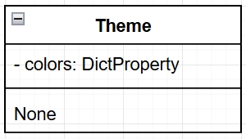

### MyApp class

This screen class contains the build method that will create an instance of my screen manager (a kivy widget whose diagram I will not create). It also has a method to find out which user is logged in, so that that user can be directed to the home page upon entering the app.

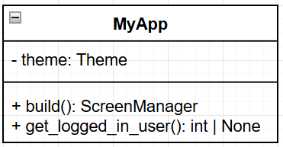

### LoginScreen class

This screen class contains methods relating to users logging in to my app.

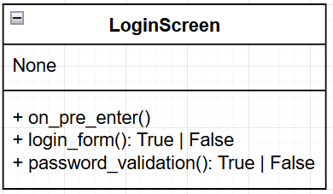

### SignupScreen class

This screen class contains methods relating to my users signing up for the first time.

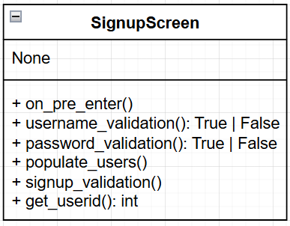

### CreateTask class

This screen class contains methods relating to the creation and validation of tasks, as well as an attribute that stores all of the logged in user’s categories for display in the category drop down menu.

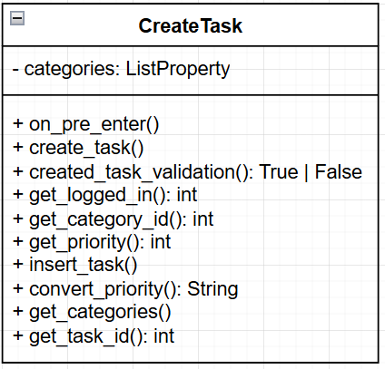

### NavigationMenu class

This screen class contains methods relating to navigation throughout the various lists of my app.

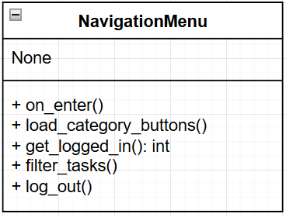

### TaskListScreen class

This screen class contains methods relating to the display of lists of tasks on screen when a task list is selected. It also includes two attributes, filter type – the type of tasks that will be displayed, and selected category – the category from which tasks will be displayed.

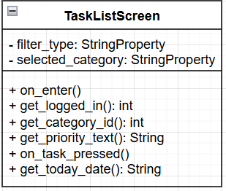

### ViewTask class

This screen class contains methods relating to the display of task data on screen, and also holds multiple string property attributes that contain all of the task’s details.

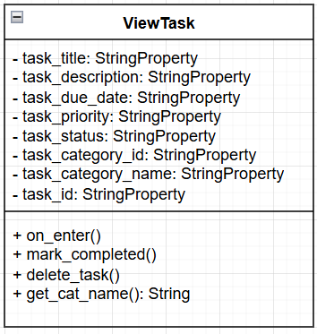

### EditTaskScreen class

This screen class contains methods relating to the manipulation of task details, as well as string property attributes to store the task’s previous details before they were edited.

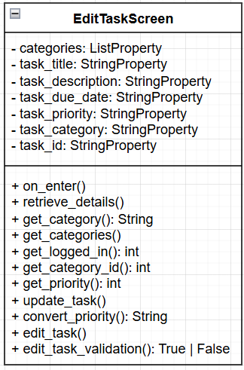

### CreateCategory class

This screen class contains methods relating to the creation of tasks by users.

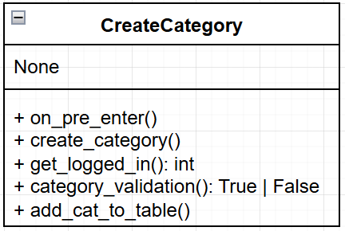

## Validation

Here are the validation measures required in each module of my program.

|  |  |  |  |
| --- | --- | --- | --- |
| Module | Module Component | Validation Criteria | Error message |
| 1 | Login | Validation of user details against database | “Invalid username/password” |
| 1 | Signup | Validation of entered user details against criteria specified in the **Signup Validation** section in algorithm design. | “Password must be greater than 6 characters”  “Password must contain a special character”  “Password must contain at least one number”  Password must contain at least one capital letter” |
| 2 | Task creation form | Presence check for all fields bar description. | “Fields must not be empty” |
| 2 | Task creation form | Validation of entered task details against criteria specified in the **Created Task Validation** algorithm, including length and type checks. | “Task name must be less than 30 characters”  “Task description must be less than 200 characters”  “Please select a valid due date” |
| 3 | Task editing | Presence check for all fields bar due date. | “Fields must not be empty” |
| 3 | Task editing | Validation of entered task details against criteria specified in the **Created Task Validation** algorithm, including length and type checks. | “Task name must be less than 30 characters”  “Task description must be less than 200 characters”  “Please select a valid due date” |
| 4 | Category creation | Validation of entered category – length check, presence check. | “Category name cannot be empty”  “Category name must be less than 20 characters” |

## Post-development Test plan

Here you can find a plan for the testing I will do at the end of development to ensure that my solution meets all of my stakeholder requirements as well as my success criteria. Each point is justified as to why it is important for my solution to be able to pass the test. All of these tests will be carried out during evaluation, with video evidence.

### User account management

#### Choose signup & login

|  |  |  |  |
| --- | --- | --- | --- |
| Test name | Test data | Expected outcome | Justification |
| Testing login button functionality | Login button pressed | On click, login screen opened | This ensures that users can log in if they want to, in order to access the application. |
| Testing signup button functionality | Signup button pressed | On click, signup screen opened | This ensures that users can create accounts if they want to, which is necessary for users that have never used the application. |

#### Signup screen

|  |  |  |  |
| --- | --- | --- | --- |
| Test name | Test data | Expected outcome | Justification |
| Testing signup if no details are entered | Username: “”  Password: “” | Error message: “All fields must be present” | This ensures that a user cannot sign up with blank details, which would cause errors. |
| Testing signup if username is not entered | Username: “”  Password: “P@55word” | Error message: “All fields must be present” | This ensures that the user cannot sign up with just a password only, which would cause errors when it came to logging in. |
| Testing signup if password is not entered | Username: “Ethan”  Password: “” | Error message: “All fields must be present” | This ensures that a user cannot sign up without entering a password, which would cause major security issues. |
| Testing signup if login is too short | Username: “Eth”  Password: “P@55word” | Error message:  “Username must be at least 4 characters long” | This helps ensure that users’ passwords are not short and easily guessable, increasing security. |
| Testing signup if password is too short | Username: “Ethan”  Password: “pass” | Error message:  “Password must be at least 8 characters long” | This helps ensure that users’ passwords are not short and easily guessable, increasing security. |
| Testing signup if password does not contain a capital letter | Username: “Ethan”  Password: “p@55word” | Error message:  “Password must contain at least one uppercase character” | This helps ensure that the users’ passwords are not easily guessable, increasing security. |
| Testing signup if password does not contain a numerical digit | Username: “Ethan”  Password: “P@ssword” | Error message:  “Password must contain at least one digit” | This helps ensure that the users’ passwords are not easily guessable, increasing security. |
| Testing signup if password does not contain a special character | Username: “Ethan”  Password: “Pa55word” | Error message:  “Password must contain at least special character” | This helps ensure that the users’ passwords are not easily guessable, increasing security. |
| Testing signup if login details are valid | Username: “Ethan”  Password: “P@55word” | User account is created and they are taken to login screen. | This ensures that if a user’s details are valid, their account is actually created. It also is a test that the signup button actual directs the user somewhere. |
| Testing back button functionality | Back button pressed | On press, user taken back to choose signup/login page. | This ensures that users do not get stuck on the signup screen. |

#### Login screen

|  |  |  |  |
| --- | --- | --- | --- |
| Test name | Test data | Expected outcome | Justification |
| Testing login if no details are entered | Username: “”  Password: “” | Error message: “Invalid username or password” | This ensures that a user cannot be granted access just by clicking login, their details must be valid. |
| Testing login if invalid username is entered | Username: “Tobi”  Password: “P@55word” | Error message: “Invalid username or password” | This ensures that a user cannot be granted access without a username that belongs to a real user. |
| Testing login if invalid password is entered | Username: “Ethan”  Password: “password” | Error message: “Invalid username or password” | This ensures that a user can only be granted access if both their username and password are valid, and match. |
| Testing login if valid details are entered. | Username: “Ethan”  Password: “P@55word” | On press, user granted access to main screen | This ensures that users are always granted access if their login details are valid. |
| Testing back button functionality | Back button pressed | On press, user taken back to choose signup/login page. | This ensures that users do not get stuck on the login screen. |
| Testing if user is saved as logged in | App opened | On opening, user is automatically taken to the Home screen rather than having to log in again. | This ensures that users do not have to waste time logging in on a device every time they open the app. |

### Task creation

#### Create task screen

|  |  |  |  |
| --- | --- | --- | --- |
| Test name | Test data | Expected outcome | Justification |
| Testing task creation if title is blank | Title: “”  Due date: “11-03-2025”  Priority: “Medium”  Category: “None”  Description: “This is a task I am using for testing” | Error message: “Title cannot be empty” | This ensures that every task has a title, or else the user wouldn’t be able to tell what task is what in the Task List Screen |
| Testing task creation if due date is blank | Title: “Testing task”  Due date: “”  Priority: “Medium”  Category: “None”  Description: “This is a task I am using for testing” | Error message: “Due date cannot be empty” | This ensures that every task has a due date, or else users would not receive due date notifications for tasks |
| Testing task creation if priority is blank | Title: “Testing task”  Due date: “11-03-2025”  Priority: “”  Category: “None”  Description: “This is a task I am using for testing” | Error message: “Please select a priority” | This ensures that every task has a priority, or else the user wouldn’t be able to focus on the most important tasks at one time |
| Testing task creation if title is longer than 30 characters | Title: “Testing task with title that is too long”  Due date: “11-03-2025”  Priority: “Medium”  Category: “None”  Description: “This is a task I am using for testing” | Error message: “Title must be less than 30 characters” | This ensures every task’s title is not too long, firstly so that it fits on screen, and secondly so that screens do not get cluttered with too much text. |
| Testing task creation if date is invalid but still contains numbers | Title: “Testing task”  Due date: “32-13-2025”  Priority: “Medium”  Category: “None”  Description: “This is a task I am using for testing” | Error message: “Please enter a valid date” | This ensures that every task’s date is a date that exists, or else the user would never receive a notification |
| Testing task creation if date is invalid containing wrong characters | Title: “Testing task”  Due date: “11/03/2025”  Priority: “Medium”  Category: “None”  Description: “This is a task I am using for testing” | Error message: “Date must be in format DD-MM-YY” | This ensures that every task’s date can be used in conjunction with python’s datetime library in order to send notifications |
| Testing task creation if description is longer than 200 characters. | Title: “Testing task”  Due date: “11-03-2025”  Priority: “Medium”  Category: “”  Description: “This description is way too long” x 10 | Error message: “Description must be less than 200 characters” | This ensures that every task’s description is not too long that it takes up too much space on screen, and ensures that the space on my users’ devices is not wasted |
| Testing task creation if all details are valid | Title: “Testing task”  Due date: “11-03-2025”  Priority: “Medium”  Category: “None”  Description: “This is a task I am using for testing” | Task is created and user is taken to the View Task screen for that task | This ensures that if all details are valid, the task is definitely added to the database and the user can view its details instantly, and access all of the actions that are provided by the View Task screen. |
| Testing cancel button functionality | Cancel button pressed | On press, user taken back to navigation menu | This ensures that users do not get stuck on the Create Task screen. |
| Testing that created task shows up in correct category in Task List screen | “Testing task” searched for in None category | Task can be found and opened | This ensures that a task is actually created, and can be interacted with in the future, which is the whole point of my app. |

### List display

#### Create category screen

|  |  |  |  |
| --- | --- | --- | --- |
| Test name | Test data | Expected outcome | Justification |
| Testing category creation if category name is blank | Category name: “” | Error message: “Category name cannot be empty” | This ensures that category names are not blank, which would be confusing to look at in the navigation menu |
| Testing category creation if category name is longer than 20 characters | Category name: “Category whose name is longer than 20 characters” | Error message: “Category name must be less than 20 characters” | This ensures that category names are not too long, preventing them from not being able to fit in the navigation menu |
| Testing category creation if category name is valid | “My new category” | Category is created and user is taken back to home page | This ensures that when a user creates a category, they then advance and are not stuck on the screen wondering what has happened |
| Testing that created category shows up in navigation menu | “My new category” searched for in navigation menu | Category is shown and can be opened | This ensures that when a category is created, it is actually displayed for use by the user, or else this feature would be pointless |
| Testing cancel button functionality | Cancel button pressed | On press, user taken back to menu | This ensures that users do not get stuck on the Create Category screen. |

#### Navigation menu

|  |  |  |  |
| --- | --- | --- | --- |
| Test name | Test data | Expected outcome | Justification |
| Testing All tasks button functionality | All tasks button pressed | On press, all tasks relating to user are displayed on screen | This ensures that users are able to view all of their tasks together if they want to. |
| Testing Today button functionality | Today button pressed | On press, all tasks that are due today are displayed on screen | This ensures that users can focus on tasks that have due dates of today. |
| Testing Completed button functionality | Completed button pressed | On press, all tasks that have been completed are displayed on screen | This is important because if a user wants to view tasks that are already completed, without this screen they would not be able to do this. |
| Testing a category button functionality | “Maths” button pressed | On press, all tasks that have been created for a given category are displayed on screen | This is important because it allows users to view tasks that they have grouped together using things personal to themselves. |
| Testing New category button functionality | New category button pressed | On press, Create Category screen is opened | This is important as it ties in with the last point – users must have the ability to group tasks by their own design. |
| Testing back button functionality | Back button pressed | On press, user taken back to Home screen | This ensures that users do not get stuck on the menu and can get back to the home screen. |
| Log out button functionality | Log out button pressed | On press, user taken back to Choose Signup/Login page | This is important because if a different wants to use the app and view/create tasks relevant to themselves, they would not be able to do it without this button. |

#### Task list screen

|  |  |  |  |
| --- | --- | --- | --- |
| Test name | Test data | Expected outcome | Justification |
| Testing if tasks can be sorted by different parameters | Task sorting parameter changed | When a parameter is pressed, tasks on screen are automatically sorted to fit that parameter | This ensures that users can decide what order is important to them and their tasks – e.g. if they deem due date to be more important than priority. |
| Testing task button functionality | Task button pressed | On press, the View Task screen for that task is displayed | This is important because my users need to be able to view task details, and manipulate tasks. |
| Testing back button functionality | Back button pressed | On press, user taken back to menu | This ensures that users do not get stuck in the Task List screen and can get back to the menu. |

### Task manipulation

#### View task screen

|  |  |  |  |
| --- | --- | --- | --- |
| Test name | Test data | Expected outcome | Justification |
| Testing if all task data is displayed correctly on screen | Task opened | All the task data is displayed correctly on screen | This ensures that users are not shown incorrect data relating to the tasks that they have created. |
| Testing Edit button functionality | Edit button pressed | On press, Edit Task screen for that task is opened with all its data already in fields | This is important because it allows users to change task details if they want to, which is something that will often happen for the students that will use my product. |
| Testing Mark Completed button functionality | Mark completed button pressed | On press, user is taken back to menu and task can only be found in the Completed list | This ensures that users can check a task off the list, so that it no longer appears in their main task list. This is important because task lists would become extremely cluttered and my users would not be able to focus on what is important if they could not do this. |
| Testing Back button functionality | Back button pressed | On press, user is taken back to menu | This ensures that users do not get stuck in the View Task screen, and can get back to the menu. |
| Testing delete button functionality | Delete button pressed | On press, user is taken back to menu, and the task can no longer be found in any list | This is important because it ensures that my users can remove any unwanted/accidentally created tasks from their lists, preventing clutter. |

#### Edit task screen

|  |  |  |  |
| --- | --- | --- | --- |
| Test name | Test data | Expected outcome | Justification |
| Testing if all task data is already in fields to be edited | Task opened | All task data is displayed correctly already in fields | This ensures that my users can actually edit the existing task details, rather than having to re-input everything, which would be a waste of time. |
| Testing confirm button functionality | Confirm button pressed | On press, user is taken back to the View Task screen for that task, and the details have been changed | This ensures that if all details are valid, the task is definitely amended in the database and the user can view its details instantly, and access all of the actions that are provided by the View Task screen. |
| Testing cancel button functionality | Cancel button pressed | On press, user is taken back to View Task screen for that task, and the details are unchanged | This ensures that users do not get stuck on the Edit Task screen, and can get back to the menu. |

### Other necessary tests

#### Notifications

|  |  |  |  |
| --- | --- | --- | --- |
| Test name | Test data | Expected outcome | Justification |
| Testing if notifications are sent for tasks due today | Title: “Task due today”  Due date: Whenever today is  Priority: “Medium”  Category: “None”  Description: “” | Notification is sent to device upon opening app | This ensures that users are notified when a task is due today, so that they can be reminded if it is not yet completed. |
| Testing if notifications are sent for tasks due tomorrow | Title: “Task due tomorrow”  Due date: Whenever tomorrow is  Priority: “Medium”  Category: “None”  Description: “” | Notification is sent to device upon opening app | This ensures that users are notified when a task is due tomorrow, so that they can be reminded that they do not have long till it needs to be completed. |
| Testing if notifications are sent for tasks due in 3 days | Title: “Task due in 3 days”  Due date: Whenever 3 days is  Priority: “Medium”  Category: “None”  Description: “” | Notification is sent to device upon opening app | This ensures that users are notified when a task is due in 3 days, so that they get plenty of time before the deadline to finish up with the task. |

# C. Iterative Development

## Prototyping

I am going to be using prototyping when developing my solution. Each of my prototypes should include a nearly fully completed set of modules, however each one should build on the last one in terms of full functionality. In order to create a solution to my problem that aligns with my stakeholders’ wants and needs, I will need to keep referring back to their requirements after each iteration of programming, and this will be the key difference between my first and second prototypes – the third one will only have minor improvements that really round off the program, as well as final aesthetic decisions.

Here is how my prototypes break down:

### Prototype 1- functionality

My first prototype will be simply a bare-bones version of my solution that just works – no special GUI features, no colouring, only the things that make the program work – the window won’t even be designed for a mobile phone to start with, it will just use Kivy’s automatic dimensions. It should contain nearly complete versions of all my modules, maybe missing a few minor details from my success criteria as well as possibly lacking the fluidity, usability and ease of use of a final product, however overall, it should work as my program is supposed to, with little to no errors.

### Prototype 2 – Final product with usability and stakeholder feedback

This second prototype will be my final product after consulting my stakeholders to find out what my solution lacks. It should really pin down the details that my stakeholders desire, and the GUI should be close to its final design as well – this was partially designed in the Usability Features section of my design stage, as shown through the screenshots I used. The main focus of this prototype will be usability – every screen needs to match my Usability Features at least somewhat, and my app should be easy to use by the end of this iteration. To prove that I have done this, I will compare each screen against my usability features at the end to show how I have fulfilled them. I will be testing this module in my Final Testing Evidence, using videos to accompany, to show that my prototype truly lines up with my success criteria.

## Prototype 1 - development

Before I begin the development of my modules, I will need to import the libraries that I will be using to create my application. These include SQLite3, which I am using for database management, some Kivy libraries, which I will be using to create the actual app itself, and the hashlib library for the hashing of my users’ passwords.

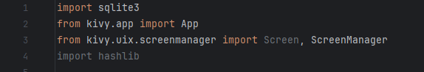

In order to ensure that Kivy is working correctly within my python file, I am going to attempt to generate a blank screen with the following code, which initialises the Screen Manager, and creates a screen with no contents, before adding the screen to the screen manager and running the app:

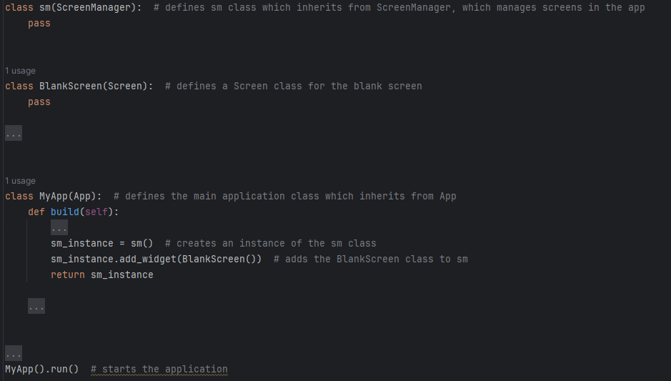

|  |  |  |
| --- | --- | --- |
| What is being tested | Expected outcome | Actual outcome |
| Screen is displayed | Plain black screen pops up | Expected outcome occurred |
| Screen closes | Screen closes properly when “X” button is pressed | Expected outcome occurred |

Evidence:

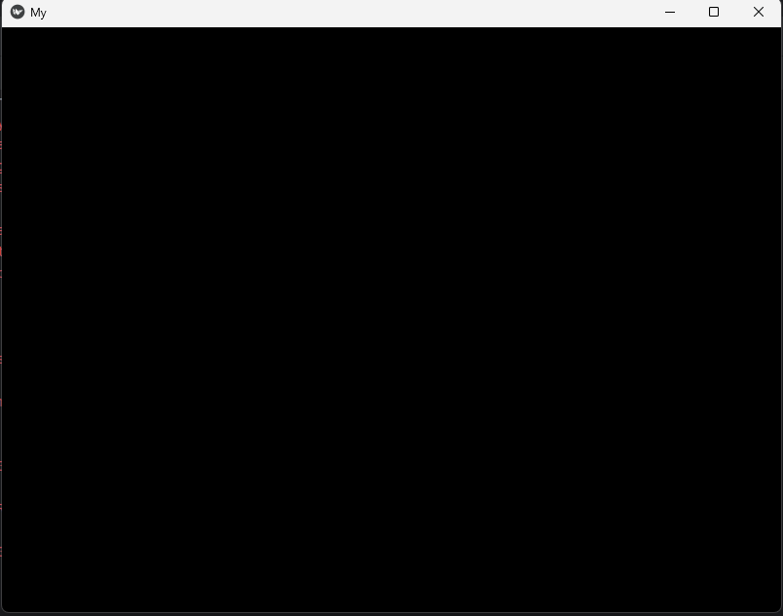

I also need to initialise my database so that it can be used with all the correct tables and fields. Then to test that the database is working I will add a query to be outputted into the terminal that will create and select a user.

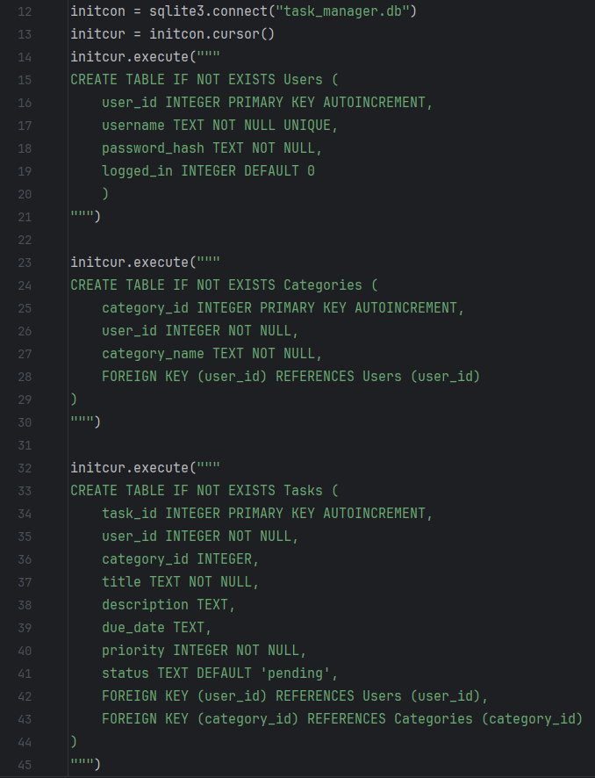

This creates the 3 tables that I spoke about in the Databases section of my design stage, with all of the relevant relationships between tables. The following code will be used to test that the database is initialised:

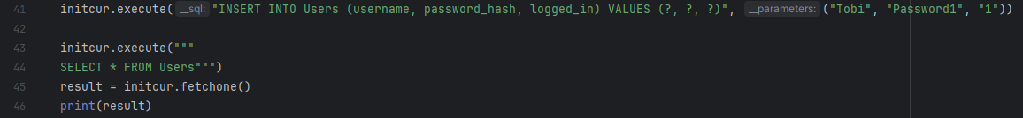

|  |  |  |
| --- | --- | --- |
| What is being tested | Expected outcome | Actual outcome |
| Query returns user data | All of the data that is used as parameters for the query are outputted | Expected outcome occurred |

Evidence:



Now that the database is initialised and working, I can begin developing the User Account Management module.

### User account management

This is the first module that I described in the decomposition of my solution, and it allows users to have their own accounts so that they can keep their data separate from other users even when on the same device. For the User Account Management module, I specified the following algorithms:

* Choose signup or login
* Login form
* Login validation
* Signup form
* Password hashing
* Signup validation
* Log out

While all of these algorithms will definitely be covered during development, sometimes they may be split over a few different methods/algorithms, that combine to create the bigger algorithm that I designed during my design stage. However, they are still all covered properly. The only algorithm which I will not cover in this section is Log Out, because it will be accessed from the main screen, not from any screen relating to user account management.

#### Choose signup or login

Firstly, I have created a .kv file called myapp.kv, which my python file will get its information from I have decided to use a .kv file because it makes it easy to separate my on screen elements from my behind the scenes python code.

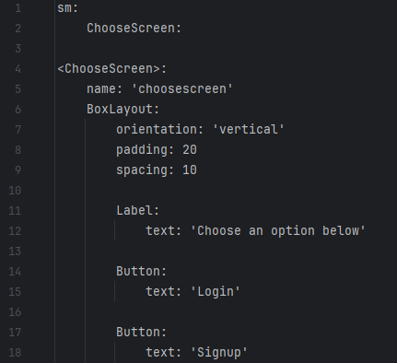

This first creates the root widget referring to my instance of the ScreenManager class called sm. I have then added an instance of the ChooseScreen class to this screen manager. On line 4, I declared the ChooseScreen class, giving it the name “choosescreen” for when it is to be switched to. I then set the orientation, padding and spacing of the screen to make sure that the elements are consistent. After this I created a label with the text “Choose an option below”, and two buttons with texts “Login” and “Signup” respectively. These buttons do not do anything currently, however they will in future. I then wrote the following code into my build function to make ChooseScreen the current screen:



I also created the class ChooseScreen which inherits from Screen:

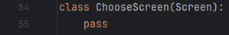

|  |  |  |
| --- | --- | --- |
| What is being tested | Expected outcome | Actual outcome |
| Screen elements display correctly | Labels and buttons appear on screen in the correct order | Expected outcome occurred |
| Buttons work | Buttons direct the user to the correct screen. | ERROR – I have not added the code for these buttons, so an error happens when they are pressed. |

Evidence:

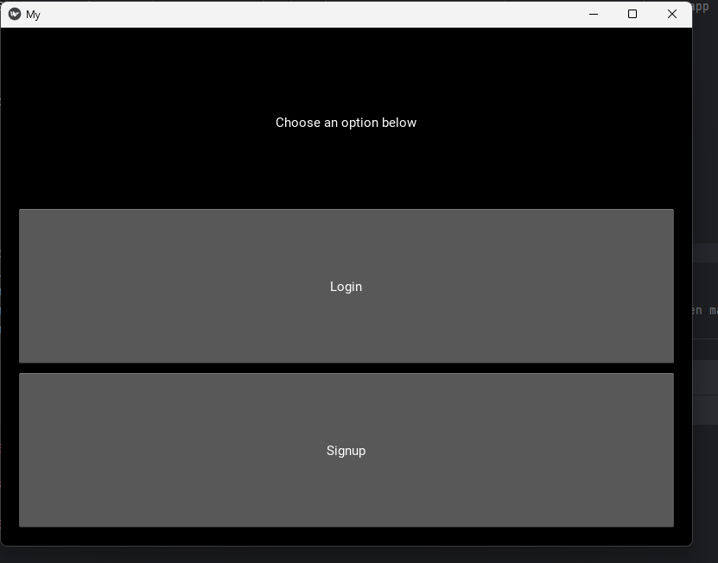

#### Login screen

Now that the initial “Choose” screen has been created, I am now moving onto the login screen. I have begun by adding the login screen to the screen manager in my .kv file, and then adding the input fields and buttons within the declaration of the class.

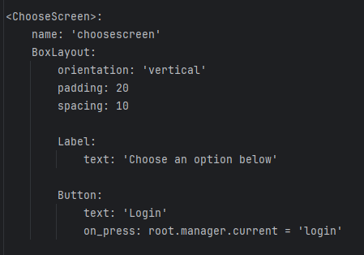

This is the updated ChooseScreen declaration which opens LoginScreen when the Login button is pressed. I have also declared the LoginScreen as can be seen below:

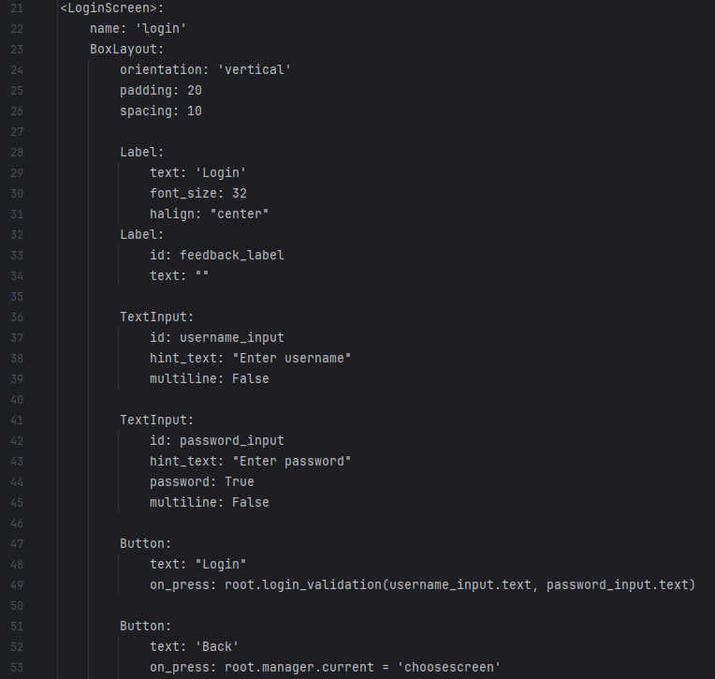

This creates the input fields and buttons that I described in my usability features for this screen, and then uses the root.login_validation() function that I defined in my login screen class definition (which I will describe in a minute). The back button changes the current screen back to the ChooseScreen so the user can pick a different option. Note that for password_input, I have put password: True – this hides the passwords characters when they are being typed, increasing security.

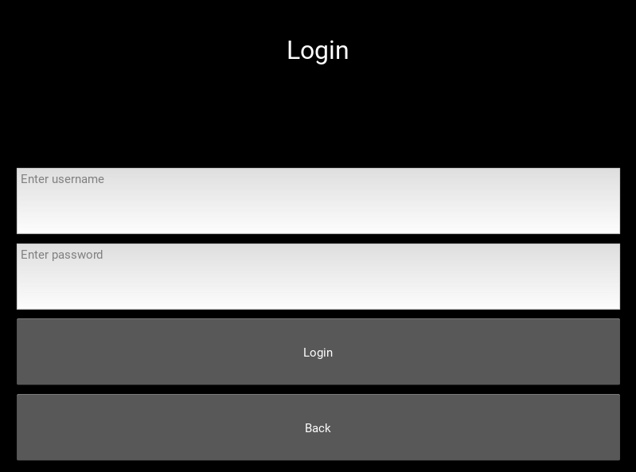

I will now define the LoginScreen class with two methods that relate to the Login Form and Login Validation algorithms that I described in my design stage: login_form() and password_validation(). The password_validation() method will compare the inputted password with the stored password.

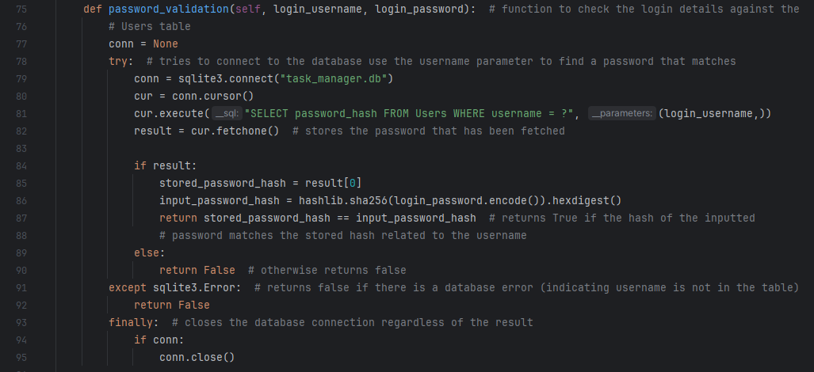

Firstly, the password_validation() method fetches the password hash relating to the inputted username, then it compares it to a hash of the inputted password. If they are the same, the method will return true, and if they are different, the method will return false. Also, if the username cannot be found in the database, the method will return false.

The login_form() method will handle the response of the app to the result of the password_validation() method. If it returns true, the user is logged in, and if false, they are greeted with a message.

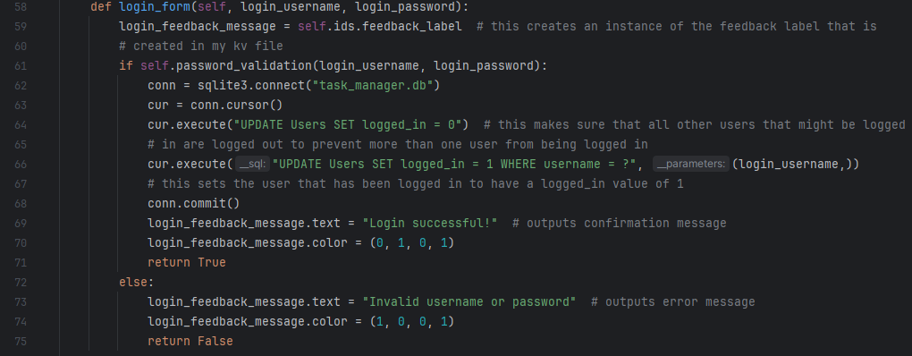

If password_validation() returns true, all other users are logged out to prevent errors, the user’s logged_in value is changed to 1 so that they do not have to log in again, and a green confirmation message lets the user know they have been logged in – this is just for now to prove that the screen is working correctly, in future the user will be directed to the main screen upon logging in. If it returns false, a different message is displayed that states “Invalid username or password” in the colour red.

These messages are created using the ID feedback_label for a label within my .kv file. When the self.ids method is called on the feedback label, login_feedback_message becomes an instance of this ID. The text is then added once the user is successful or unsuccessful in logging in.

Below is the entire class definition for my LoginScreen widget:

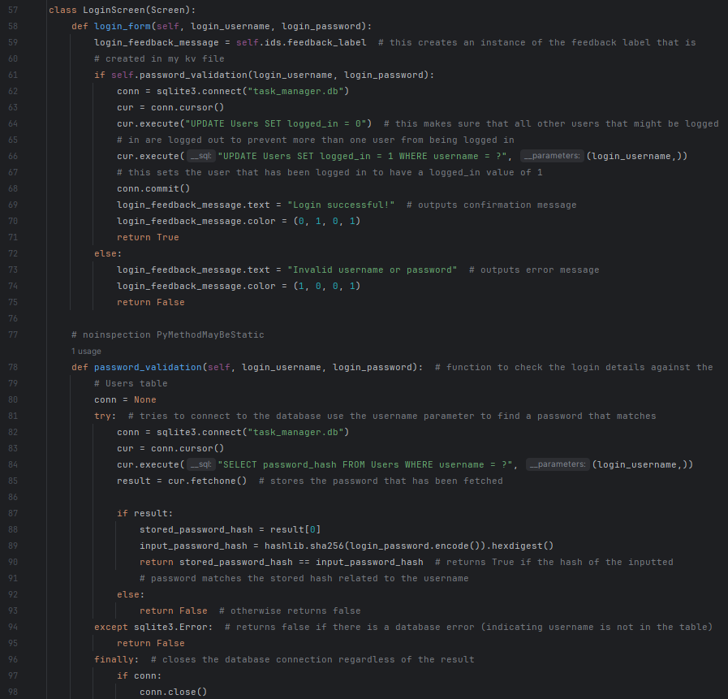

|  |  |  |
| --- | --- | --- |
| What is being tested | Expected outcome | Actual outcome |
| Screen elements display correctly | Labels and buttons appear on screen in the correct order | Expected outcome occurred |
| Login button grants access | When correct username and password is entered, access is granted. | ERROR – I have not added any login data to the database that matches the SHA-256 hashing algorithm so any attempt to log in will prove useless – I will amend this once the Signup form is programmed |
| Feedback labels display correctly | Feedback label displays the outcome of the login attempt. | Expected outcome occurred |

Incorrect details message

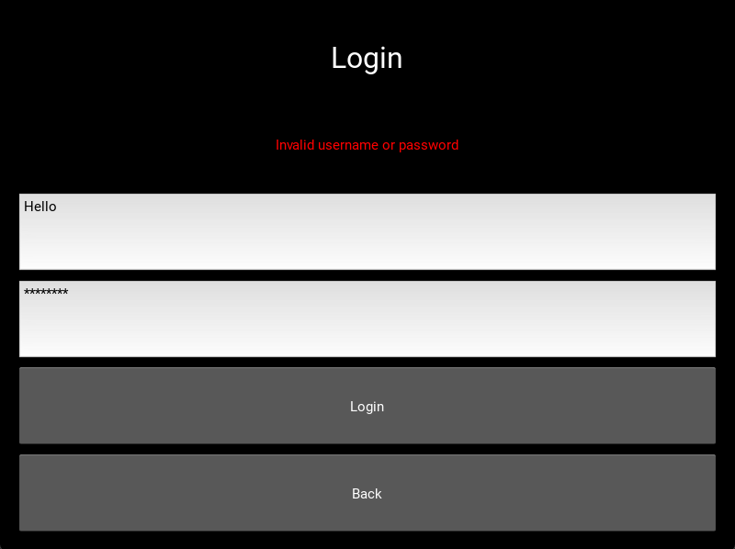

#### Signup Screen

To begin creating the signup screen, I need to amend my .kv file to include SignupScreen in the screen manager:

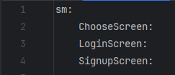

As well as amend my ChooseScreen widget to navigate to the SignupScreen when the Signup button is pressed:

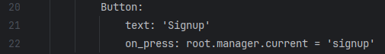

And then I need to create the SignupScreen widget in my .kv file as well:

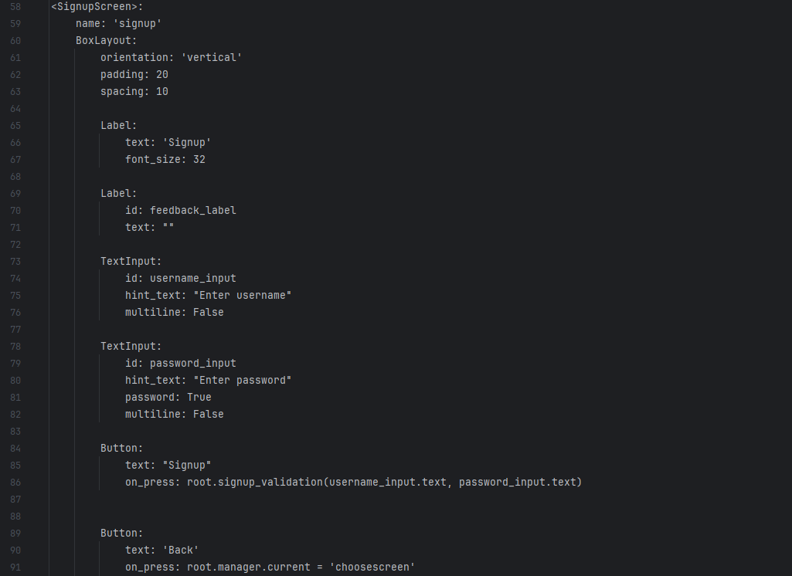

This creates a very similar screen to the LoginScreen, with one key difference: Pressing the Signup button causes the signup_validation() function (which will be described later) to be called. Other than that, the widget is identical to the LoginScreen.

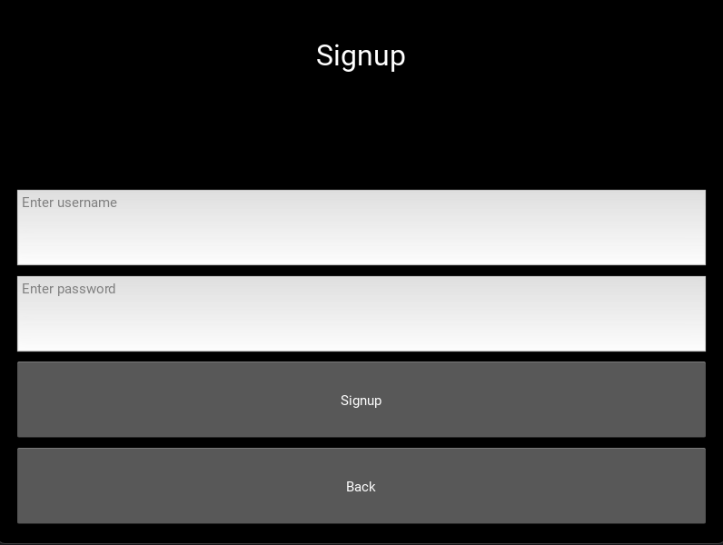

Now that my .kv file has been prepared, I need to define the class and its methods in my python file, which begins with addressing the 3 algorithms in my algorithm design section: Signup Form, Signup Validation, and Password Hashing. These are now split across 4 different methods within the Signup screen: username_validation(), password_validation(), populate_users() and signup_validation().

Beginning with username_validation(), the aim of this method is to ensure 2 things: that the username is over 4 letters long, and the username is not already taken by another user.

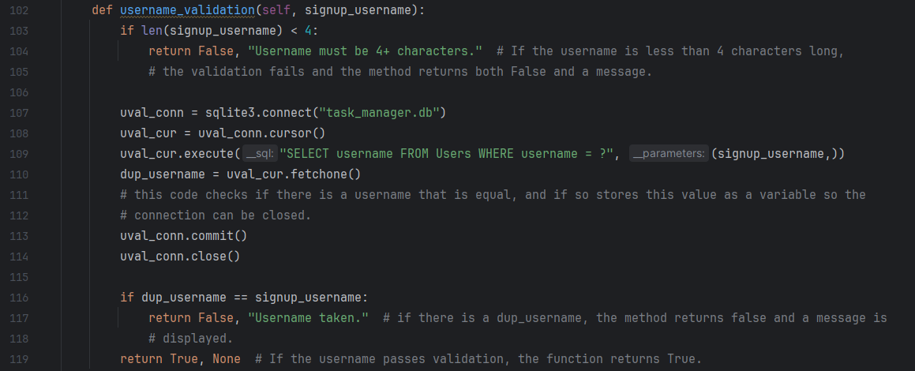

This method always returns 2 values, a Boolean and a string that can be used as a message for a feedback label. For example, if the length of the username is less than 4, it returns False, and “Username must be 4+ characters.”. If the username is present in the database already, it returns False, and “Username taken.”. If the username is not either of these, it returns True and no message.

The second method, password_validation(), needs to ensure that user passwords follow the following criteria:

* 8 characters or longer
* Contains at least one uppercase character
* Contains at least one number
* Contains at least one special character

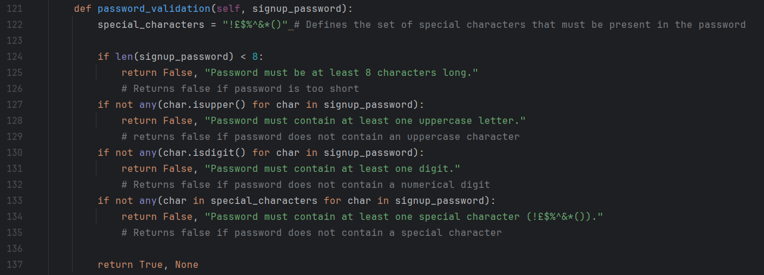

Similar to the username_validation() method, it always returns 2 values, a Boolean and a message. If the password satisfies all the validation criteria, it returns True and no message. This method is necessary because it ensures the security of my users’ data by making sure passwords are not easily guessable.

The third method, populate_users(), adds the knew user’s username and hashed password to the Users table using an SQL query.

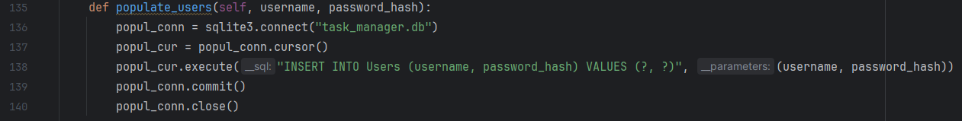

I have not commented this code because all it does is update the database with knew information, which I have described and commented many times previously – also the query that I use has been described in the SQL Queries section.

Finally, the three algorithms I have described come together in the signup_validation() algorithm, which passes the user’s inputted username and password into the other three algorithms in turn:

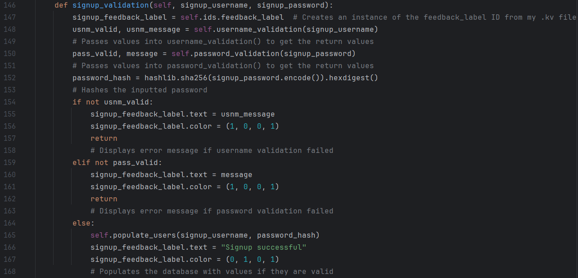

This retrieves the output of the validation methods when the user’s input values are passed into them, hashes the passwords, and displays the relevant messages that help the user know if they have succeeded in signing up, or if they have failed and why.

#### Directing to main screen

In order for my login to actually work, I need to set up a basic Main screen that the user is directed to upon logging in, so I will quickly define this screen within the .kv file:

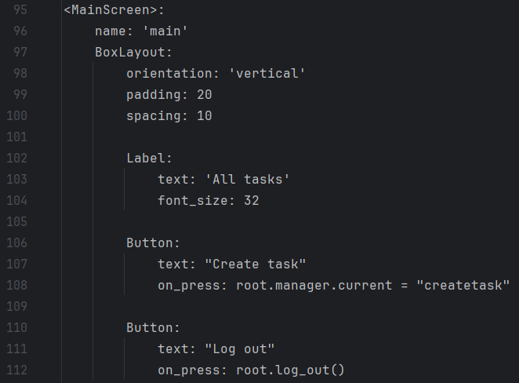

This creates a screen just like my other screens, and I have labelled it “All tasks” just for these purposes. I then added a button with text “Create task” which directs to the CreateTask screen, and another button with text “Log out” which called the log_out() method that I will define next. I will then add the screen to my python file:

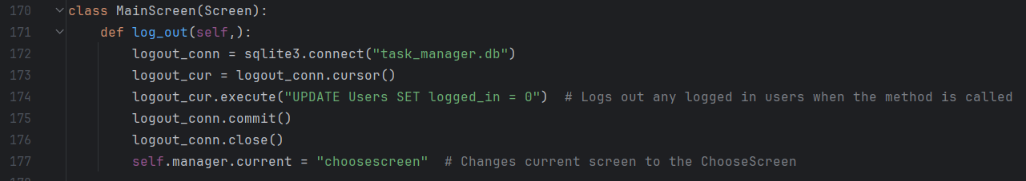

This defines the log_out() method within the MainScreen class, which sets all logged_in values to 0, meaning all users are logged out. Finally I added the MainScreen to the screen manager in the build method:



And I then amended the login_validation() method to direct to the main screen if the login details are valid:

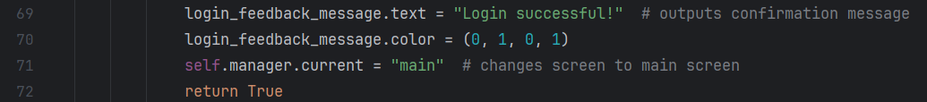

Now, if a user logs in, they will be directed to the main screen, which is shown below:

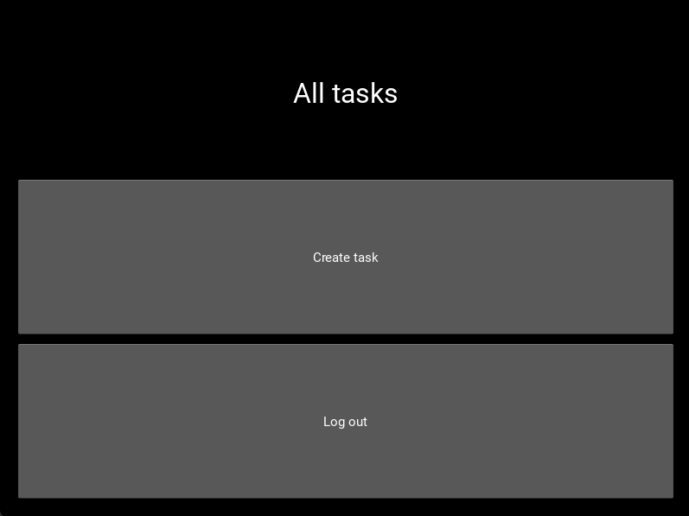

This screen has no usability features that I want to talk about because it is merely a placeholder for the actual all tasks screen, which will be created when I develop the **List Display** module.

One of the features I wanted was for users to not have to log in on the same device unless they have been logged out. This means that, if a user is logged in, the app must automatically direct to the Main Screen when it opens.

Firstly, I must create a method within the App class that fetches a logged in user:

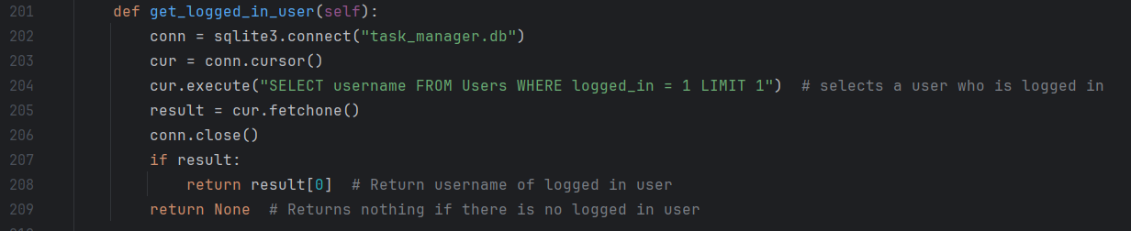

This searches the Users table for a user that is logged in – of which there will never be more than one. It then returns the username of that user, if there is one, or returns None if there isn’t one. Now that this method is created, I need to modify the build method to either:

1. Direct straight to MainScreen if a user is logged in
2. Direct to ChooseScreen if no user is logged in

I have added this code to the build method:

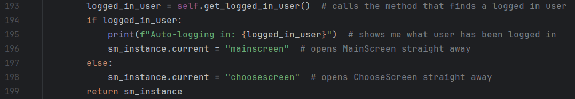

Which does one of the two options I described depending on if there is a logged in user or not. I will now test the code.

|  |  |  |
| --- | --- | --- |
| What is being tested | Expected outcome | Actual outcome |
| MainScreen elements display correctly | Labels and buttons appear on screen in the correct order when a user is logged in | Expected outcome occurred |
| Logged in user does not have to log in again | MainScreen opens automatically if there is already a user logged in | Expected outcome occurred |
| User can log out | User’s logged_in is set to 0 when Log out is pressed. | Expected outcome occurred |

**Evidence:**



Since the user “Tobi” is already logged in, this is displayed in the Run window and the main screen opens automatically.



When I pressed the log out button, this was displayed in the Run window, and the final value is 0, indicating that logged_in is 0 and Tobi is no longer logged in.

#### Testing signup and login

This concludes the first iteration of my User Account Management module, and I am now going to be testing the entire module as a whole – I tested the ChooseScreen and LoginScreen separately, however there is no point testing the SignupScreen without using it alongside the LoginScreen to prove that a user can both sign up and log in.

**Signup Screen**

|  |  |  |  |
| --- | --- | --- | --- |
| What is being tested | Test data | Expected outcome | Actual outcome |
| Screen elements display correctly | None | Labels and buttons appear on screen in the correct order | Expected outcome occurred |
| If the program does not allow no data to be inputted when signing up | Username: Blank  Password: Blank | Error message | “Username must be 4+ characters” – this is a sufficient error message for now, because the main thing is that it prevents empty fields from being inputted. |
| If the validation recognises that a username is too short | Username: Tob  Password: myP@55word | Error message for username too short | “Username must be 4+ characters” |
| If validation recognises that the password is too short | Username: Tobi  Password: myP@55 | Error message for password too short | “Password must be at least 8 characters long” |
| If the validations recognises that the password has no uppercase characters | Username: Tobi  Password: myp@55word | Error message for no uppercase character | “Password must contain at least one uppercase letter” |
| If the validation recognises that the password has no numerical digits | Username: Tobi  Password: myP@ssword | Error message for no numerical digit | “Password must contain at least one digit” |
| If the validation recognises that the password has no special characters | Username: Tobi  Password: myPa55word | Error message for no special character | “Password must contain at least one special character (!£$%^&*()@) |
| Validation recognises that inputs are valid | Username: Tobi  Password: myP@55word | Success message | “Signup successful” |
| Validation recognises that username is already taken | Username: Tobi  Password: myP@22word | Error message for username taken | FAIL – “SQLite.IntegrityError: UNIQUE constraint failed: Users.username” |

**Fixing the error**

It has now come to my attention that my code for preventing multiple users with the same username has failed, and I must figure out a fix for this.

After searching through my code, I realised that the error lies within the username_validation() method within the SignupScreen widget. When I search for a duplicate username, I set dup_username = uval_cur.fetchone, which correctly fetches any duplicate username found in the database:



However, the value I fetched is a tuple, not a string, because fetchone() always fetches a tuple. In the method, the tuple dup_username is compared with the string signup_username to check if they are equal:



As one is a tuple and one is a string, they can never be equal, so the method will never return False, and the issue will never be dealt with. This is what led to the SQLite.IntegrityError.

To fix this error, I will change to code to return False if the fetchone() function fetches any value, because this will always be a duplicate. Here is my modified code:  
 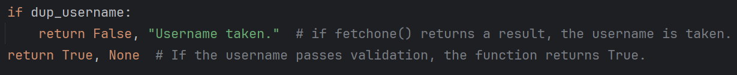

Now to retest the code:

|  |  |  |  |
| --- | --- | --- | --- |
| What is being re-tested | Test data | Expected outcome | Actual outcome |
| Validation recognises that username is already taken | Username: Tobi  Password: myP@22word | Error message for username taken | “Username taken” |

**Login Screen**

Now that I have some data in my database (from the successful test of my signup screen), I am going to use those login details to attempt to log a user in, as well as use incorrect login details to see how the program responds.

|  |  |  |  |
| --- | --- | --- | --- |
| What is being tested | Test data | Expected outcome | Actual outcome |
| If the program does not allow no data to be inputted when signing up | Username: Blank  Password: Blank | Error message | “Invalid username or password” |
| Validation recognises that inputs are valid | Username: Tobi  Password: myP@55word | MainScreen is loaded | Expected outcome occurs. |
| Validation recognises that inputs are invalid | Username: Tobi  Password: myP@22word | Error message for invalid details | “Invalid username or password” |

My first iteration of my User Account Management module is now fully tested and any errors have been corrected, so now I will be moving on to the second module, Task Creation.

### Task creation

Now that the User Account Management module has been created, I can move onto the next module, Task Creation. While this module will eventually involve Category creation, I thought it best to leave this out for this first iteration because it is not that complex and, while categories are integral to my final solution, for now I can just define my own categories using SQL queries, and I will cover this in my second iteration.

Up until this point, I have been designing using the default window size for Kivy. Now, I am going to be designing using an aspect ratio that fits my final product, a mobile app, 9:16. The resolution I am going to be using that fits this aspect ratio is 360x640. This is the code I have used to achieve this:



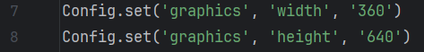

I have used the Config library, which allows me to customise app settings before the app is started, to control the width and height of the app to how I would like it.

Now I am moving onto declaring the CreateTask screen in my .kv file, and to do that I have been referencing the screen that I designed in **Usability Features** to make sure I have every detail. The create task screen includes:

* Title entry field
* Due date entry field
* Priority selection buttons
* Category selection menu
* Description entry field
* Create and cancel buttons

I will be describing my development of the screen declaration section by section. Before, my .kv file screen declarations were quite simple so I could just describe them as a whole, but this one is complex and I will need to describe my process when creating it. Firstly, I need to create the CreateTask screen in the file with a box layout that contains basic details such as orientation, padding and spacing. I then need to add a large label with the text “Create task” to act as the title of the screen.

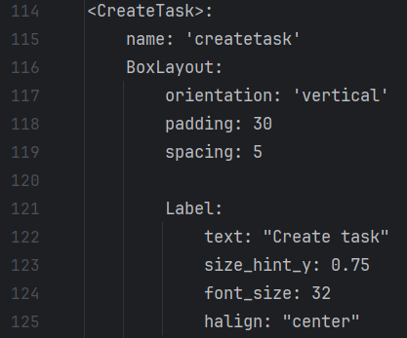

All of my on screen sections will have size_hint_y: 0.75 so that they take up less space proportionally, allowing for more space for the Description, which might involve multiple lines of text. This code creates the following screen:

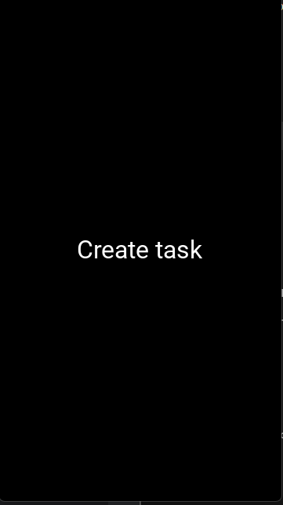

Next, I am going to add the first section, which will involve a label that says “Title”, and an entry field that says “Enter task title”:

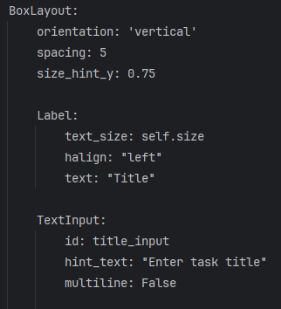

I have created another vertical BoxLayout and added the two elements to it. Again, this layout has size_hint_y: 0.75 to make sure it takes up less space proportionally. Spacing is 5 like usual, and there is no padding because it inherits the padding from its parent box layout. The screen now looks like this:

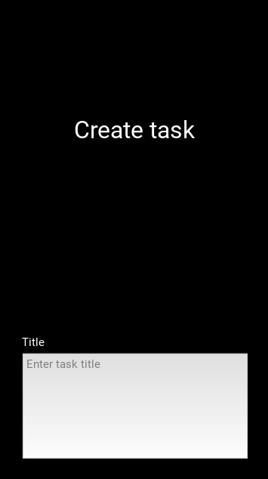

I now need to do the exact same again, but for the due date entry field:

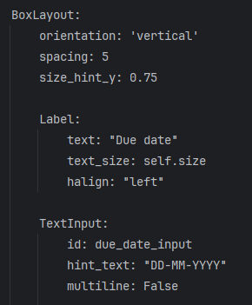

Which makes the screen look like this (no explanation because it is identical to the previous code):

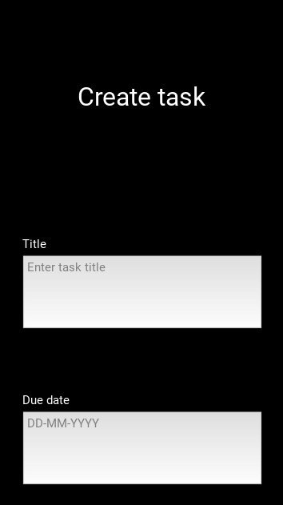

Next, I need to add the priority radio buttons – now this is where it gets more complicated. This involves two box layouts: the vertical parent box layout, which includes the title of the section (“Priority”) and the horizontal child box layout, which includes the three priority levels laid out horizontally with their radio buttons.

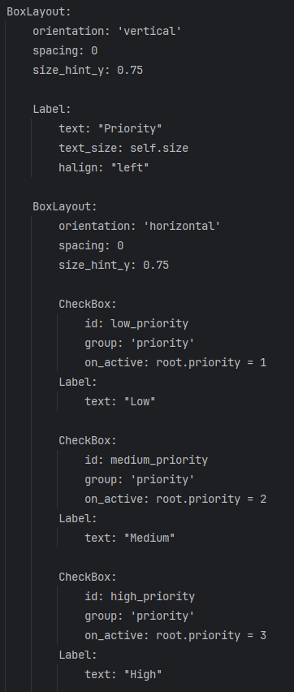

Firstly, I created the main, vertically orientated box that all of the Priority components would be stored in, this time setting spacing to 0 so that space is not wasted between the label and the radio buttons. I then placed the “Priority” label inside this main box, and defined another box with horizontal orientation, into which I could place the 3 radio buttons, right next to each other.

I then created 3 CheckBox widgets within this box layout, with low, medium and high priority IDs respectively, and they all have an on_active event that determines what root.priority is set to based on which one is selected, 1, 2 and 3 respectively. The CheckBox widgets are added to the ‘priority’ group, ensuring that only one priority can be selected at a time. The screen now looks like this:

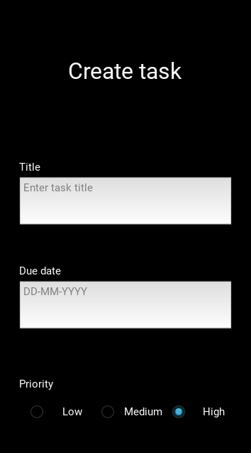

I now need to create the category menu, which involves a label and a spinner widget:

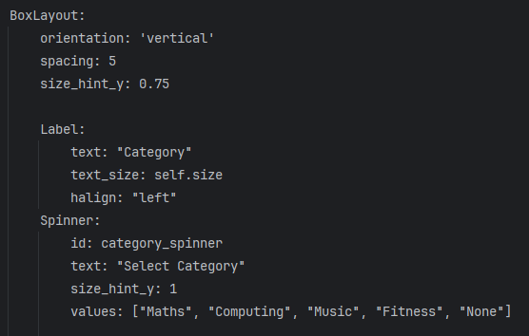

The spinner widget, which allows users to select one value from a number of values, acts as my drop down menu for users to select a category. The values that I have added are merely placeholders, for when the user can add their own categories – I will cover this in my second prototype. The screen now looks like this:

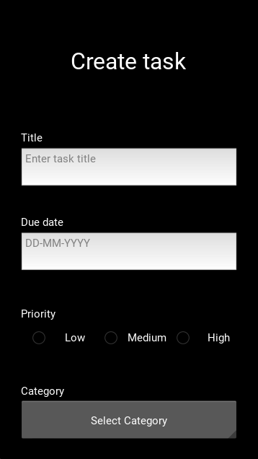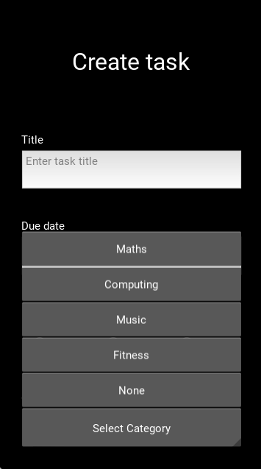

Now I need to add the description text input:

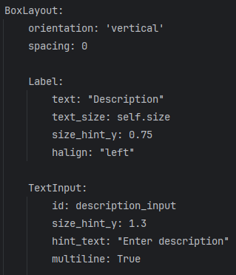

Which uses the same format as I have used for my other text inputs, however the size_hint_y for the box layout is not set, making it 1 so it takes up all available space, and the Label and TextInput widgets are set to 0.75 and 1.3 respectively, so that the input field takes up more of the space within the box. This makes the screen look like this:

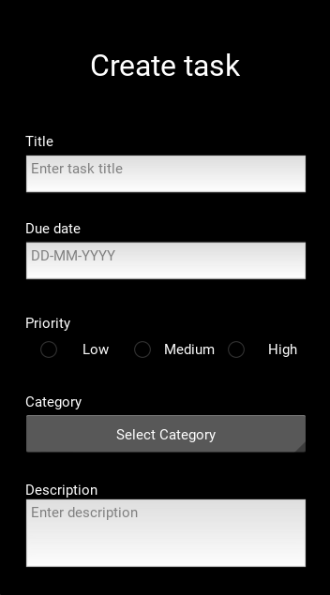

Now all I need to add are the two buttons on the screen, “Create” and “Cancel”, which I want to be placed next to each other horizontally.

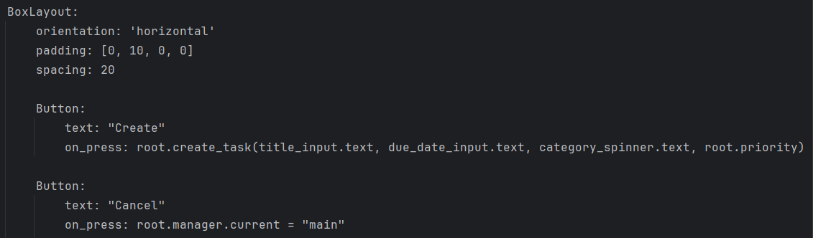

I have set the padding within this horizontal box to 10 from the top, so that there is more space between the description box and buttons, and I have set the spacing of this box to 20 so that there is a decent amount of space between the two buttons as well.

When the “Create” button is pressed, it will call the create_task() method (which I will define later) and passes all of the users task data into it. When the “Cancel” button is pressed, the user is taken back to the main screen.

Now that the screen is finished, this is what it looks like:

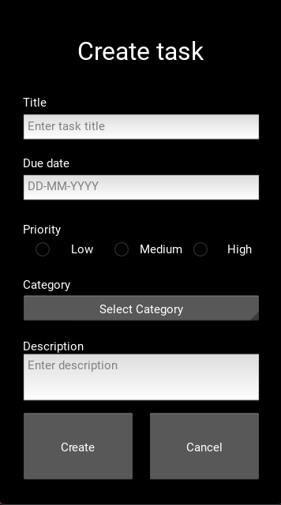

I will now perform a few tests on the screen, keeping in mind I have not yet created the python code to go along with it.

|  |  |  |  |
| --- | --- | --- | --- |
| # | What is being tested | Expected outcome | Actual outcome |
| 1 | CreateTask screen elements display correctly | Labels, buttons and text input fields appear on screen in the correct order | Expected outcome occurred |
| 2 | Fields accept user input | I am allowed to type in the fields that have been displayed | Expected outcome occurred |
| 3 | Priority buttons allow me to select one, and only one | When I click on one, it is selected, and when I click on another, that one is selected and the previous one is deselected | Expected outcome occurred |
| 4 | Category spinner allows me to select a category | When I click the spinner, the categories are displayed, and selecting one works | Expected outcome occured |
| 5 | Cancel button works | When I click the cancel button, I am taken back to the Main screen | Expected outcome occurred |

**Evidence:**

**1: CreateTask screen elements display correctly**

This has been evidenced in the previous section

**2: Fields accept user input**

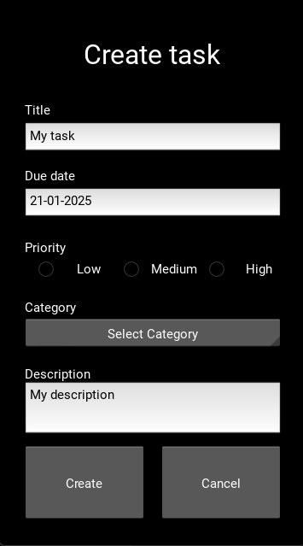

**3: Priority buttons allow me to select one, and only one**

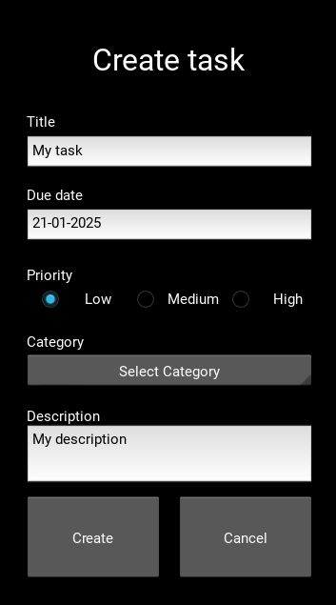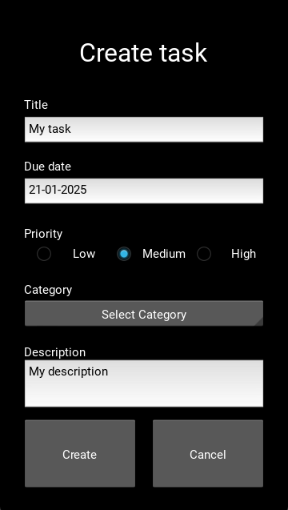

Here I set priority to low, then pressed medium, and the low priority was removed.

**4: Category spinner allows me to select a category**

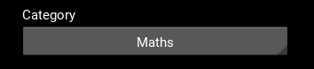

Here, I clicked “Maths” when the spinner was displayed.

**5: Cancel button works**

There is no real way to evidence this, but the cancel button does indeed work.

Now that the CreateTask screen has been created within my .kv file, and all of its on screen elements work correctly (disregarding those that require python code to work), it is time to move on to creating all the methods that will be used within the CreateTask class in my python file.

These methods include:

* on_pre_enter()
* create_task()
* created_task_validation()
* get_logged_in_user()
* get_category_id()
* get_priority()
* insert_task()

Firstly, I need to make sure that the form is empty when the user presses Create Task, because if they cancelled, then went to create a task again, by default any information they entered before would still there. I will be using the on_pre_enter() method, which determines what happens to the screen before the user sees it.

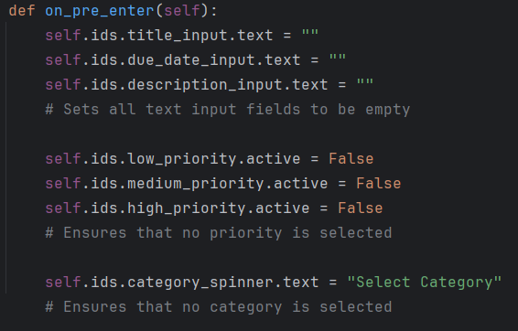

This ensures that every field, button and spinner is empty, so the user can always enter new data without having to remove old data.

Now I need to create the created_task_validation(), which will be called inside the create_task() method. It will make sure of things:

* Title is present
* Title < 30 characters
* Description < 200 characters
* Due date is correct format
* Priority and category fields have been selected

First I will need to import the datetime library into python so that the date can be checked:



And now I can create the method:

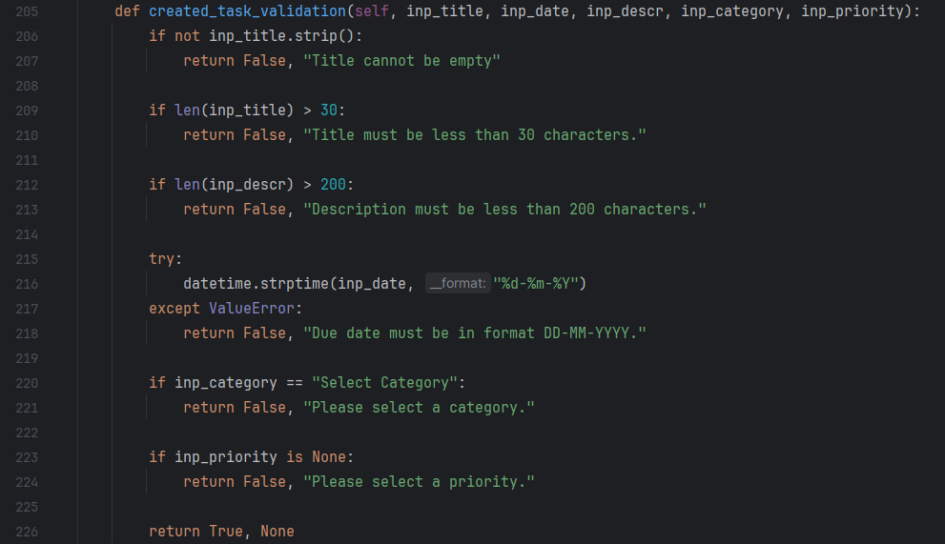

As you can see, each input value is passed into the method and validated using the criteria I specified before. Each error returns False, as well as a message that I will use for a feedback message that will be displayed to the user. To check that there is a title present, I have used the .strip() function so that even if the title has only spaces, it will return False and that it cannot be empty. For the date, I have used the datetime.strptime() function, which converts the date (which is a string) into a datetime object to check if it is in the correct format.

I need to add a feedback label to the .kv file so that if there is an error, it is displayed to the user with directions on what to do instead.

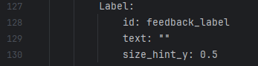

The text of this label will be changed to reflect what happened in the error.

Now I need to make sure that when a user creates a task, that task is related to their user_id in the tasks table. To do this I will create a method that retrieves the user_id of a user that is logged in:

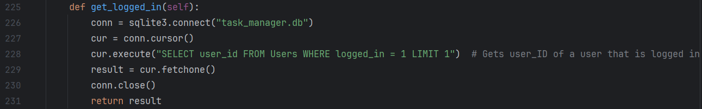

Next, I need to make sure that when a user creates a task, that task is related to the relevant category_id in the tasks table. To do this I will create a method that retrieves the category_id based on the name of the category that has been selected.

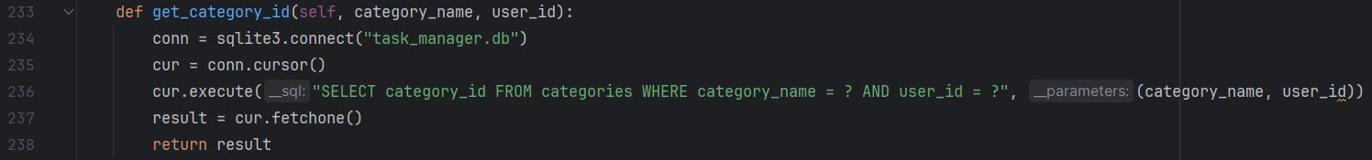

I now need to create a method that determines what priority the task is.

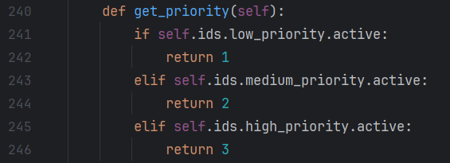

This checks which priority button is active, returning 1, 2 or 3 if the priority is low, medium or high.

Finally, I need to create a method that inserts the task data into the database using an SQL query.

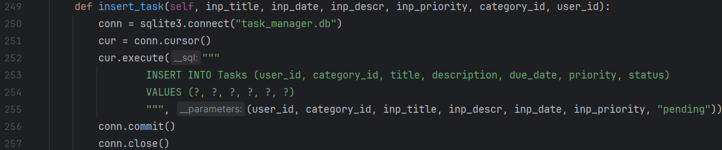

This adds all of the details to the Tasks table, including the foreign keys user_id and category_id.

Now that all of the methods that will be used by the create_task() method have been created, I can create that method itself. All it will do is retrieve the input values from Kivy, call all of these methods using the input values as parameters, and use the insert_task method to add the task to the database.

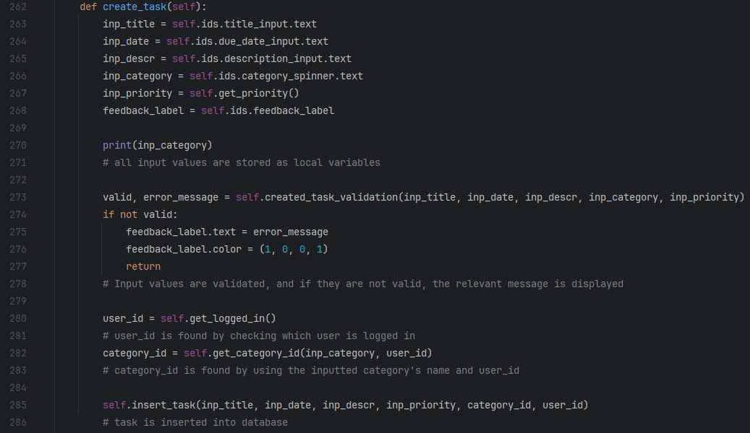

As you can see, all of the methods I defined earlier come together in this method, which validates the input values, finds which user to store the task to, finds which category to store the task to, and inserts the task into the Tasks table. The first iteration of the Create Task screen is now completed, and I can now move onto testing this module.

#### Testing task creation

Because I am leaving out user category creation for this first prototype, I will need to add some of my own categories to my Categories table so that created tasks have a category they can relate to. To do this I am going to add the same categories that I added to my .kv file to the Categories table using an SQL query:

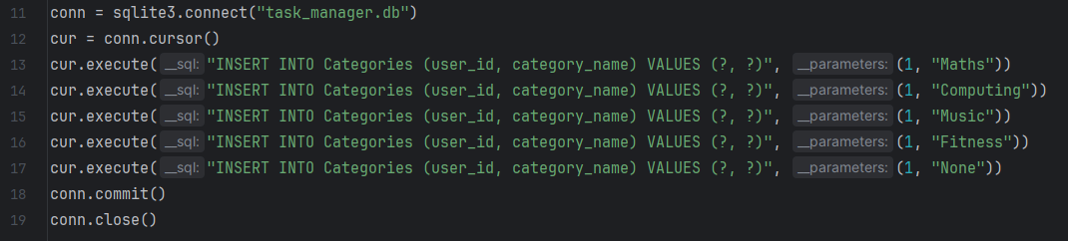

This adds the exact same categories that I have specified in the .kv file: Maths, Computing, Music, Fitness and None, which reflect some categories an actual user might add to their own categories.

Now that I have categories added, I can test what happens when I try to enter a range of test data.

|  |  |  |  |
| --- | --- | --- | --- |
| What is being tested | Test data | Expected outcome | Actual outcome |
| If the program does not allow no data to be inputted | Title: Blank  Due Date: Blank  Priority: Blank  Category: Blank  Description: Blank | Error message | “Title cannot be empty” |
| If the program does not allow title to be longer than 30 characters | Title: MyTaskMyTaskMyTask  MyTaskMyTaskMyTask  Due Date: 21-01-2025  Priority: Low  Category: None  Description: This is my description | Error message | “Title must be less than 30 characters” |
| If the program does not allow a description longer than 200 characters | Title: MyTask  Due Date: 21-01-2025  Priority: Low  Category: None  Description: “This is my description” x10 | Error message | “Description must be less than 200 characters” |
| If the program does not allow invalid date format | Title: MyTask  Due Date: 99-99-9999  Priority: Low  Category: None  Description: This is my description | Error message | “Due date must be in format DD-MM-YYY” |

|  |  |  |  |
| --- | --- | --- | --- |
| If the program does not allow empty priority | Title: MyTask  Due Date: 21-01-2025  Priority: Blank  Category: None  Description: This is my description | Error message | “Please select a priority” |
| If the program does not allow empty category | Title: MyTask  Due Date: 21-01-2025  Priority: Low  Category: Blank  Description: This is my description | Error message | “Please select a category” |
| If the program allows a task to be created normally when all inputs are valid | Title: MyTask  Due Date: 21-01-2025  Priority: Low  Category: None  Description: This is my description | Task is displayed in run window when SQL query requests to view tasks | ERROR: “sqlite3.ProgrammingError: Error binding parameter 2: type 'tuple' is not supported” |

It has come to my attention that creating a task causes an error that means that the task is not added to the database. When I press create, after adding all of the valid data above, I get the following error:



This shows me that the error is occurring when the get_category_id() method is called. I can see now that this is because the user_id parameter is being passed as a tuple, rather than an integer. To remedy this, I will first change the get_logged_in() method so that it returns the integer value from the tuple:

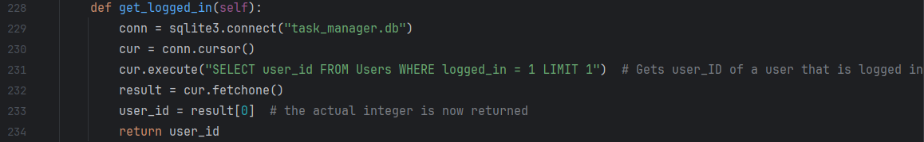

And I will also change the get_category_id() method so that it returns an integer as well to prevent further errors down the line:

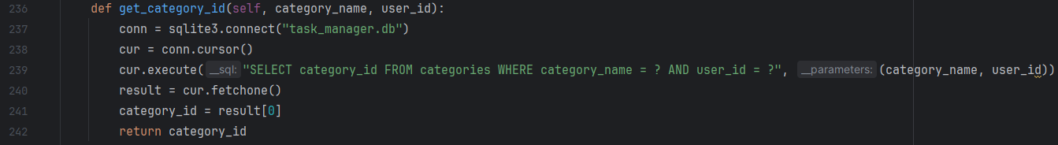

Now that all IDs are integers when they are used as parameters, the program should work properly. I will input the same data that I inputted last time, then search the Tasks table to see if it has been added:

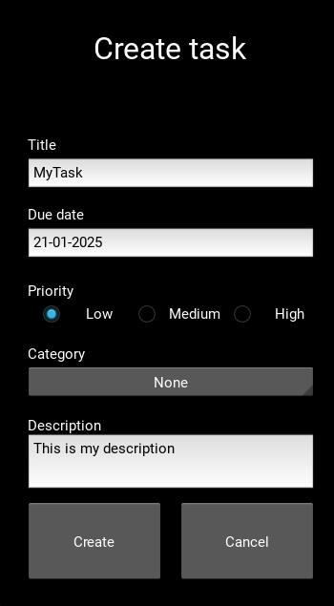

This is what has been inputted, and when I search the Tasks table after, I am greeted with this:



Proving that the task with correct input values has been added to the table in the correct format. My CreateTask screen is now working properly, and I can move on to the next module.

### List Display

While I described this module after the Task Manipulation module in decomposition, I have decided it would be better if I created this first, so that I can actually view all of my tasks within the app. There would be no point developing the Task Manipulation module before this, because I wouldn’t actually be able to use or test it without selecting a task within the app first – which will be done through the List Display module.

This module will have 3 key sections:

* Navigation menu
* View task lists
* Task sorting

And I am going to be focusing on the navigation menu first, as it is from where all of the task lists will be able to be viewed.

#### Navigation menu

The navigation screen will have buttons that direct the user to a list of tasks containing all tasks from a certain category. The screen will consist of the following:

* Predetermined categories (Today, All Tasks, Completed)
* User created categories
* New Category button
* Back button
* Log Out button
* Edit button (icon)

However, I am going the leave out the New Category button and the Edit button because they both relate to category creation, which I am leaving until the next prototype. Also, I am going to leave the log out button on the main screen for now, in future I might choose to put it in the navigation menu but I am not making the decision now. So the first iteration of my navigation menu will consist of the following:

* Predetermined categories
* User created categories (will just be my placeholder categories for now)
* Back button

This simplifies the navigation menu to include only what is necessary for this first iteration. Now that I know what I am going to be doing, I can begin creating the screen.

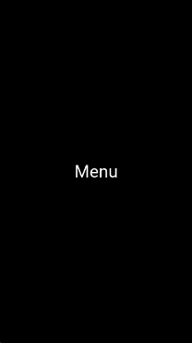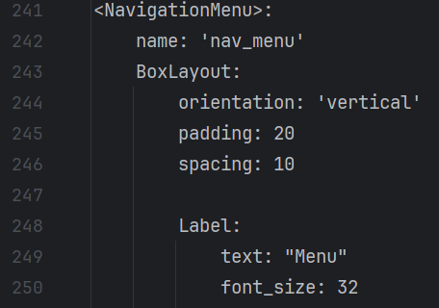 Firstly I need to declare the Navigation screen widget with a title in my .kv file and add it to the screen manager. I will do this as I have done for all other screens, so no explanation is needed.

I also need to add a button that directs to the menu in the main screen, define the NavigationMenu screen class in the python file, and add the menu screen to the screen manager in the build method:

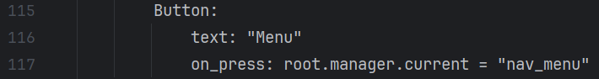 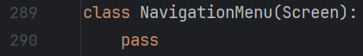

My main screen now looks like this:

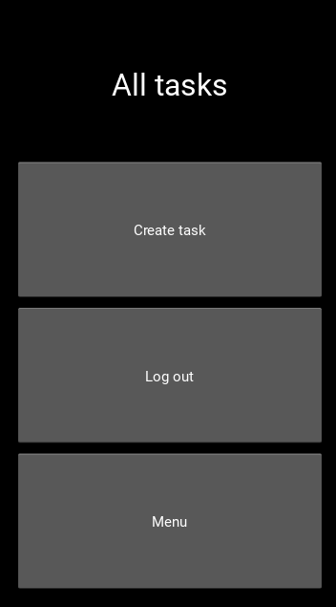

I am actually going to change the main screen so that its title is just “Main screen” for now, because it is a bit misleading for all of it to say all tasks:

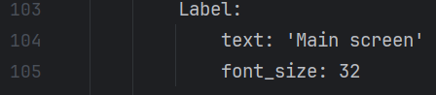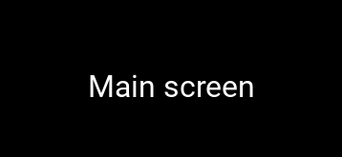

And I need to add the buttons. I need this screen to be dynamic, so that it can display the names of any categories in the categories table as buttons. To do this I will need to edit the .kv file:

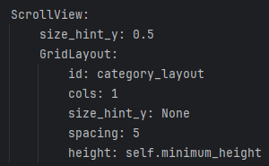

Firstly, I have used the ScrollView widget, so that if the user has a lot of categories they can scroll through them. If I didn’t do this, some categories might not be accessible as they would be off the screen. I then created a grid layout into which category buttons can be added in future using the class methods that I will define later. I have used a grid layout instead of a box layout because they expand dynamically based on how many widgets they contain, preventing a long, messy list of buttons. This grid layout has 1 column, and the height is self.minimum_height, which makes it the total height of its children so that scrolling works correctly.

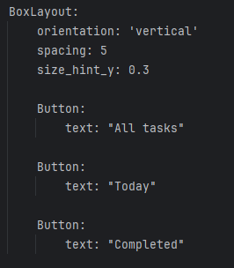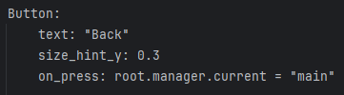I also need to make sure that buttons for my 3 predetermined lists are also displayed on screen, which I will do using a simple box layout and some buttons, and I have also added a back button at the bottom of the screen:

This is what the screen looks like now, and the space in the middle is where the scrollable list of categories will be:

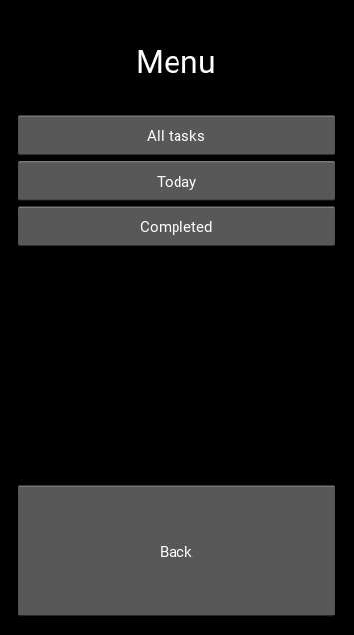

Next, I need to define the methods for the screen. These will include:

* load_category_buttons()
* open_category_screen()

Firstly, load_category_buttons() will fetch the names of all categories that my user has created from the Categories table, then it will create buttons using the grid layout’s ID, “category_layout”.

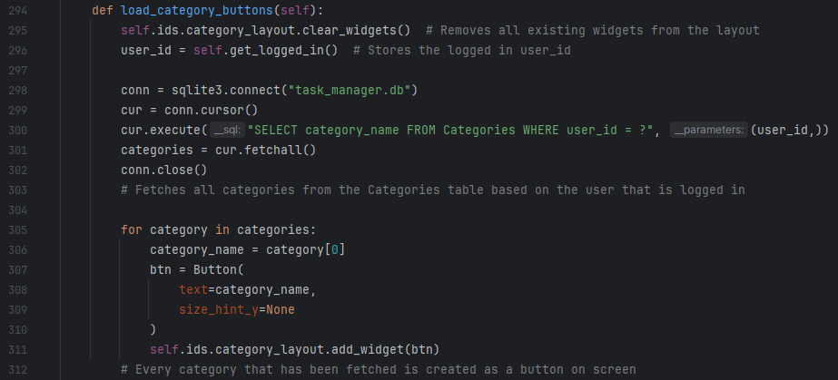

This method first gets rid of any widgets that were previously part of the screen (to prevent categories that might have been deleted from being displayed) then it calls the get_logged_in() method (which I defined for another screen but it is the same code for this class) to find out the user_id of the logged in user. Using this user_id, it finds all categories in the Categories table that relate to it, and fetches them. Finally, it uses a for loop to convert each category into a button with the text being the category name, and each button is added to the category layout.

The get_logged_in() method has been described before but I am going to show a screenshot again just to prove that I defined it within this class as well:

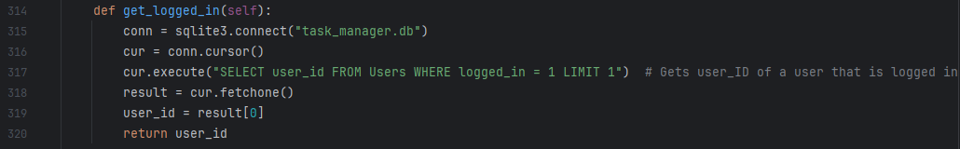

This does not need explanation as I have explained this exact code before.

After attempting to run this code by opening the NavigationMenu screen, I realised that this method is never actually called, so the screen is just blank. To fix this I have added the on_enter() method to the screen, and called load_category_buttons() within it:

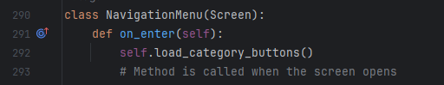

Now, when I open the screen, it displays like it is supposed to:

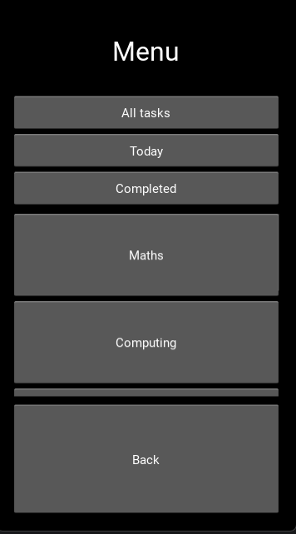

As you can see, the user’s categories are in the middle, and this list can be scrolled through. The first iteration of the navigation screen is now finished, and I can move onto what is opened when one of these lists/categories is clicked: the task list screen.

#### View task lists

My Task List screen will display all tasks that fit a certain criteria e.g. are due today, relate to a specific category, are completed etc. While users of my final product will have the ability to sort tasks by certain parameters, for my first prototype I will be leaving this feature out as it is not essential to the core functionality of my program.

Firstly, I need to update my Navigation Menu code so that when the category buttons are pressed, they actually open the relevant task list. I have added a lambda function within my for loop, passing the category name of the button that is pressed into a new “filter_tasks()” function that I will define next.

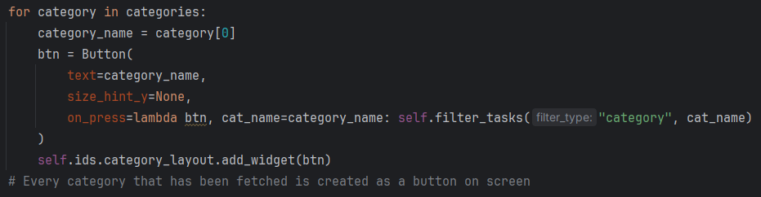

I have used the lambda function here because, without it, all of the buttons would reference the last category name in the list, rather than the one specific to that button. This would happen because the correct button would be overwritten after each iteration of the loop, so each button would reference the last category in the list.

I also need to edit the “All tasks”, “Today” and “Completed” buttons in my .kv file so that they also call the filter_tasks() function when pressed.

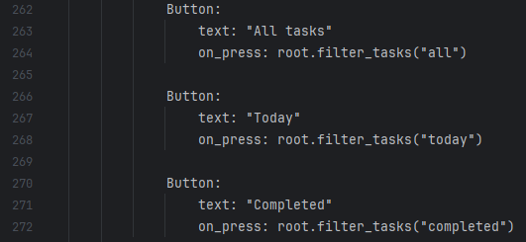

Now, when any button on the screen is pressed (other than the back button) the filter_tasks() method will be called. This method will display the Task List differently depending on the button that was pressed. I will have two different types of filtering, category filtering, which will display tasks relevant to a category, and status filtering, which will filter tasks on all of the other criteria (all, today, completed). I am now going to define the filter_task() method within the navigation screen:

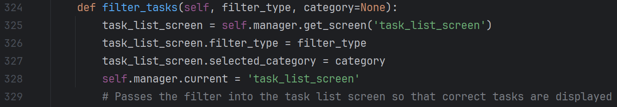

This uses the parameters “filter_type” and “category”, with category being set to None if no category is entered – this happens when using status filtering. This code looks confusing for now, because it calls the task_list_screen, which I haven’t defined yet, and it also sets certain values (filter_type and category) which haven’t been created yet. I am going to define the task_list_screen now so that this method makes sense.

Firstly, I need to create this screen in my .kv file. It will actually be very similar to the navigation menu screen, which is why I will not go into detail about the design choices.

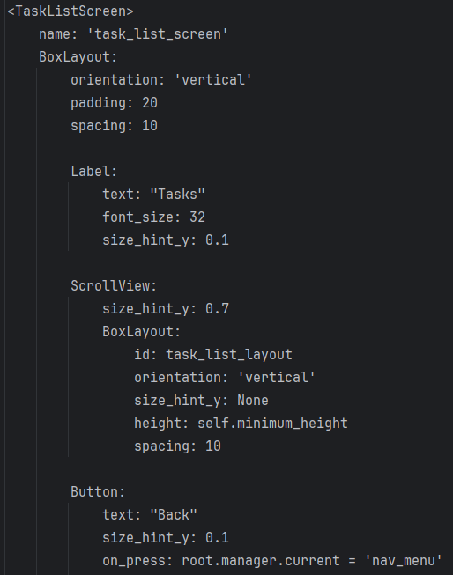

Now I need to define the screen class in my python file, and it will contain the following:

* filter_type property
* selected_category property (if a category list has been selected)
* on_enter method for as soon as the screen is opened
* get_today_date() method to find todays date in case the “Today” list is selected
* get_logged_in() method to find the user id of the user that is logged in
* get_category_id() method to find the category id of the category that has been selected

To use properties in kivy, I will need to import the properties library.



Now that this is imported, I can declare the screen and create the two properties:

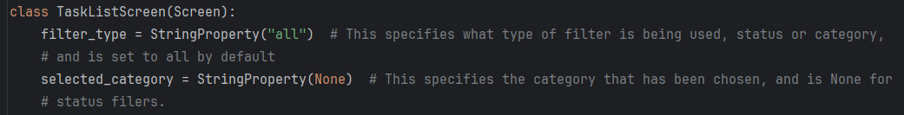

Now that this has been created, my filter_tasks() method should make sense, as it sets the properties of the Task List screen based on what type of filtering is being used. I now need to create the on_enter() method, which should do the following:

* Create SQL queries based on the filter criteria
* Select the relevant tasks from the Tasks table using the queries
* Add each task as a button to the screen, displaying the Title, Due date and priority

Firstly, I need to create the SQL queries:

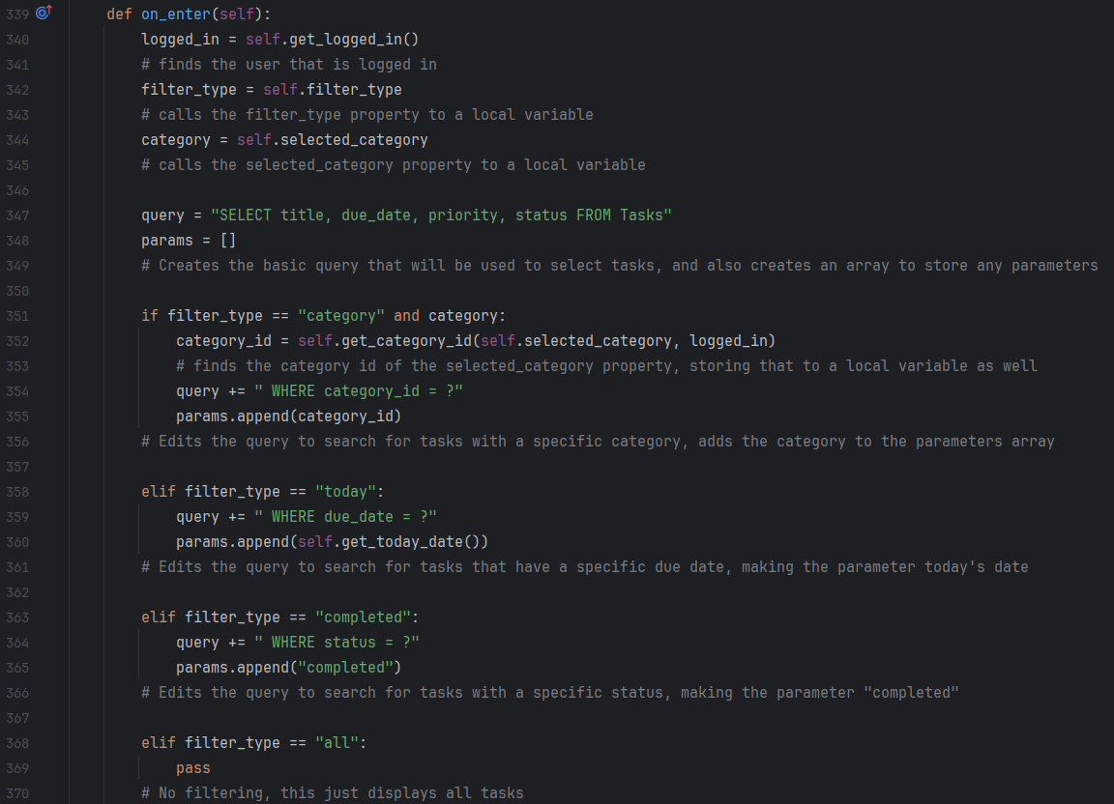

This uses a query that changes based on an if statement: if the filter_type is category, the query changes to find a specific category, and so on.

I now need to select the relevant tasks from the Tasks table:

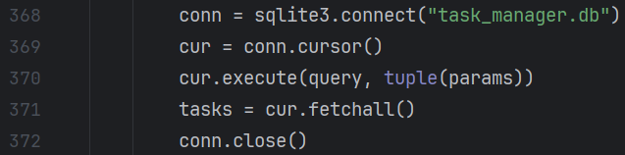

This combines the query and the params, which are passed as a tuple, and fetches all tasks that fit that criteria. Not much explanation is needed for this.

Now, I need to add all of the selected tasks to the screen:

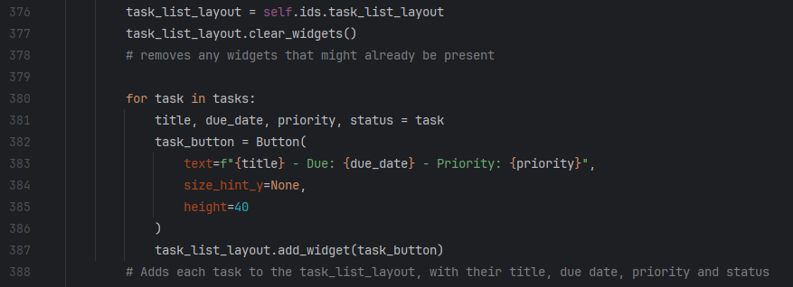

To find todays date, I will use the datetime library again:



The last two methods, get_logged_in() and get_category_id() have been used in other classes so I don’t need to describe them, but I will add screenshots below:

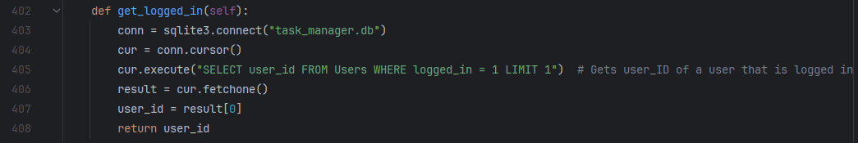 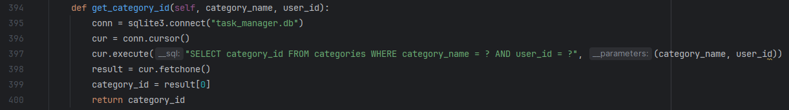

The Task List screen is now created, and I can test the List Display module.

#### Testing list display

For testing purposes, I am going to create a few tasks for each category, as well as a few that are due today as well – the date is 24th February 2025 at the time of writing this. I will add a few screenshots underneath the table as well to prove that everything is working correctly.

|  |  |  |  |
| --- | --- | --- | --- |
| What is being tested | Test data | Expected outcome | Actual outcome |
| Screen elements display correctly | None | Labels and buttons appear on screen in the correct order | Expected outcome occurred |
| Tasks relating to a specific category display when that category’s list is opened. | Tasks for the following categories:   * Maths * Computing * Music * Fitness * None | When the button for a category is pressed, a list of tasks that relate to that category is displayed on screen. | Expected outcome occurred |
| If “All tasks” button works | N/A | All tasks are displayed on screen and are scrollable | Expected outcome occured |
| If “Today” button works | I added a task with the due date set to today. | Tasks due today are displayed on screen | Expected outcome occurred |

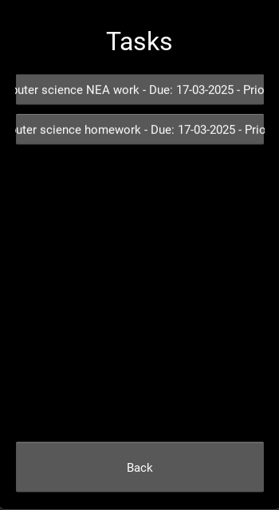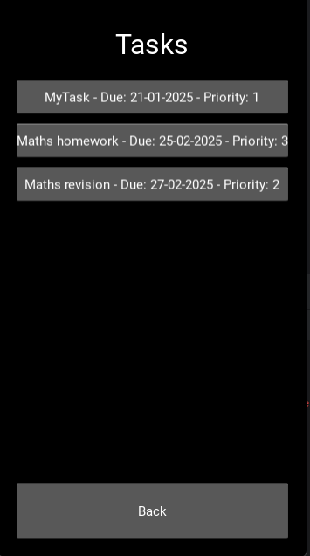**Evidence:**

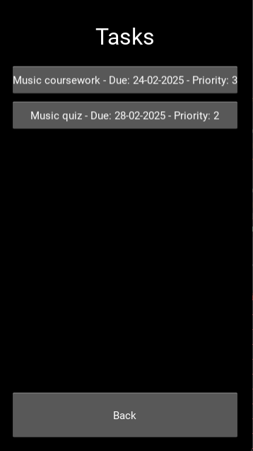

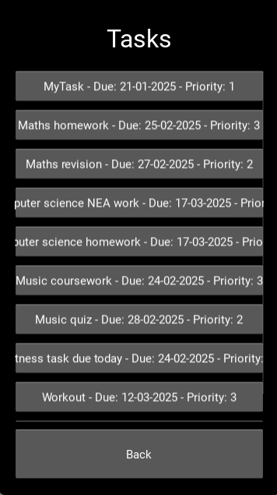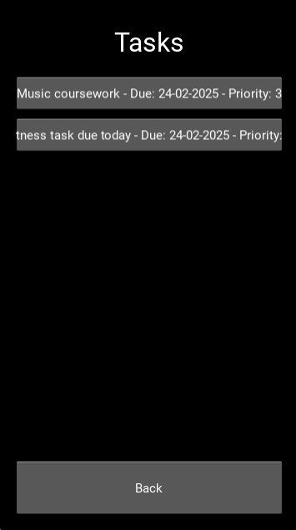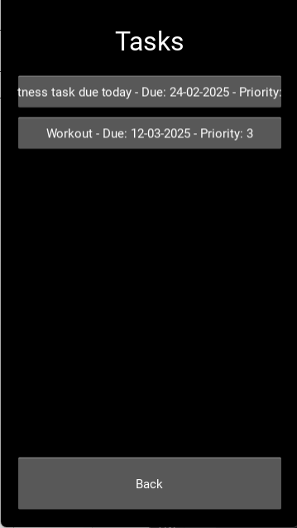**Description in image order:**

1. Shows tasks relating to maths category
2. Shows tasks relating to computer science category
3. Shows tasks relating to music category
4. Shows tasks relating to fitness category
5. Shows tasks due today (as can bee seen by the due date)
6. Shows all tasks, is scrollable

Now that the List Display module is tested and fully working, I can now move onto the final module – task manipulation.

### Task manipulation

This fourth and final module of development that I described when decomposing my solution will contain the following features:

* Individual task viewing
* Task editing
* Task deleting
* Marking tasks as completed

Which I can get started developing right away.

#### View task screen

When opening a task list, all of the tasks are displayed as buttons already, so now my job is to make these buttons direct to the View Task screen for that specific task when pressed. First, I will need to define the screen in my .kv file, define the screen class in my python file, and add it to the screen manager in both files I have added a button to the screen to take the user back to the navigation menu, just so that when I am developing I don’t have to keep reloading the app to get to other screens.

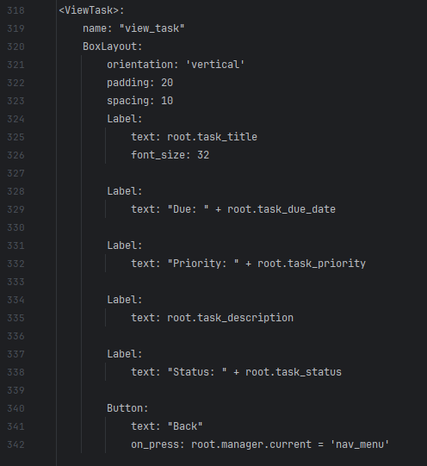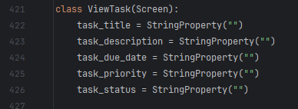

I have added a few properties to the View Task screen so that it can change dynamically depending on the task that was clicked. This is mirrored in the .kv file, with each piece of task data referencing one of these properties rather than being a set value.

Next, I need to alter my TaskListScreen class, adding a method that will determine what happens when one of the tasks is pressed:

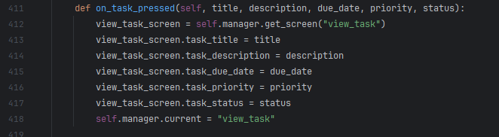

When this method is called, the properties of the View Task screen will be changed to match whatever values have been passed into the method, and the screen manager will change the current screen to the View Task screen.

Next, I need to make sure that this method is actually called when a task is pressed, using the on_press property upon the creation of each button in the Task List screen:

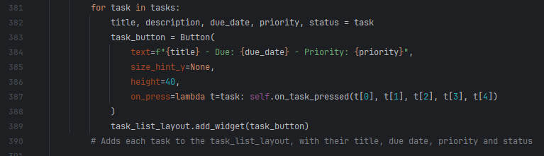

As you can see, I have used a lambda function again, for the same reason that I used one before, to pass the task details into the on_task_pressed() method. I will also need to alter the SQL query from the on_enter method of the Task List screen to include status as well:



#### View task testing

|  |  |  |
| --- | --- | --- |
| What is being tested | Expected outcome | Actual outcome |
| Screen elements display correctly | Labels and buttons appear on screen in the correct order | ERROR - ValueError: ViewTask.task_priority accept only str |

As soon as I pressed on a task to open it, the program crashed and I was given the above error message. This is because I tried to pass the priority, which is an integer, into a string property, which would never work. Instead, I am going to create a new method to convert this into text for display as low, medium or high. I have defined this method inside of the Task List screen:

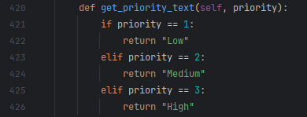

And I have called it during the setting of the priority property of the View Task screen:

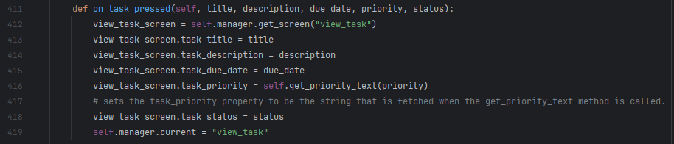

Now, the screen displays as it should when a task is clicked:

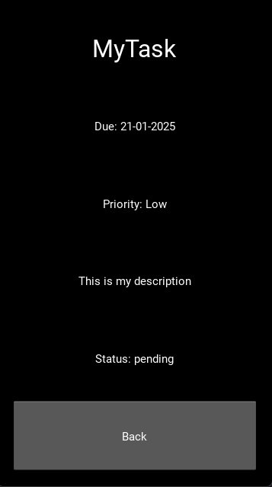

#### Mark task completed

This section will be quite short as it only contains one button, which will change the status of a task from “pending” to “completed”. Firstly, I need to modify my Task List screen to only display tasks that are pending.

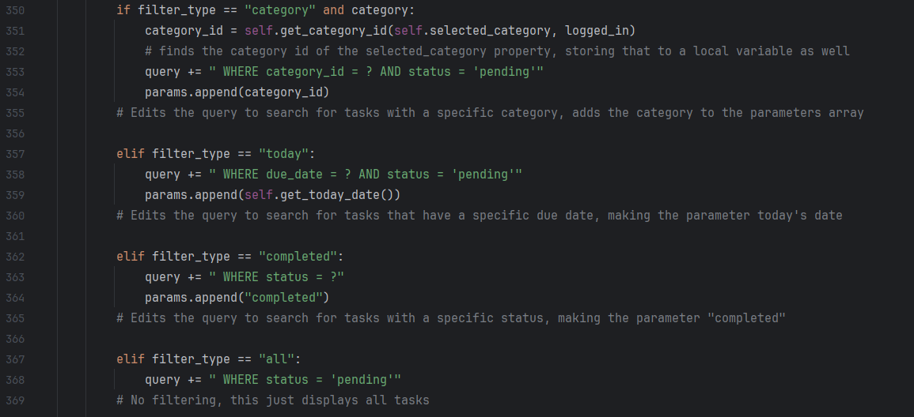

As you can see here, now all of the queries have “AND status = ‘pending’” added onto them, except for when filter_type = completed, then the query has “WHERE status = completed”.

Now I can add the “Mark completed” button inside my view task screen, and define a method that changes the tasks data in the Tasks table:

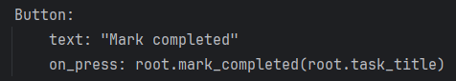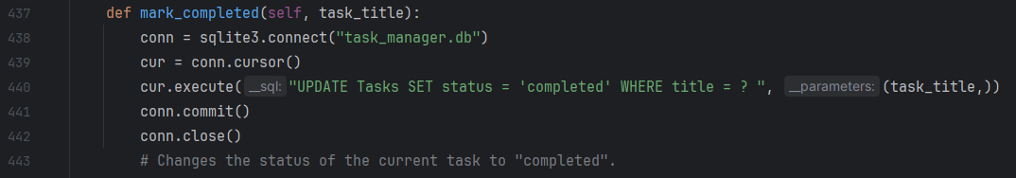

And I will now test this button.

#### Mark completed testing

|  |  |  |
| --- | --- | --- |
| What is being tested | Expected outcome | Actual outcome |
| Button displays correctly on screen | Button is displayed in the correct place | Expected outcome occurred |
| Button changes status | Task status is changed from “pending” to “completed” | Expected outcome occurred |
| “Completed” list works correctly | When the “Completed” list is selected from the navigation menu, all completed tasks are displayed. | Expected outcome occurred |

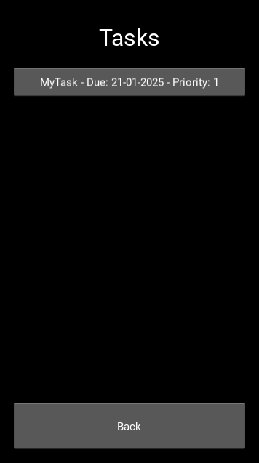**Evidence:**

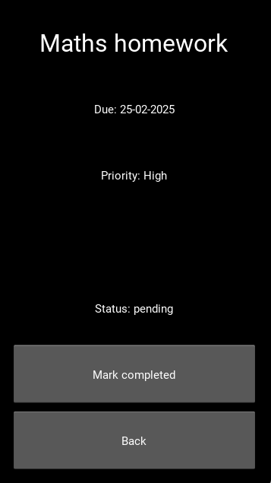Here you can see the “Mark completed” button displaying correctly, then the task list that is displayed when “Completed” is selected from the navigation menu, and what is returned in the run window when I run a query to find all completed tasks.

#### Delete task

This is another button that I will need to add to the view task screen. Upon pressing it, the task will be deleted from the database. I am not going to add a pop up message that says “Are you sure you want to delete” just yet, so that I can focus on the core functionality of the button, just making sure it works, but I might add this feature in a future iteration of development.

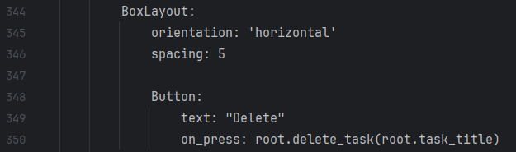

Firstly, I added the button to a horizontal box layout. I did this because I want to place the edit button next to it, in the same layout, as I described in my usability features. I then created the button, and made sure that it called the delete_task() method which I will define in my python file in a second, passing the task_title property as a parameter.

I also want to add a label near the top of the screen which will say “Task deleted” once a task has been deleted, so I will do that now:

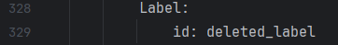

I will use the delete_task() method to add text to this label that says “Task deleted”, but for now all I need is to define it with an ID.

Next, I will need to create a method in my ViewTask class which will use an SQL query to delete the task from the table, as well as change the label to say “Task deleted” rather than be blank:

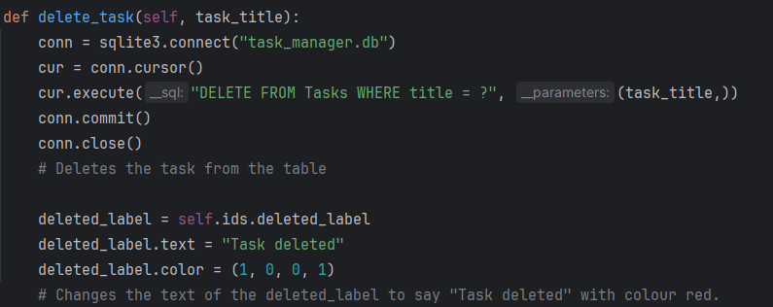

This method creates an SQLite3 connection, then uses a query to delete the task, passing the task title as a parameter. It then makes the text of the deleted label say “Task deleted” and sets the colour as red. I will now test this button.

#### A screenshot of a phone AI-generated content may be incorrect.A screenshot of a cell phone AI-generated content may be incorrect.A screenshot of a phone AI-generated content may be incorrect.Delete task testing

|  |  |  |
| --- | --- | --- |
| What is being tested | Expected outcome | Actual outcome |
| Button displays correctly on screen | Button is displayed in the correct place | Expected outcome occurred |
| Button causes feedback message | Red feedback message pops up that says “Task deleted” | Expected outcome occurred |
| Task is properly deleted from table. | Task can no longer be found in table when button is pressed. | Expected outcome occurred |

As you can see in the images above, the Button shows up correctly, and the correct message is displayed when it is pressed. Then, when I look for the task “Maths homework” in the “All tasks” list, it is not there, proving that it has been deleted. Now that this button is tested, I can move onto the final part of the task manipulation module: task editing.

#### Edit task screen

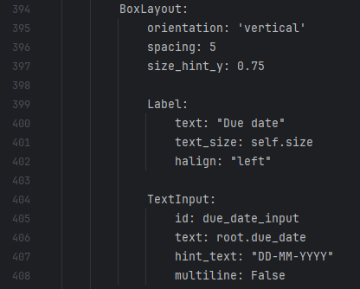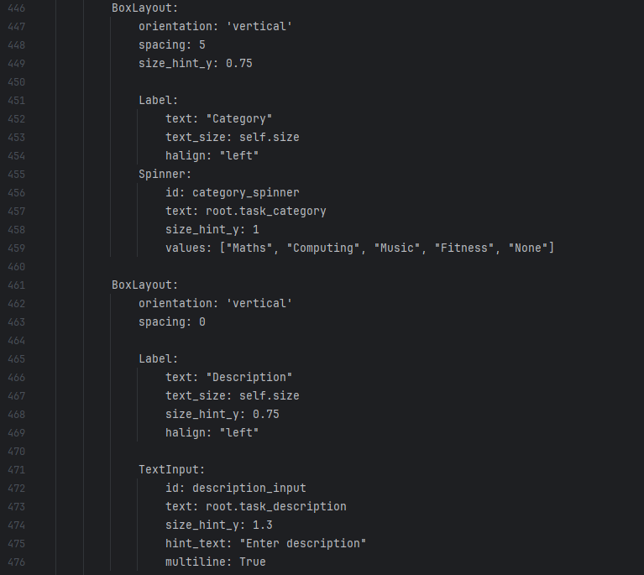This is the final part of my task manipulation module, and it is what gives users ultimate control over their tasks. The Edit Task screen will be extremely similar to the Create Task screen, just with the fields already filled in. First I will define it in my .kv file.

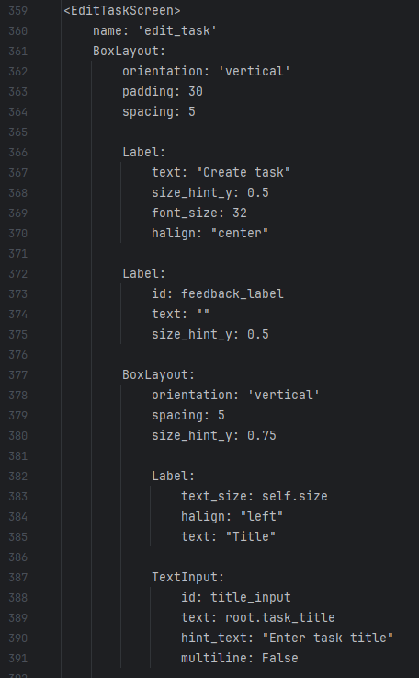As you can see here, I have first of all copied the first section of code from my Create Task screen, changing one thing for the title field – the text inside of the field now refers to the property task_title (which I will create in my python class later) where before there was nothing but the hint text. I did the same with the due date, description and category inputs, again, this time setting their text values to the properties task_due_date, task_description and task_category respectively, again which I will define in the python class later.

I now just need to make sure the correct priority button is selected:

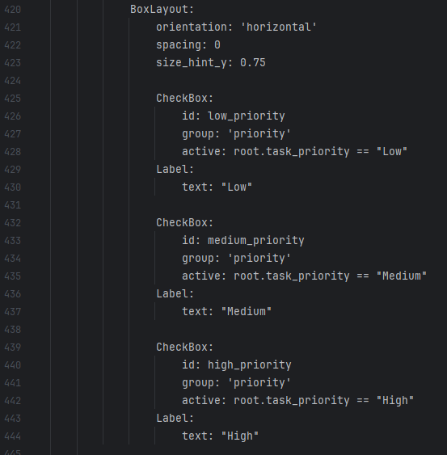

And I did this by using the “==” so that they are only active when the task_priority property is set to that specific priority.

Now for the python class. I am going to begin by defining the properties that I have discussed:

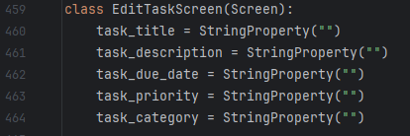

Now that the properties have been created, I need to create an “Edit” button in the view task screen and make sure that when the button is pressed, the current task’s details are passed into the Edit Task screen to become relevant properties. Firstly I will create the button within my .kv file:

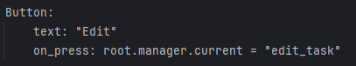

And I need to create a method within the edit class that retrieves the correct task information to be displayed, and I need this method to be called when the “Edit” button is pressed.

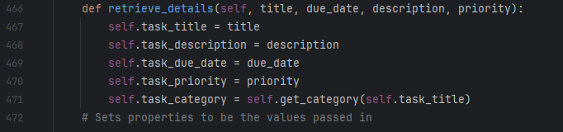

As you can see, the task_category property has been set to what is returned when the get_category() method is called, and I will define that next:

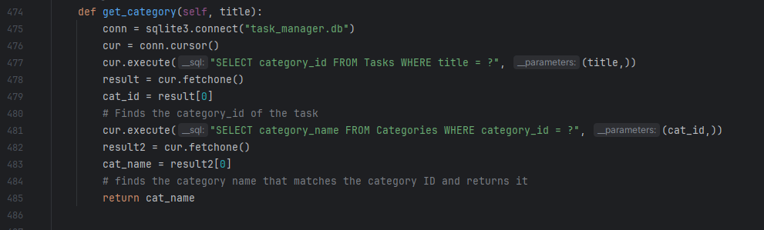

This method takes the title of the task that has been inputted and finds the category id of the category that that task is in, then takes that id and finds the name of the category that that id corresponds to and returns it. When this method is called, the task_category property is set to the category name that is returned by this method.

Now all I need to do is make sure the retrieve_details() method is called upon the pressing of the Edit button, which I will do within my .kv file.



This is the altered button, now with another on_press that causes the retrieve_details() method to be called, passing the properties from the View Task screen. Now the screen displays as it should:

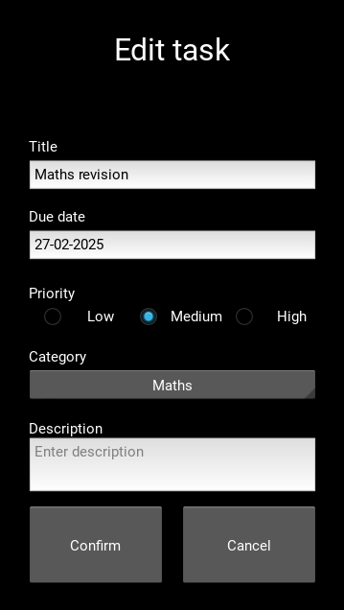

The last thing to do for this screen is to make sure that the confirm button works, with all of the same validation as the Create Task screen. In my .kv file, I have already said that the Confirm button should cause the edit_task() method to be called. This will have the same logic as the Create button in my Create Task screen, so first I will copy the created_task_validation() method into the Edit Task screen class, and rename it edit_task_validation()

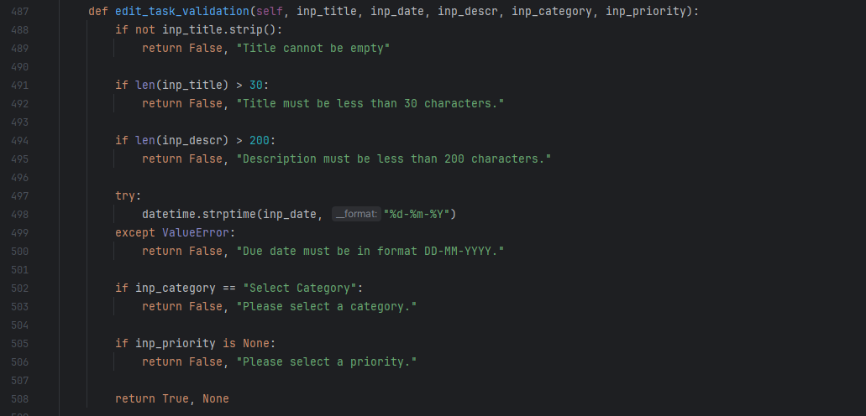

I am not going to describe this method because I already did so for the created_task_validation() method, and this uses the exact same logic. Next, I am going to copy 3 other algorithms from the Create Task screen: get_logged_in(), get_priority() and get_category_id(). These have also previously been described so they will need no explanation.

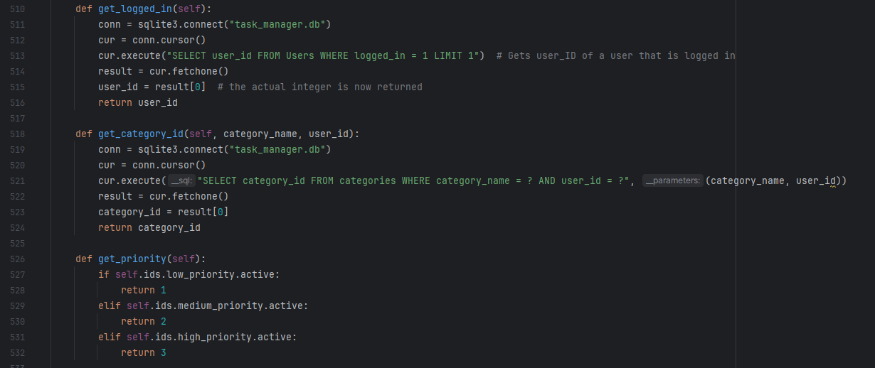

The next method that my Edit Task screen will require is a method that will update the task in the Tasks table with the new data that has been inputted. I will call this the update_task() method.

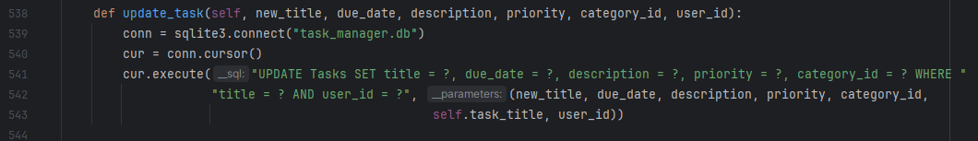

When this method is called, the task details that are passed into it are used to update the table with these details, replacing the old task details.

The final method I will define for the Edit Task screen is the actual edit_task() method, which will call all of the other methods that I have just defined, combining them into one method that can be called upon the pressing of the “Confirm” button.

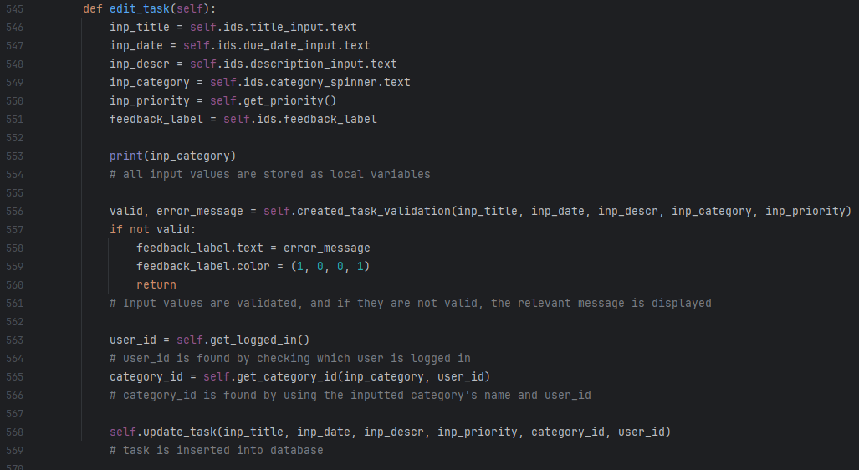

Now that the code for this screen is finished, I can move on to testing it.

#### Edit task screen testing

Because the validation logic I used has already been tested in the Task Creation module, I will not be retesting this, instead I will do some basic tests on the Task table and View task screen to check that tasks are actually altered, and correctly, after the confirm button has been pressed.

|  |  |  |  |
| --- | --- | --- | --- |
| What is being tested | Test data | Expected outcome | Actual outcome |
| Confirm button causes task to be changed in database – title change | Original task title: “Maths Revision”  New task title: “Maths revision edited” | When I fetch tasks from tasks table, the task that I edited has been changed correctly. | ERROR – confirm button raises no errors in run window, but the task has not been changed when I view it in the database. |

As soon as I tried to alter a task, I checked the Tasks table to make sure it had been changed, but nothing had happened to it. I realised that I never committed the database query in my update_task() method, so I will do that now:

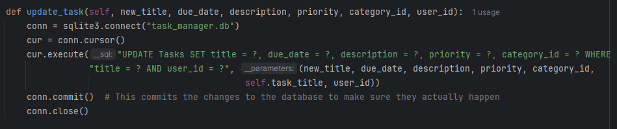

Now, when a user edits a task, the changes should be properly committed to the database. I will retest this now:

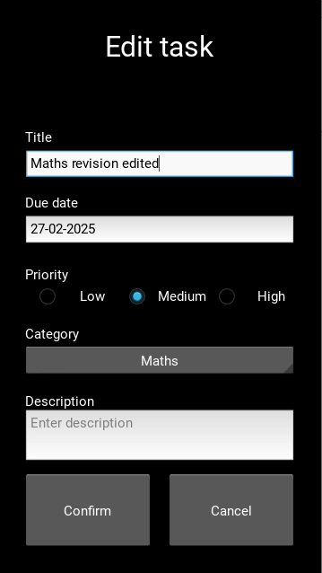

This is the change to the title that I made, and this is the task in the tasks table once I pressed confirm:  


And I can now test the editing of other fields.

|  |  |  |  |
| --- | --- | --- | --- |
| What is being tested | Test data | Expected outcome | Actual outcome |
| Confirm button causes task to be changed in database – date change | Original task date: 27-02-2025  New task date: 07-03-2025 | When I fetch tasks from tasks table, the task that I edited has been changed correctly. | Expected outcome occurred |
| Confirm button causes task to be changed in database – priority change | Original task priority: Medium  New task priority: High | When I fetch tasks from tasks table, the task that I edited has been changed correctly. | Expected outcome occurred |
| Confirm button causes task to be changed in database – category change | Original task category: Maths  New task category: None | When I fetch tasks from tasks table, the task that I edited has been changed correctly. | Expected outcome occurred |
| Confirm button causes task to be changed in database – description change | Original task description: Blank  New task description: “My edited task description” | When I fetch tasks from tasks table, the task that I edited has been changed correctly. | Expected outcome occurred |

## Prototype 1 - review

This first prototype, which represents the bare-bones, simple version of my product and emphasises functionality over usability, has been successful overall. My stakeholders are happy with my progress, and are confident that I can push through to finish the application in my second and final prototype.

In this prototype, I have managed to achieve a fully working version of my product, that users can interact with almost as if it were the final product – the absence of the categories feature is the only true limiting factor in this. However, if this is ignored (as it will be addressed in the next prototype), even if I were to submit this prototype for users to use, it would be generally ok and would work pretty much fine. To further back this up, I am going to have my stakeholders test the prototype and give me feedback on what I can do the truly fulfil my success criteria.

In conclusion, the development of my first prototype, while not complete and still lacking in some areas, has been comprehensive and successful, and it has everything in place for me to finalise the product and make it ready for use.

### Prototype 1 black box testing

While before, I conducted my stakeholder research by consulting a broad range of students, for the testing and feedback of my first prototype, I will narrow it down to include just 3 individuals so that I can get more focused feedback on what I need to do to meet my success criteria. These 3 individuals will be Ethan Bajulaiye, Sam Williams and James Basford. They will perform tests, then give me feedback based on these tests, as well as an importance rating for what actions can be taken based on the feedback.

Because the feature that allows users to create and edit categories has not yet been created, I am going to be giving them access to the account that I created during testing, that already has the placeholder categories that I created connected to the account. This way, they will be able to fully test the program while not running into the error of not being able to use task categories. However, I am still going to allow them to create their own accounts, just to test that the User Account Management module works.

#### User account management black box testing

|  |  |  |  |
| --- | --- | --- | --- |
| Stakeholder | Test | Test data | Outcome |
| Ethan | Signup form | Username: Ethan  Password: Iam@cl0wn | Signed up successfully |
| Sam | Signup form | Username: SamW  Password: 5@Mwill45 | Signed up successfully |
| James | Signup form | Username: James  Password: T@sk5here | Signed up successfully |
| Ethan | Login form | Username: Ethan  Password: Iam@cl0wn | Granted access |
| Sam | Login form | Username: SamW  Password: 5@Mwill45 | Granted access |
| James | Login form | Username: James  Password: T@sk5here | Granted access |

**Feedback based on testing:**

Overall, my stakeholders loved this module for its simplicity and ease of use. They told me that it fits my success criteria perfectly. However, they pointed out 2 things to me:

|  |  |  |  |
| --- | --- | --- | --- |
| Stakeholder(s) | Feedback | How I can action this in my next prototype | Importance |
| Sam | When they signed up, they were greeted with a success message, however it did not take them anywhere and they had to physically press cancel and then go to log in. | I will add another “on_press” to my .kv file for when the “Signup” button to make sure that the screen is changed back to the choose screen. | High |
| Sam, James | When they logged out and went back into one of the forms, the previously entered data was still in the fields, and the previous success/error feedback messages were still there as well. | I will add an “on_pre_enter” method to my screen classes with code to wipe any widgets of inputs and outputs so that each time a screen is opened it is empty. | High |

#### Task creation black box testing

For this module and all of the following modules, I gave my stakeholders access to the account that was linked to my placeholder categories.

|  |  |  |  |
| --- | --- | --- | --- |
| Stakeholder | Test | Test data | Outcome |
| Ethan | Task creation form | Title: Pay Tobi money  Due date: 27-02-2025  Priority: High  Category: None  Description: Pay Tobi the £200 that I owe him | Task added successfully |
| Sam | Task creation form | Title: Integration homework  Due date: 12-03-2025  Priority: Medium  Category: Maths  Description: Complete exercises 2 and 3 from the Integration booklet. | Task added successfully |
| James | Task creation form | Title: Finish NEA  Due date: 07-03-2025  Priority: High  Category: Computing  Description: Final tweaks on my NEA project. | Task added successfully |

**Feedback based on testing:**

Again, my stakeholders told me that they liked my task creation form, and that the module worked well – they specifically liked that, unlike my signup and login forms, when they opened the task creation form, all the fields were already empty. However, they still had some things they wanted ironing out for the next prototype:

|  |  |  |  |
| --- | --- | --- | --- |
| Stakeholder(s) | Feedback | How I can action this in my next prototype | Importance |
| All | When creating a task, they were only given a feedback message if there was an error, not if the task had been created. | I will add a message to my created_task_validation() that will be returned if the task details are valid and the task has been added to the table. | High |
| All | Similar to the signup form, when they pressed create, they were not directed back to the main screen, they had to press cancel to do that. | I will add an “on_press” property to the create task button that will direct the user back to either the main screen, or the View Task screen for the task they just created. | Medium |

#### List display black box testing

|  |  |  |  |
| --- | --- | --- | --- |
| Stakeholder | Test | Test data | Outcome |
| Ethan | Task List screen | Find the task that he created during the last test in the “None” category. | Task located successfully |
| Sam | Task List screen | Find the task that he created during the last test in the “Maths” category. | Task located successfully |
| James | Task List screen | Find the task that he created during the last test in the “Computing” category. | Task located successfully |
| All | Navigation menu | Test usage of all lists | Lists displayed correctly |

**Feedback based on testing:**

Aside from specifically testing the Task List screen, my stakeholders also carried out some general tests on this module, checking that the functionality was good and that everything worked properly with the menu. While they liked how the module worked, they also had the most feedback for it as well. They had the following feedback for this module:

|  |  |  |  |
| --- | --- | --- | --- |
| Stakeholder(s) | Feedback | How I can action this in my next prototype | Importance |
| Ethan | When viewing tasks in the task list screen, certain tasks could not fit on the buttons because their titles were too long. | I will either make the task titles cut off and add “…” to the end, or I will make the task buttons larger to fit more text on. | High |
| All | Users have no way to create categories. | I will add a new “Create Category” screen, as well as the ability to edit categories. | Very high |
| Sam | There is no title above the list of categories, meaning it is more difficult for users to differentiate between the pre-created lists and the user-created lists. | I will add a label above the category scroll view to mark what are user created categories. | Low |
| All | There is no way to sort tasks by specific parameters such as due date and priority. | I will add a sort button at the top of the list view screen. At this point in time, this may not be feasible, but I will try to include it if I can. | Medium |
| James, Sam | Category buttons are quite large in the menu. | I will make them smaller by setting a specific height for each button. | Low |
| Ethan, James | Task lists have no relevant title – every time a list is opened the title is just “Tasks”. | I will add a dynamic title label that changes depending on the name of the list. | Medium |

#### Task manipulation black box testing

|  |  |  |  |
| --- | --- | --- | --- |
| Stakeholder | Test | Test data | Outcome |
| All | View task screen | View the task that they created when testing the task creation module. | Task located successfully |
| All | Edit task screen | Edit the task that they created when testing the task creation module. | Task edited successfully |
| All | Mark completed | Mark the test that they created when testing the task creation module completed. | Task completed successfully |
| All | Delete task | Delete the task that they created when testing the task creation module. | Task deleted successfully |

**Feedback based on testing:**

My stakeholders commended me on being able to implement this module in such a comprehensive way, as it contained a lot of features that had to line up with my other modules in order to work correctly. James still had one piece of feedback to give however:

|  |  |  |  |
| --- | --- | --- | --- |
| Stakeholder(s) | Feedback | How I can action this in my next prototype | Importance |
| James | View task screen does not tell user what category the task is in, like it was supposed to in “Usability Features”. | I will add an extra label to display the task’s category. | High |
| Sam, James | When a task has been edited, the user has to click cancel to get back to the View Task screen for that task. | I will add an on_press() property to take the user back to that task’s View Task screen. | High |
| All | When the task is created and the user presses cancel, the View Task screen for that task still displays the old task information from before the task was edited. | I will add a method that will make the new task details the properties that are displayed on the View Task screen. | High |

#### General feedback based on testing

Aside from the testing of individual modules, my stakeholders also had some general feedback for my program:

|  |  |  |  |
| --- | --- | --- | --- |
| Stakeholder(s) | Feedback | How I can action this in my next prototype | Importance |
| Ethan, James | When screens are opened, there is a quick blink of old data that was part of that screen (not forms – I addressed the forms already) before the new data is displayed. | I have been using on_enter() methods for my program up until this point, which means the new buttons/data is displayed once the screen is opened. I will instead use on_pre_enter() so that the screens have new data as soon as they are opened. | Low |
| All | My GUI does not match the usability features (theme wise) – I informed them about this beforehand but they still needed to make sure it would happen in prototype 2. | I will change the theme of my app completely using Kivy. | High |
| Ethan | Ethan thought it would be a good idea that tasks that are due today automatically get a high priority, and I agreed with this. | I will add a method that automatically altered every task due today to have a high priority as soon as the app is opened. | Medium |
| All | The notifications feature that I talked about in analysis has not been addressed. | I will be adding this feature to my second prototype using python’s plyer library. | High |
| Sam | Task_id field is not present in my Tasks table | I will add this to the table so that every task has a unique identifier | High |

I have now received all the feedback on my first prototype, and I can do a brief plan of action for my second one.

### Prototype 2 action plan

This is the prototype 2 action plan that I will create with my stakeholders to figure out what is achievable and what is not for prototype 2. I will be separating this plan into 2 sections: should achieve and could achieve. This is so that I can have a clear idea of what is absolutely necessary for my second prototype.

#### Should achieve

|  |  |  |  |
| --- | --- | --- | --- |
| Feature | # | Description | Justification |
| Category creation and manipulation | 1 | This feature will allow users to create categories unique to their accounts that they can add tasks to. | This was part of my success criteria and is an integral part of my solution to the problem. It will allow users to separate their thoughts and focus solely on one subject/thing at a time. |
| Make tasks fit on screen at all times | 2 | Sometimes if a task’s title is too long it ends up not being able to be displayed on screen, so I will make the buttons a different size to accommodate all tasks up to 30 characters (which is my maximum). | This is necessary for my users to be able to properly interact with task lists – if they can’t see the full title of the task they are looking for, they might not be able to find it. |
| Feedback message/advancement through screens upon the press of every button | 3 | A lot of my buttons appear to do nothing when they are pressed, when in reality, they are all doing something behind the scenes. I will make sure that this is made evident to my users every time. | This is necessary because I want my users to know that their actions within the app have actually caused something to happen without them having to track it themselves, which wastes time. |
| All forms empty when they are opened (apart from Edit Task form) | 4 | Some of my forms (e.g. login and signup) tend to display data that was previously inputted when they are opened, so I will use the on_pre_enter() method to wipe them of their data every time they are opened. | This is necessary because I don’t want my users to have to remove old inputs just to add new ones, which is a waste of time. I want them to be able to add their fresh data as soon as they open the screen. |
| Category displayed in View Task screen | 5 | When a user views a task’s details, they will be able to see what category that task is in as well. | This is necessary because, for example, if a user opens a task from the All Tasks, Today or Completed lists, they will have no way of telling what category that task is in, unless they are specifically told. |
| GUI overhaul | 6 | I will make my GUI match the one described and demonstrated in my usability features. | This is necessary for 2 reasons: I want my app to look nice for my users, and I want all of the usability features I described to be accessible and working. |
| View task screen shows changes from editing immediately. | 7 | As soon as the user clicks “Confirm” in the edit screen, they will be directed back to the View Task screen which will display all of the task’s new details. | This is necessary because I don’t want my users to get confused and think that their task was not edited correctly. |
| Notifications | 8 | I will add notifications using plyer based on a task’s proximity to its due date | This was originally one of my success criteria, and was also a necessary feature derived from my initial stakeholder research. |
| task_id field | 9 | I would add the task_id field to the Tasks table | This is necessary because it makes sure that any changes made to a task are only made to that task, not any task the has an identical title, which could happen as my “title” field does not have a unique clause. |

#### Could achieve

|  |  |  |  |
| --- | --- | --- | --- |
| Feature | # | Description | Justification |
| Task sorting | 1 | This feature would allow users to sort tasks by their details when viewing them in task lists. | This was part of my success criteria, however due to time constraints I am unsure if I will be able to include it in my program. |
| List titles change dynamically | 2 | This would change the title of any list that has been displayed so that it matches the actual title of the list, rather than saying “Tasks”. | This would stop my users from becoming confused as to what list they are in, however it is not completely necessary as this is unlikely. |
| High priority for tasks due today | 3 | This feature would automatically update the priority of any task that is due today to “High” so that | This will make my users aware that a task of importance because it is due today, making them more likely to take action on that task. |

### Prototype 1 success criteria

Here are tables of my success criteria, and how far along to completion I am at this moment in time. For the criteria that need to be completed still, I have linked them to a feature that I should/could achieve, from the tables above.

**User account management**

|  |  |  |  |
| --- | --- | --- | --- |
| **#** | Feature | Completion | Steps to completion |
| **1** | Signup/login form | Nearly completed | Should achieve (3)  Should achieve (4) |
| **2** | Signup validation | Fully completed | None |
| **3** | Login validation | Fully completed | None |
| **4** | Password hashing | Fully completed | None |

**Task management system**

|  |  |  |  |
| --- | --- | --- | --- |
| **#** | Feature | Completion | Steps to completion |
| **1** | Relational database | Nearly completed | Should achieve (9) |
| **2** | Task creation system | Nearly completed | Should achieve (1)  Should achieve (3)  Should achieve (4) |
| **3** | Task edit system | Nearly completed | Should achieve (3)  Should achieve (7) |
| **4** | Task sorting functionality | Not started – I may not be able to include this in my solution | Could achieve (1) |
| **5** | Task viewing | Nearly completed | Should achieve (5) |
| **6** | Navigation menu | Nearly completed | Should achieve (2)  Could achieve (2) |

**Other success criteria**

|  |  |  |  |
| --- | --- | --- | --- |
| **#** | Feature | Completion | Steps to completion |
| **1** | Notifications | Not started | Should achieve (8) |
| **2** | Simple and intuitive UI | Partially completed | Should achieve (6) |

## Prototype 2 - development

Rather than developing my second prototype module by module, I will instead focus on specific sections of code that can be added or changed from my initial prototype to make it more of a complete solution. The first, and most important, section that I will develop is category creation. Furthermore, I will not be going as in detail into my code as my development process remains the same as it was for my first process: define screen in .kv file with buttons, labels, etc. and then define methods for that screen within the python files. However, any new logic that I employ will be fully described.

### Categories

#### Create category screen

This section will involve a form with a single entry field that allows users to create their own categories, and will follow the basic structure of all of my other forms. I will first define the screen in my .kv file, however I won’t be describing it much because the methods I used have already been used and explained many times before in my documentation.

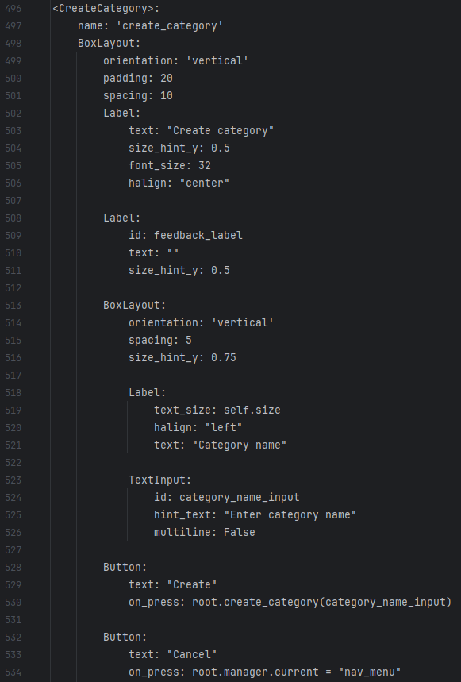

This screen looks like this when displayed:

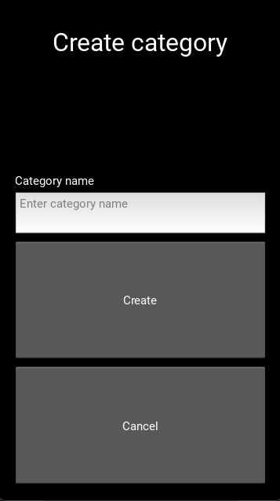

It consists of the title “Create category”, an entry field for the category name, a create button which calls the method “create_category” which I will define in a second, and then a cancel button which takes the user back to the navigation menu.

Next I will create the python code for the button. This screen will have 4 methods:

* create_category()
* get_logged_in()
* category_validation()
* add_cat_to_table()

The first one, create_category(), will call the other three within itself. I will first define these three, starting with get_logged_in()

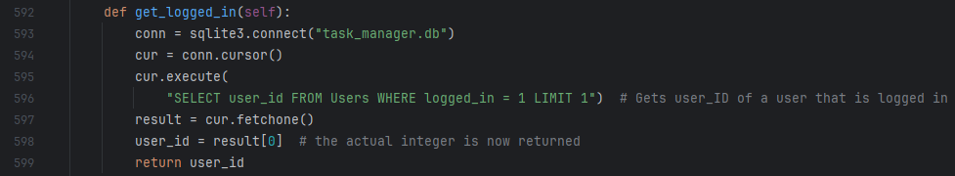

This method has been described before, all it does is return the user id of the user that is logged in. Next I will define the category_validation() method:

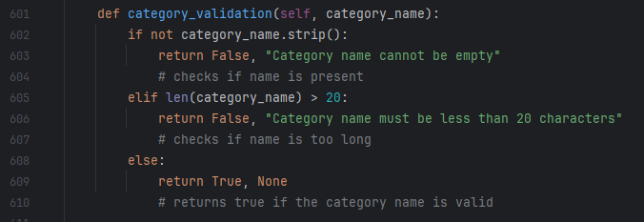

This method is also quite simple and it returns True with no message if the category is valid, and False with a message if it is not. The requirements for a category name to be valid is that it is not empty, and that its name is less than 20 characters. Now for the add_cat_to_table() method:

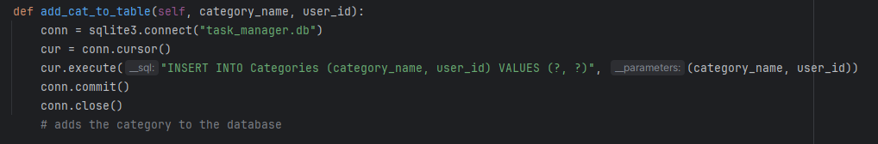

This method adds the category to the table, with the user id as the foreign key.

Finally I will define the create_category() method itself.

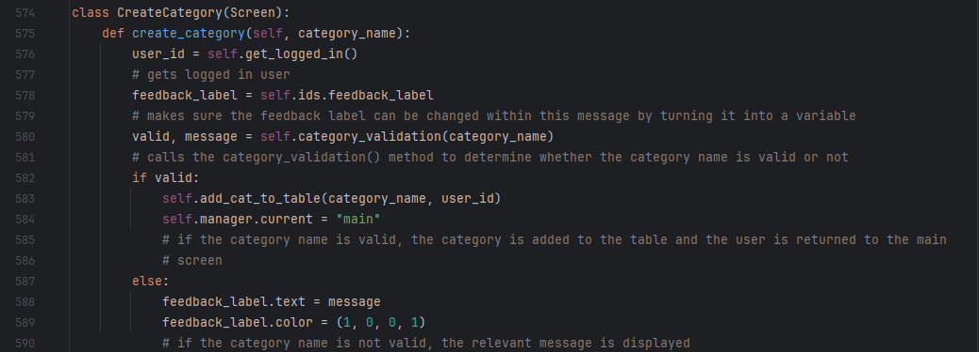As you can see, this method finds the logged in user, then validates the category, and adds it to the category table with its name and user id if it is valid, displaying a message if it is not valid. I will now test this screen’s validation.

|  |  |  |  |
| --- | --- | --- | --- |
| What is being tested | Test data | Expected outcome | Actual outcome |
| If the program does not allow the category name to be empty. | Category name: BLANK | Error message | “Category name cannot be empty” |
| If the program does not allow category name to be longer than 20 characters | Category name: mycategory x 5 | Error message | “Category name must be less than 20 characters” |
| If the program allows a valid category to be added to the Categories table | Category name: My new category | Program returns to main screen, new category shows up when queried for | Expected outcome occurred |
| If new categories display correctly in the navigation menu | Above category after creation | Category is displayed with all other categories | Expected outcome occurred |

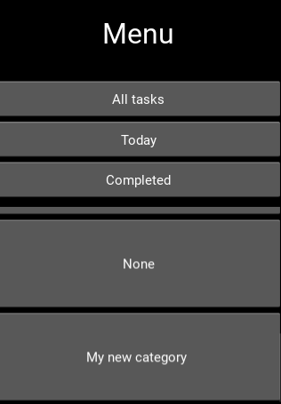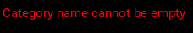**Evidence:**

As you can see, all the necessary error messages were displayed, and the new category was added to the database and the navigation menu.

#### Create category button

Now that the Create Category screen works, I need to create a button in the navigation menu that directs to this screen so that my users can create categories, not just me in testing. I will define this in my .kv file:

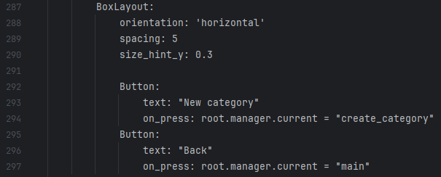

As you can see, I have added the button to a new horizontal box layout, along with the Back button that was already part of the screen. This matches up with my design for this screen in the Usability Features section of design, with the “New category” and “Back” buttons next to eachother. The navigation menu now looks like this:

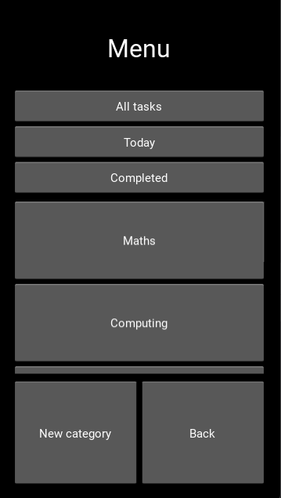

And I will now test this button:

|  |  |  |
| --- | --- | --- |
| What is being tested | Expected outcome | Actual outcome |
| Buttons display correctly | “New category” and “Back” buttons are displayed on screen horizontally next to eachother. | Expected outcome occurred |
| “New category” button works | Pressing the “New category” button takes you to the Create Category screen | Expected outcome occurred |

#### Create/edit task category integration

Currently, when creating or editing a task, the category spinner displays like so:

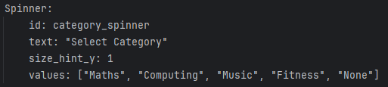

Using placeholder categories rather than user created categories. Instead, I want this screen to display the categories that are relevant to the user that is using the program, that they have created themselves. To do this I will create a List Property in my Create Task and Edit Task python classes. I will first import the ListProperty library:



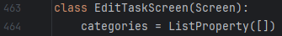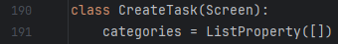Then I will define this property in both of my screens:

And I will make the category spinner values in both the Edit Task and Create Task screens correspond to this particular property in my .kv file:



Next I need to create a method that will actually get the categories from the Categories table and populate the categories list property with them.

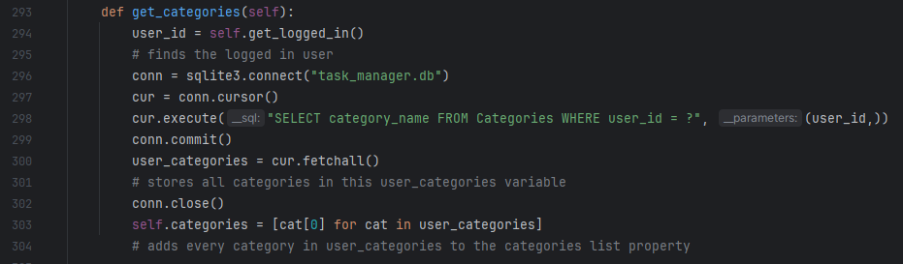

This method gets all of the categories that relate to the currently logged in user, and adds them to the list property for display in the categories spinner.

I have added this method to both the Create and Edit task screens, along with the following line to my on_enter() methods:

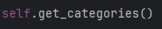

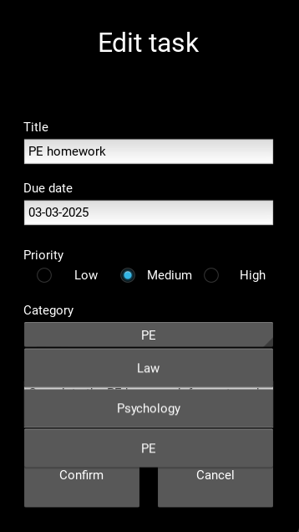Which calls this method every time one of these screens is opened. Now I can test this feature. I deleted all my current categories and tasks from their tables, and created 3 new ones “Law”, “Psychology” and “PE”.

|  |  |  |
| --- | --- | --- |
| What is being tested | Expected outcome | Actual outcome |
| Categories are displayed on Create and Edit screens | Actual tasks from Categories table are displayed when creating or editing tasks | Expected outcome occurred |
| Creating a task with these categories works and the task is added correctly. | Tasks created for a specific category show up when that category is selected in the menu | Expected outcome occurred |

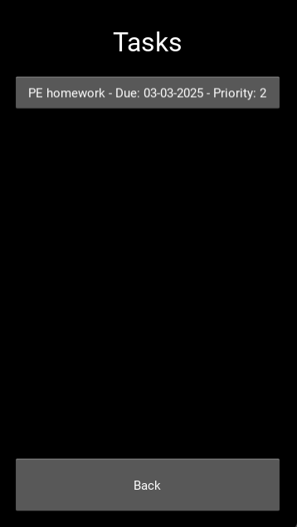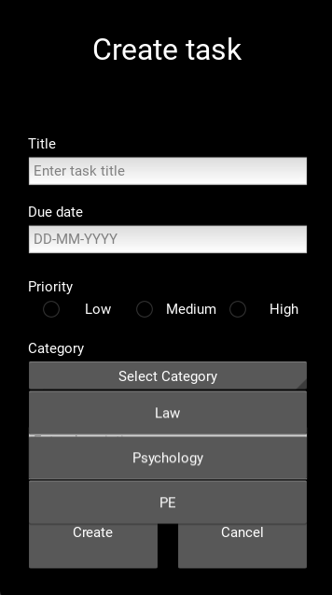Evidence:

As you can see, these categories are being displayed in both screens correctly, and the task I created withing the PE category is being displayed in the PE list.

#### Categories – final touches

There is now only 2 things to sort out in terms of my new categories functionality. The first one is that “None” needs to be a category that every user has as soon as their account is created. I will do this by adding some SQL as soon as a user signs up, however first of all I need to add a method to my SignupScreen class that will get the user id of the user that has just signed up:

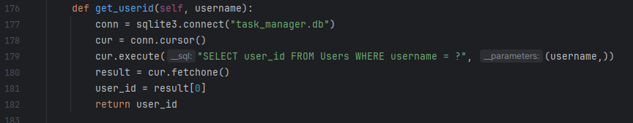

This is very similar to my get_logged_in() method that I defined multiple times for other screens, however it uses the username as a parameter rather than logged_in. I now need to change my populate_users() method so that it also automatically adds the “None” category for every user that signs up.

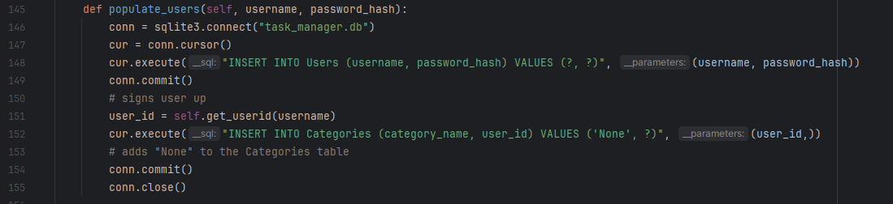

This method now calls the get_userid() method to get the user who has just signed up, and adds the “None” category to the Categories table with the foreign key of that user’s user id. I will now test signing up.

|  |  |  |
| --- | --- | --- |
| What is being tested | Expected outcome | Actual outcome |
| Signing up still works correctly | No errors occur when signing up just because of new code | Expected outcome occurred |
| “None” category created upon signup | When signing up, the “None” category is created instantly and can be seen in the navigation window | Expected outcome occurred |

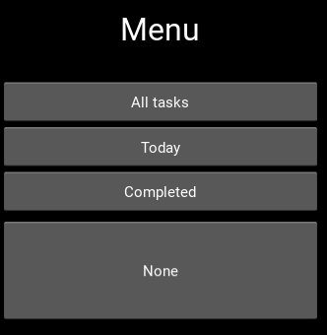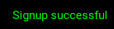**Evidence:**

As you can see, signing up works, and the “None” category is present.

The second thing that I need to add isn’t really related to my new categories functionality, but rather to the navigation menu – I want categories to be displayed with smaller buttons because the current ones are big and ugly. I will do this by adjusting their height when they are created:  
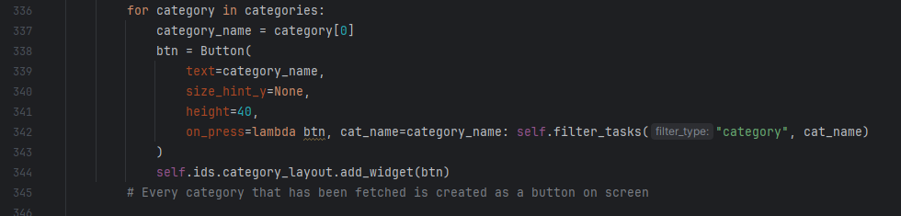

Now, categories look like this when they are displayed:

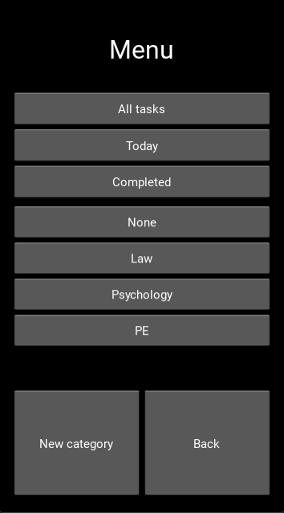

And I can move onto my next section of prototype 2.

### Task lists – sizing

The second thing that I mentioned when planning what I should include in my second prototype was that I want all of the task details that are displayed in the Task List screen to fit in their buttons, rather than running off screen as they sometimes do. I will give an example here: I have created a task with the title “Task whose name is too long”, and this is how it displays on screen:

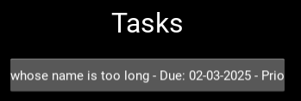

As you can see, part of the task’s title at the start, and its priority at the end, is cut off because it doesn’t fit inside the task button. To fix this I will change the for loop that initialises the creation of task buttons in a Task List.

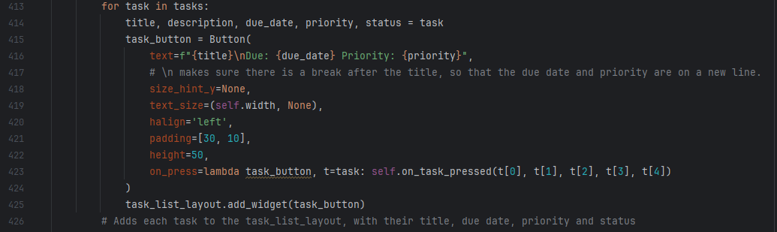

Now, there is a break after the task’s title, so that the title is on one line, and the due date and priority are on another. This means any task’s title (which will always be under 30 characters) will fit inside the button. I have added the “halign”, “text_size” and “padding” properties to each button to make sure they appear properly, aligned to the left, with enough space between the text and the edge of the button. I also changed the button’s size to 50 to accommodate these changes. The screen now displays like this:

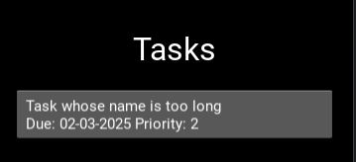

With all of the necessary details fitting inside the button.

### Task list error

While using my application, I came across an error: when a user viewed all tasks, they ended up viewing not only their task, but also other users’ tasks as well. This confused my to start with, because I thought that everything was contained within a user’s account. However, after looking through my code, I realised it was because I wasn’t adding the user id as a parameter when selecting tasks for my Task List view. I edited my queries and now they look like this:

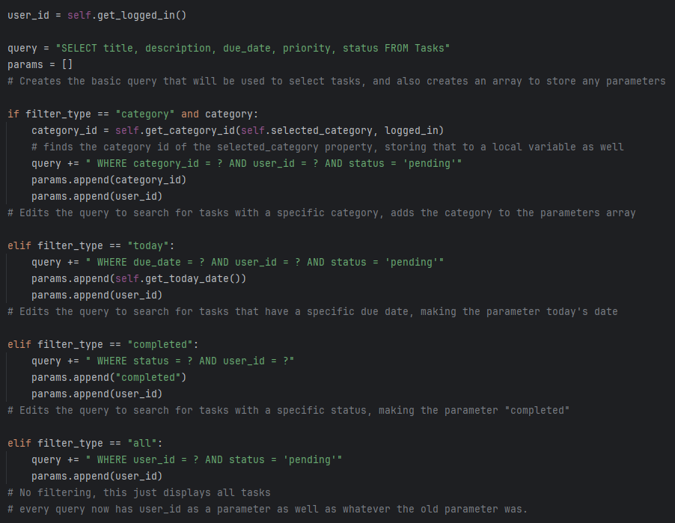

Now, every query uses user_id as a parameter as well, not just what the original parameter was.

### Improved button functionality

The third thing that I discussed as a feature for my second prototype was that I wanted all of my buttons to display to users that something had happened when they were pressed, or for them to advance the users to a new screen. I am going to be doing this module by module.

#### User account management

Firstly, I want signing up to automatically take the user to the login screen.

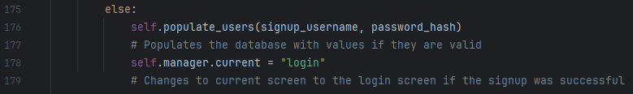

As you can see, if the signup details were valid, they are added to the Users table as before, but now the user is automatically advanced to the login screen, instead of there being a feedback label and the user having to press cancel, then login. This saves the user time.

#### Task creation

Currently, when one of my users creates a task, they are not taken anywhere and they are not even given a feedback message. They have to press cancel to leave the screen, which seems counter intuitive because it will feel like they are cancelling the creation of the screen. Instead, I want my users to be immediately taken to the View Task screen for the task that they have just created. To do this I will need to add some code to the create_task() method.

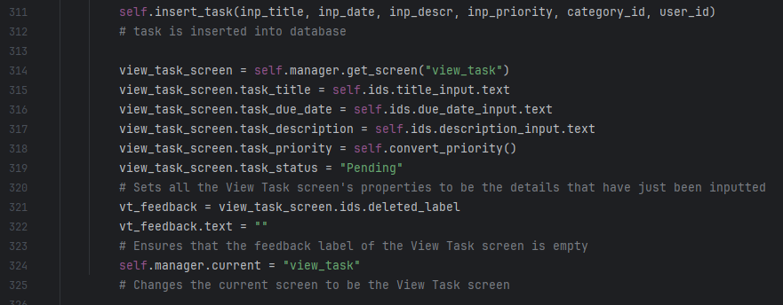

This code sets the View Task Screen’s properties to be the details of the task that has just been created, then changes the screen to the View Task screen. As you can see, I have called a new method called convert_priority(), which outputs a string version of the task’s priority.

I will create this method now:

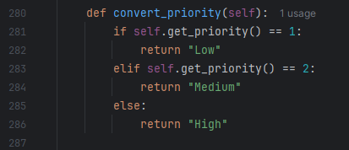

As you can see, this method calls the get_priority() method (which I already defined in my first prototype) and converts its output into a string that reflects the integer version of the priority. I will now test that this works.

|  |  |  |
| --- | --- | --- |
| What is being tested | Expected outcome | Actual outcome |
| “Create” button works properly | Pressing the “Create” button takes the user to the View Task screen for that task | Expected outcome occurred |
| Task details display correctly when | When signing up, the “None” category is created instantly and can be seen in the navigation window | Expected outcome occurred |

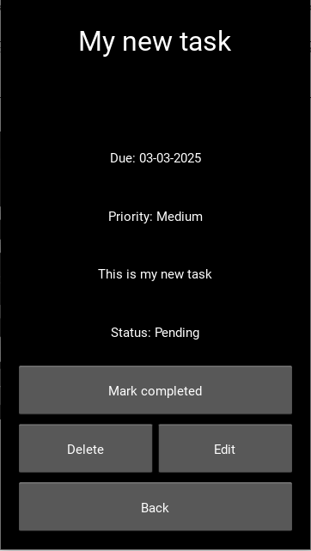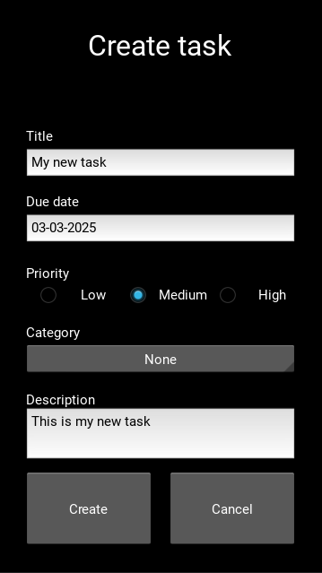**Evidence:**

As you can see, I created a task, and as soon as I created it, I was taken to the View Task screen for that task, showing that the feature is working correctly.

#### List display

There are no extra button functionality features that I want to add to this module, because the navigation works exactly how I want it to.

#### Task manipulation

There are three buttons that I want to add extra steps to in this module, two from the View Task screen and one from the Edit Task screen. Firstly, in the View Task screen, I want both the “Delete” and “Mark completed” buttons to direct the user back to the navigation menu. I will do this in my python file:



As you can see, all I had to do was make the screen change to the menu within my delete_task() and mark_completed() buttons. I will now test this code.

|  |  |  |
| --- | --- | --- |
| What is being tested | Expected outcome | Actual outcome |
| Delete button changes screen to menu | When a task is deleted, the user is taken back to the navigation menu | Expected outcome occurred |
| “Mark completed” button changes screen to menu | When a task is marked completed, the user is taken back to the navigation menu | Expected outcome occurred |

I cannot really add evidence for this, so instead I will add video evidence when it comes to my black box testing at the end of this prototype.

The next button I want to change is the “Confirm” button in my edit task screen. When the user presses this, I want them to be taken back to the View Task screen for that task, with all of the new changes saved. I will do this by changing the properties of that screen just before the screen is changed.

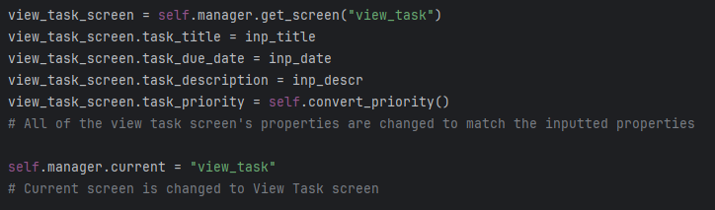

As you can see, all of the properties belonging to the View Task screen are changed to the properties that are inputted by the user, then the screen is changed to the View Task screen. I had to call the convert_priority() method again, to make sure the priority was a string, so I added it to the Edit Task screen as well (I wont screenshot this as it is the exact same as the one from the Create Task screen.

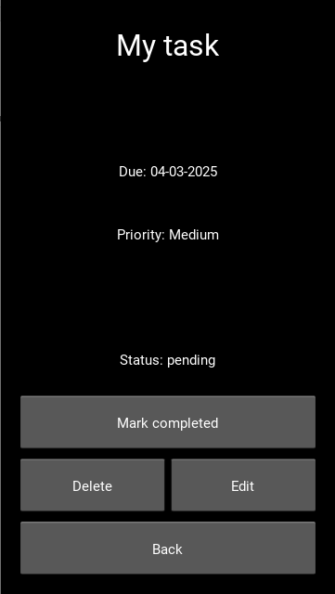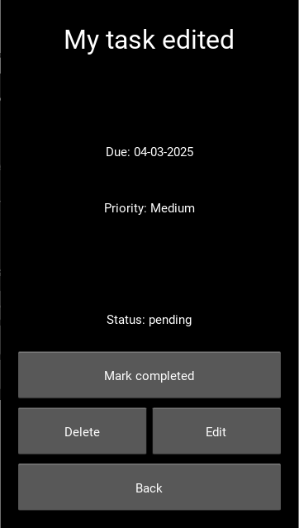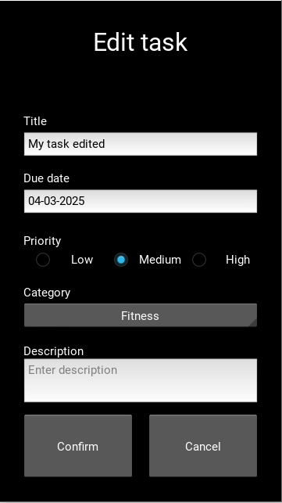I will now test this new button functionality.

|  |  |  |
| --- | --- | --- |
| What is being tested | Expected outcome | Actual outcome |
| Pressing “Confirm” changes screen correctly | The screen changes to the View Task screen for the edited task, with the new details being displayed as well. | Expected outcome occurred |

As you can see, the task was called “My task”, then I pressed the edit button, changed the name to “My task edited”, pressed the confirm button, and the screen was immediately changed to the View Task screen for that task. I will prove this fully in my video testing.

### Ensuring forms are empty

One thing that my stakeholders commented on with my first prototype was that some of the forms already had data in them (from past entries) when they were opened. The fix for this is quite simple, I just need to change the id of each entry field to have blank text using the on_pre_enter() method. The Task Creation module already makes sure that fields are empty when it is opened, but my other modules do not.

#### User account management

Firstly, I need my signup and login forms to be empty:

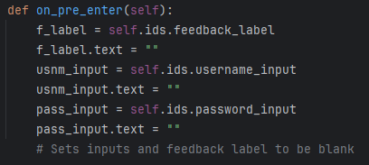

I added this exact code to both screen classes, which used the IDs of each widget on the screen to make them all blank. Now I will test:

|  |  |  |
| --- | --- | --- |
| What is being tested | Expected outcome | Actual outcome |
| Signup form is always blank when opened | When I add text to the fields, then press back, then open the screen again, the text should have disappeared. | Expected outcome occurred |
| Login form is always blank when opened | When I add text to the fields, then press back, then open the screen again, the text should have disappeared. | Expected outcome occurred |

I don’t have any way of proving this worked without videos, so I will add a video of this to my black box testing.

#### List display

When the “New category” button is pressed from the navigation menu, previous inputs are not cleared from the form, so I will do this now.

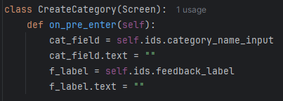

I added this on_pre_enter() method to my Create Category screen class, which set the feedback label and the category name field to be empty when the screen opens. I will now test this

|  |  |  |
| --- | --- | --- |
| What is being tested | Expected outcome | Actual outcome |
| Create Category form is always blank when opened | When I add text to the fields, then press back, then open the screen again, the text should have disappeared. | Expected outcome occurred |

This concludes this new feature, and again, I will add evidence of this feature working in videos in my black box testing of this prototype.

### View task screen alteration

I want my View Task screen to show the category that a task is in as well as its other data. I will do that by also fetching the task’s category when the other data is fetched. Firstly, I need to make category_id a property of the View Task screen.

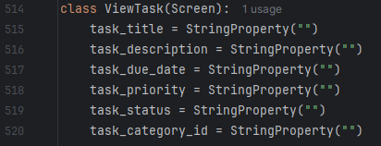

Now, when a task button is pressed, I need the category_id of that task to be set as the task_category_id property. I will do this by modifying the on_task_pressed() method from my Task List screen class.

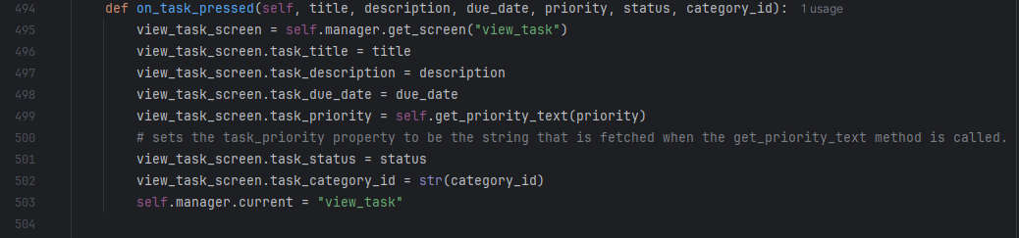

I have added “category_id” as a parameter for this method, and have set the task_category_id property to be this parameter. Now I need this to be passed into my lambda function upon the creation of the task button. First, I will make sure it is selected from the database by adding “category_id” to the query that is in my on_pressed() method for this screen:



Next, I will modify my for loop and lambda function to accept an extra value, category_id:

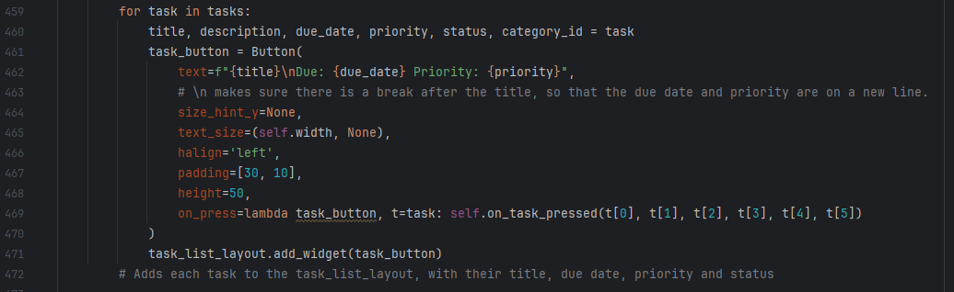

As you can see, the lambda function now passes 6 values into on_task_pressed() rather than 5. Next, I need to create a property called task_category_name within my View Task screen which will store the actual name once it has been converted from a category id.

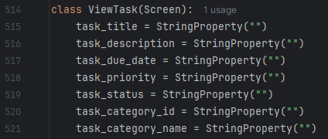

Now, I need to create a method within my View Task screen that changes the category ID into its respective category name.

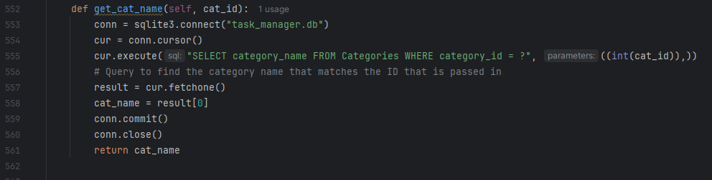

This method uses an SQL query to find the category name that matches the category ID that has been passed in. Finally, I need to call this function when the screen is opened:

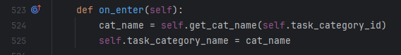

And add a label that can use this category name to my .kv file:

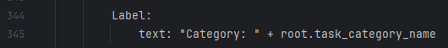

Now, when I open a task from a task list, its category is displayed as well as its other details.

However, this causes a problem: when the “Create” button in the Create Task screen and the “Confirm” button in the Edit task screen are pressed, the task_category_id property is never set, meaning that the on_enter() method for the View Task screen will have nothing to pass into the get_cat_name() method. To fix this, I will assign the task_category_id property within the create_task() method:

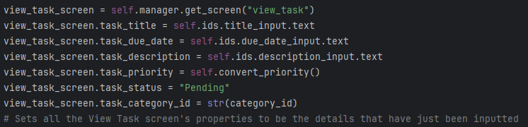

And I will also do the same within the edit_task() method:

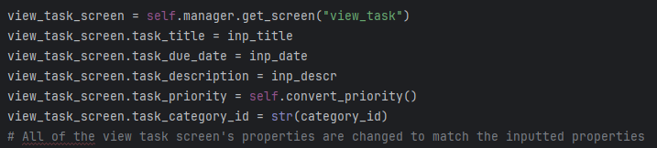

Now, every location that a task can be accessed from will also pass the category id of that task into the View Task screen’s task_category_id property, and the correct category for a task will always be displayed in the View Task screen, and I will test this now.

|  |  |  |
| --- | --- | --- |
| What is being tested | Expected outcome | Actual outcome |
| When a task is created, the View Task screen for that task comes up with the correct category. | Category displays as normal | Expected outcome occurred |
| When a task is edited, the View Task screen for that task comes up with the correct category. | Category displays as normal | Expected outcome occurred |
| When a task is selected from a Task List, the View Task screen for that task comes up with the correct category. | Category displays as normal | Expected outcome occurred |

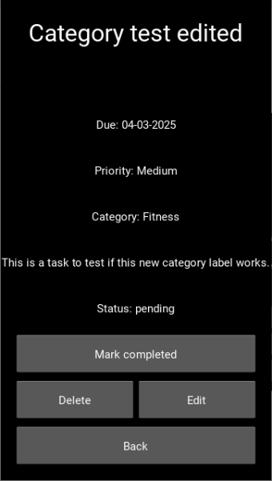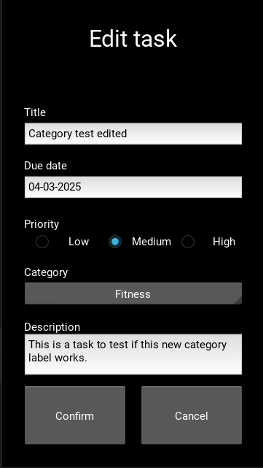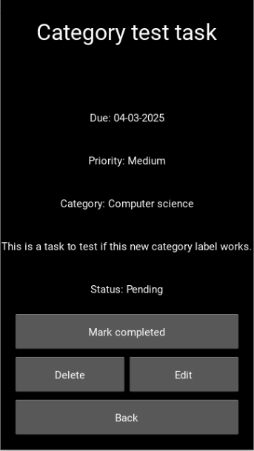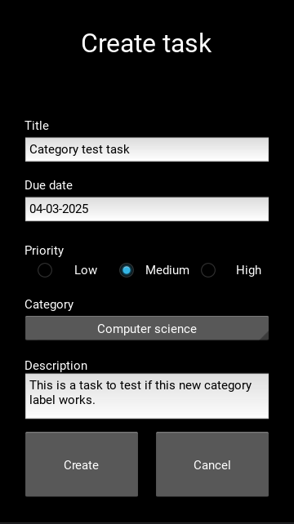**Evidence:**

As you can see, I created a task called “Category test task”, and its correct category was displayed as soon as I created it. Next, I edited the task, and changed the category to “Fitness”, and when I confirmed the changes, the new category was displayed properly as well.

### Task ID field

My current table has no way of uniquely identifying tasks, meaning any action performed on a task may also be performed on another task if it has the same title. This is because I have used the “title” field of my Tasks table multiple times to be the WHERE part of my SQL queries. Instead, I need this to be task_id because it means that manipulations that happen to one task will happen to that task only, even if there are multiple tasks with the same title. Firstly, I am going to delete the database. Then, I need to re-write the initialisation of the Tasks table to include the task_id table.

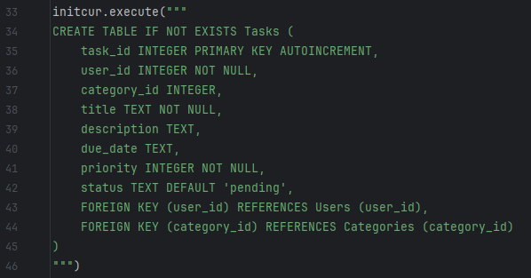

Now, the primary key of the tasks table is task_id, and it automatically increments by 1 with every task. Next, I need to edit all of my code and queries that use “title” instead of “task_id”. I will screenshot all of these, with comments as well.

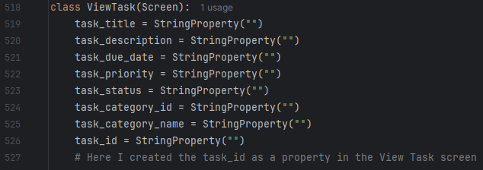



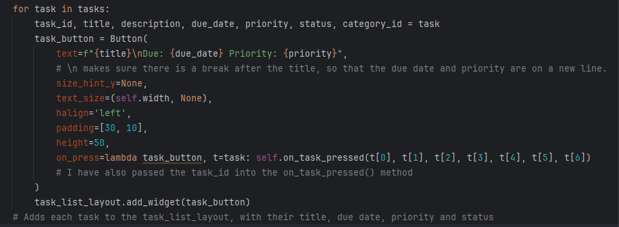

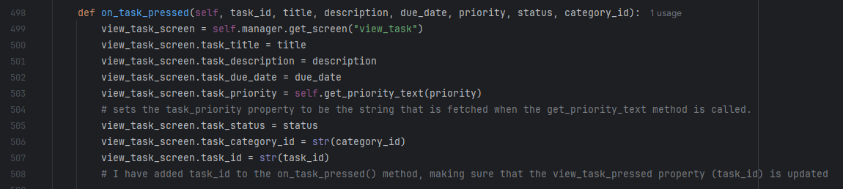

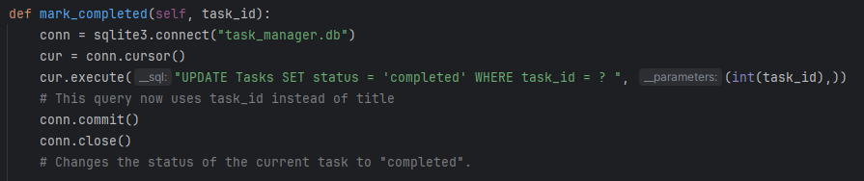

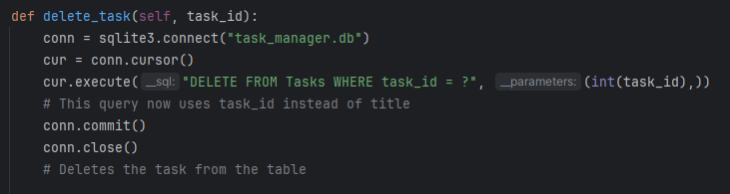

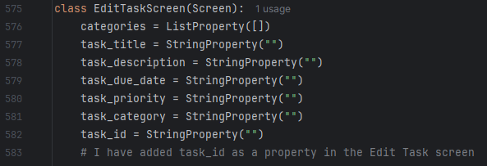

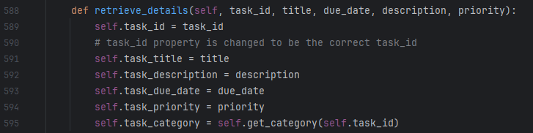

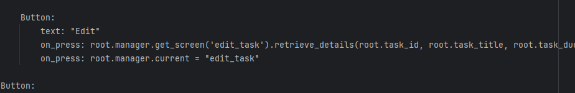



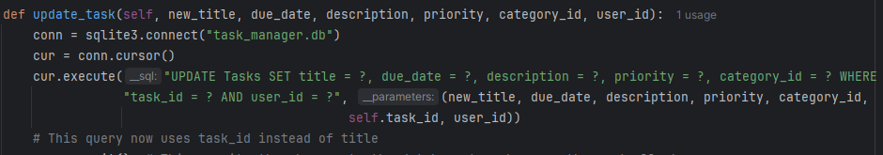

Now that I have updated my code to reflect the changes in the database, I will be testing that all of the changes work.

|  |  |  |
| --- | --- | --- |
| What is being tested | Expected outcome | Actual outcome |
| Task creation module still works | Task can be created with no errors | Expected outcome occurred |
| List display module still works | Lists can be displayed with no errors | Expected outcome occurred |
| Viewing tasks still works | Individual tasks can be viewed with no errors | Expected outcome occurred |
| Editing tasks still works | Tasks can be edited with no errors | Expected outcome occurred |
| Completing tasks still works | Tasks can be marked as completed with no errors | Expected outcome occurred |
| Deleting tasks still works | Tasks can be deleted with no errors | Expected outcome occurred |

To my surprise, all of the changes I made worked correctly and I did not have to fix any errors, so now I can move onto the GUI overhaul.

### GUI Overhaul

In order for my program to match the usability features that I described during my design, I need to change my entire GUI. I need it to have the following features:

* White background
* Black text
* Dark grey buttons (for regular buttons) with white text inside
* Black outlines for buttons and text entry fields
* Coloured buttons for certain actions
  + Red for log out button
  + Red for delete button
  + Blue for edit button

Firstly, I need to import a function into my python file that allows me to specify colours using hexadecimal values, and I also need to import the DictProperty class so that I can define the colours that I want for my theme inside a dictionary.





This means I can easily change colours of all of my features, which is necessary for the GUI to look like how I want it to look. Next, I need to create the Theme class in my python file, which will store a DictProperty with all of the colours that I will use for my project:

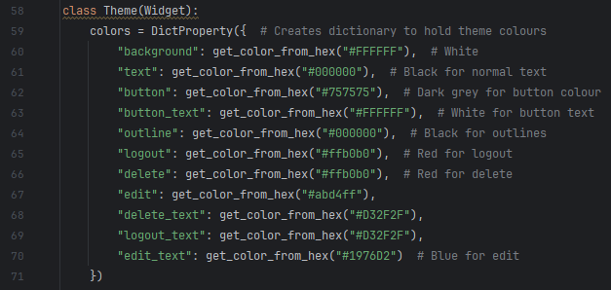

Here, I have defined all of the colours that I will be using throughout my project, however I might change or update this in future if I want to.

#### White screen

Next, I am going to make sure every screen has a white background. I will do this by creating a new type of screen widget that will inherit from the normal screen widget, and make sure any screen that is of this new type has a white background.

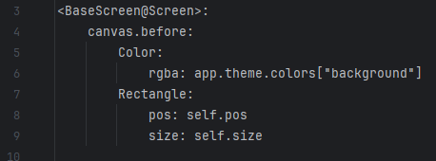

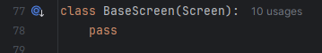This creates a new type of widget that inherits from the basic screen widget. The “canvas.before” property makes sure that the colour is applied to the screen before it is opened, and the “Rectangle” property inside of this makes sure that the colour fills the entire screen. I have selected the “background” colour from my “colors” dictionary. Next, I need to define the BaseScreen class inside of my python file, and make sure all of my screens inherit from it.

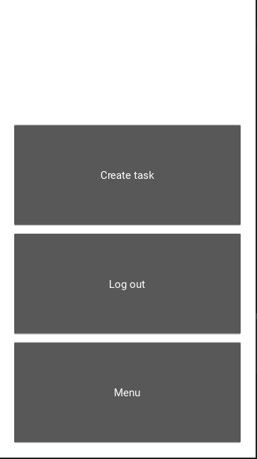Here you can see that I created the class, then made the Signup screen a BaseScreen widget rather than a Screen widget – I did this for all of my other screens as well but I won’t waste time screenshotting that. The main screen now looks like this:

#### Grey buttons, black text

Next, I will make sure all buttons follow the design that I created, and made sure all labels were black

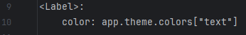:

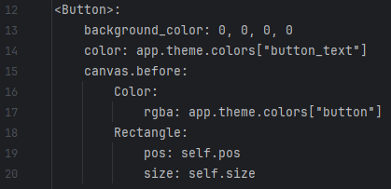

Here, I set the colour of the button to be initially white, then I added the button colour on top of it to make sure there wasn’t any mixing with the original colour. This is because Kivy’s default button colour is a dark grey, and if I added the button colour to that, it would have been tinted by it rather than be the colour I chose, so instead I made it white, which wouldn’t affect any colour that I added afterwards. My main screen now looks like this:

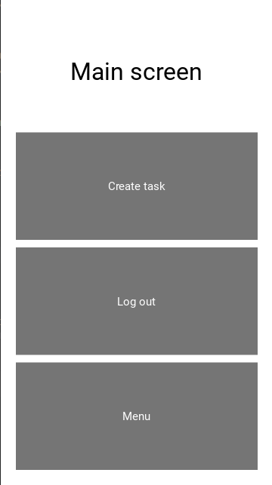

#### Coloured buttons

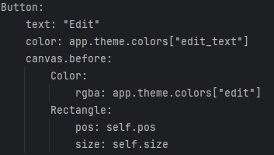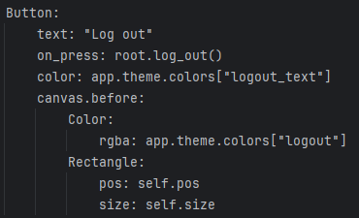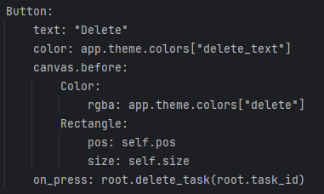The next feature I will add is the coloured buttons to match my usability features. I will do this for the delete button, the edit button and the log out button.

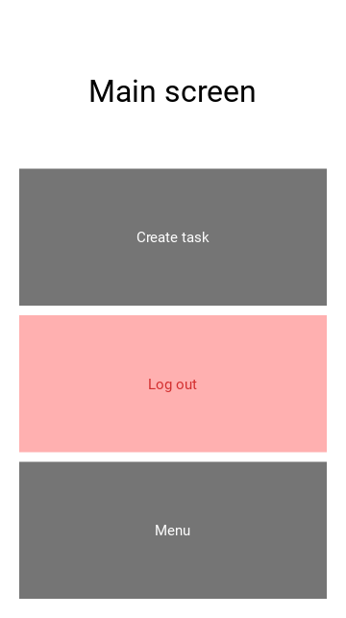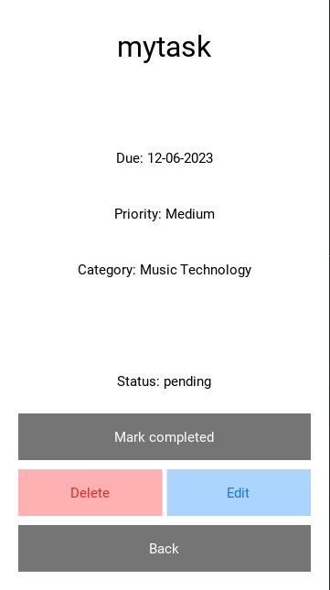Here is what these changes look like:

#### Final touches

Finally, I am going to make every screen look as close to my usability features as possible. I am not going into detail, but I will screenshot every screen definition from my .kv file, and show what the changes look like.

##### Main screen

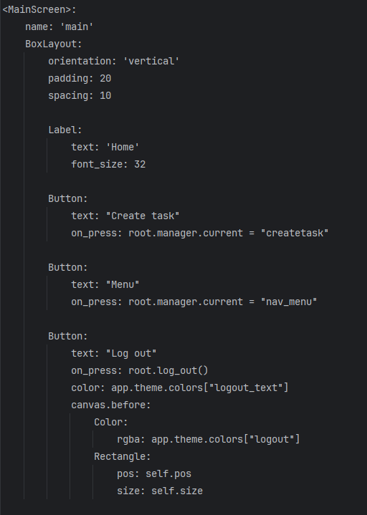

##### Signup

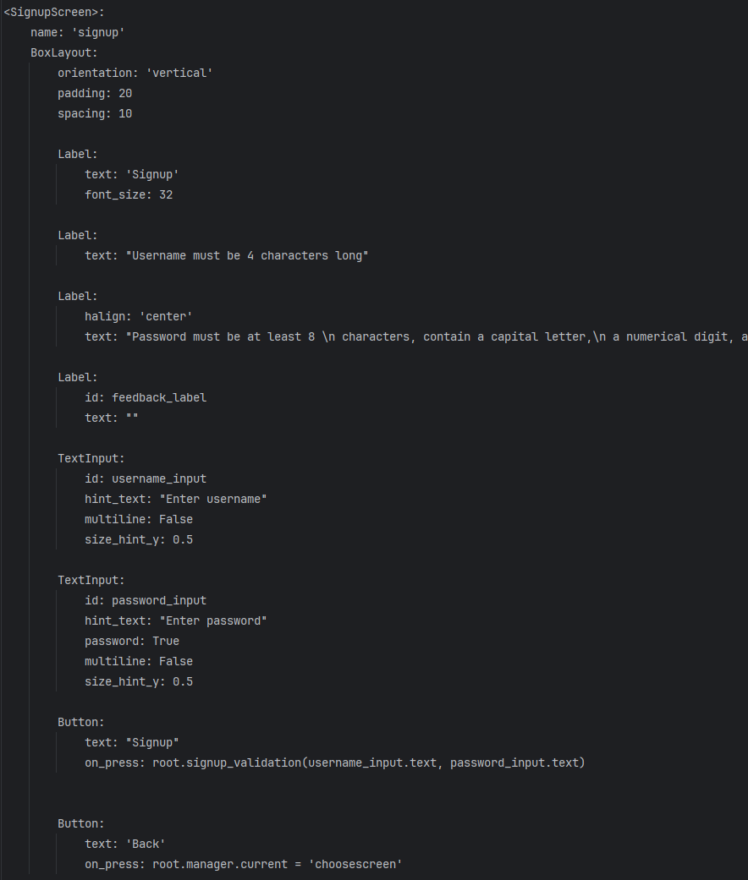

##### Login

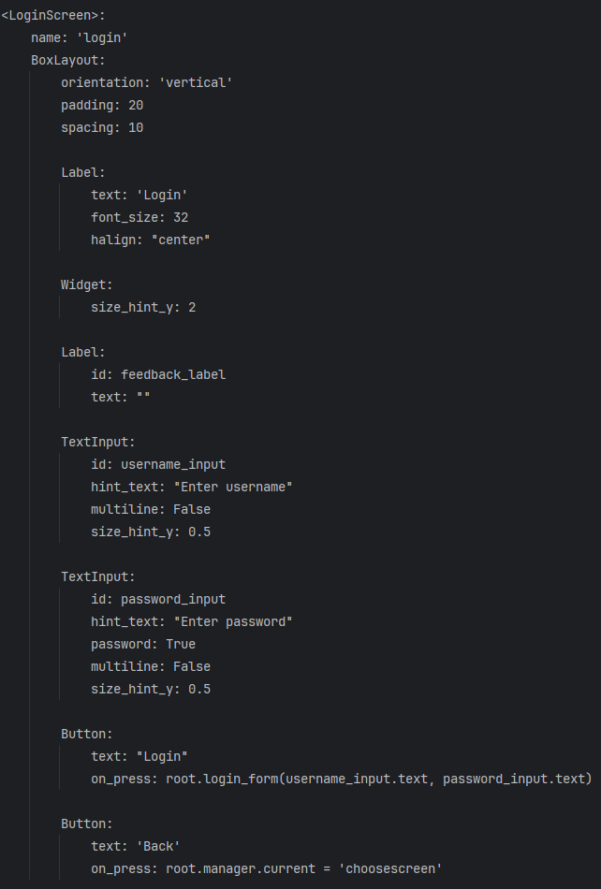

##### cREATE TASK

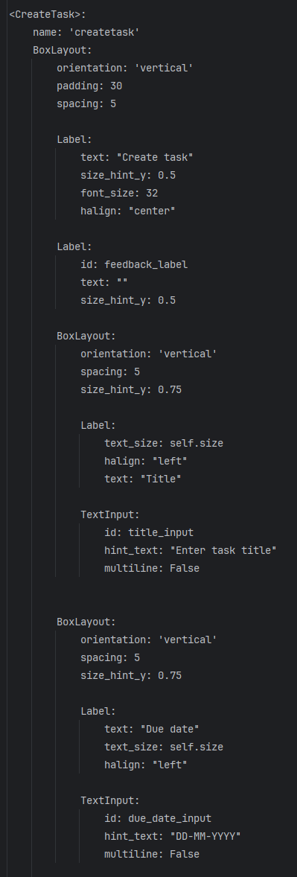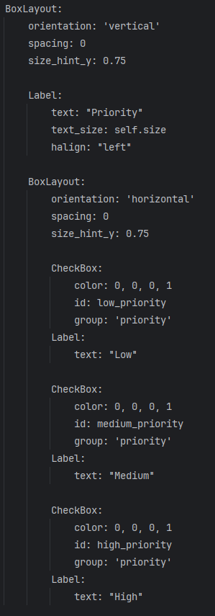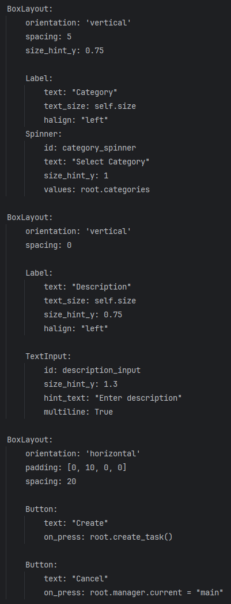

##### nAVIGATION MENU

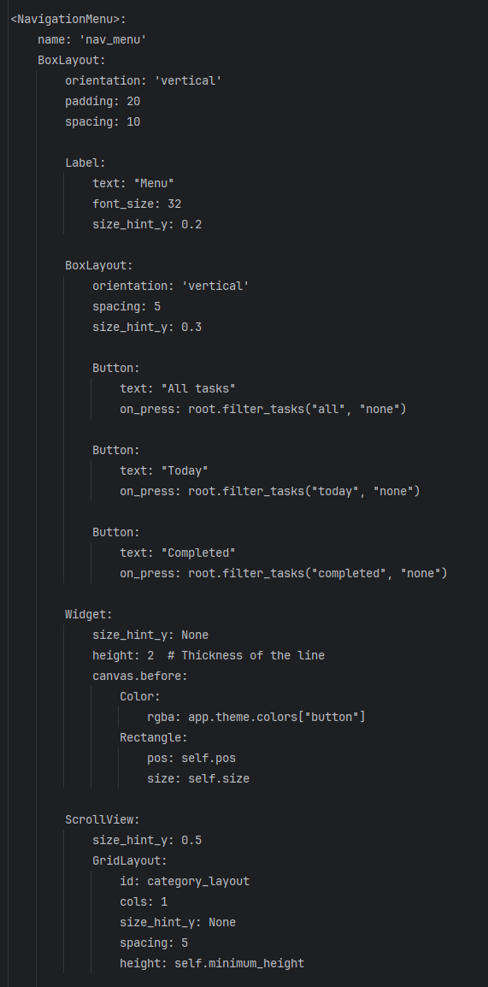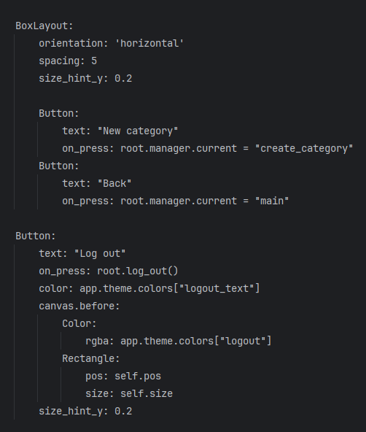

##### tASK LISTS

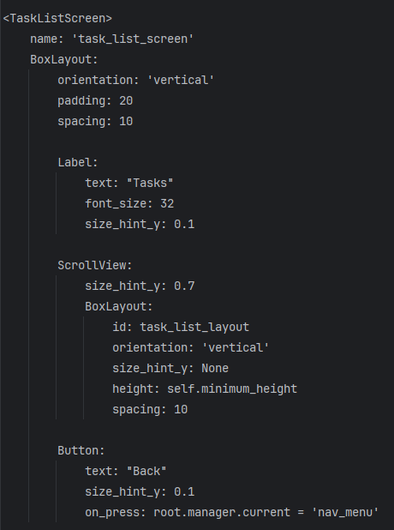

##### vIEW TASK

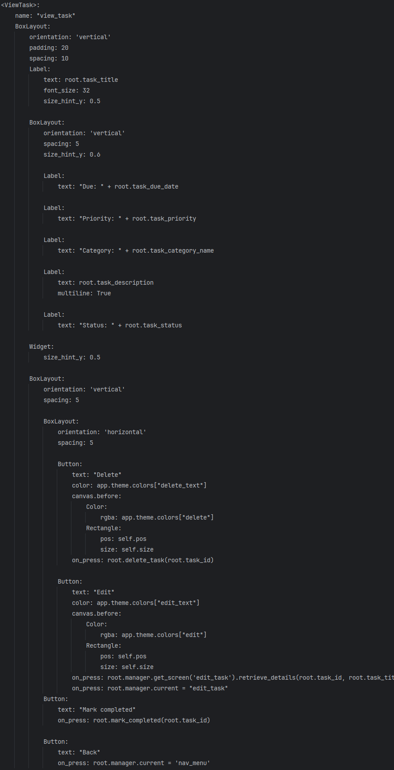

##### eDIT TASK

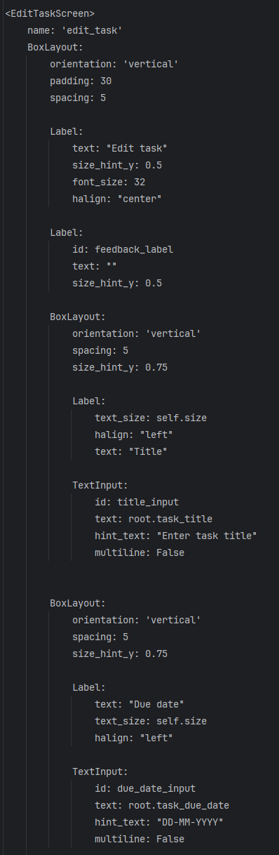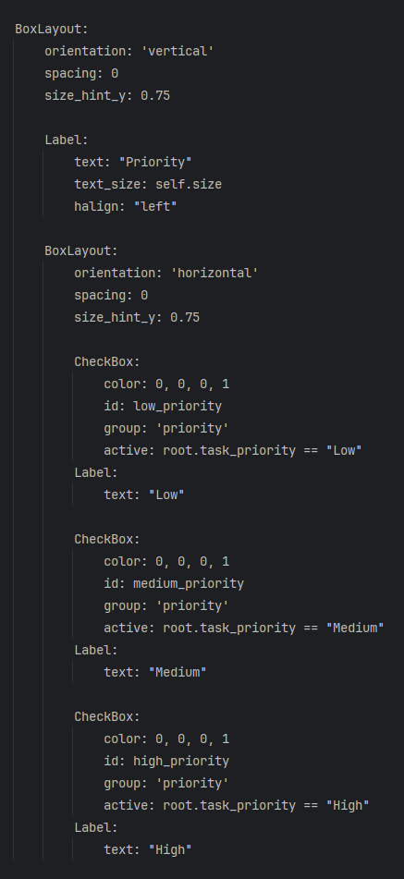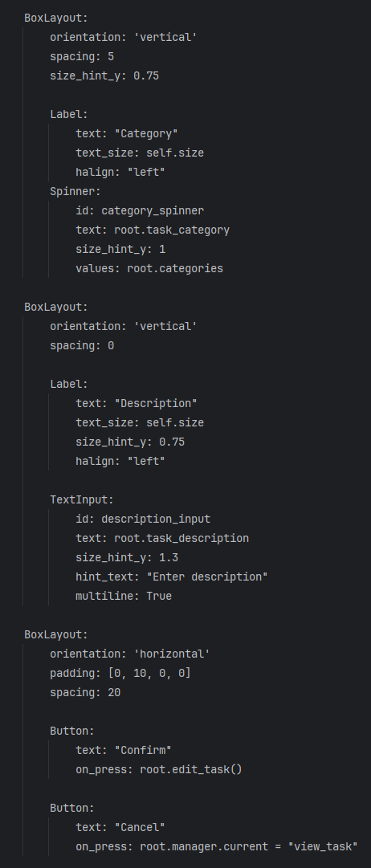

##### cREATE CATEGORY

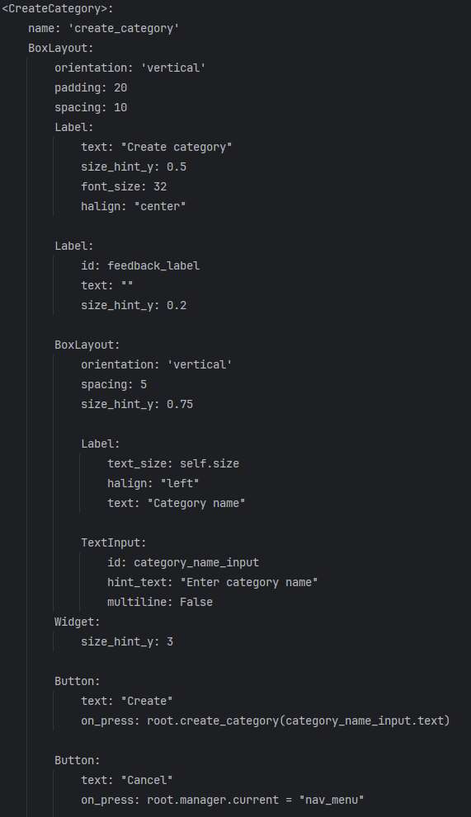

#### New GUI

Here is the evidence that my GUI now lines up with my usability features.

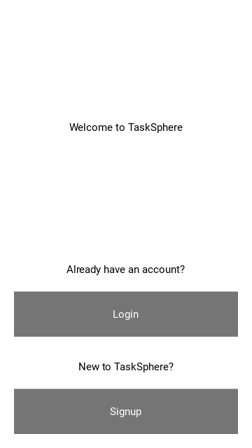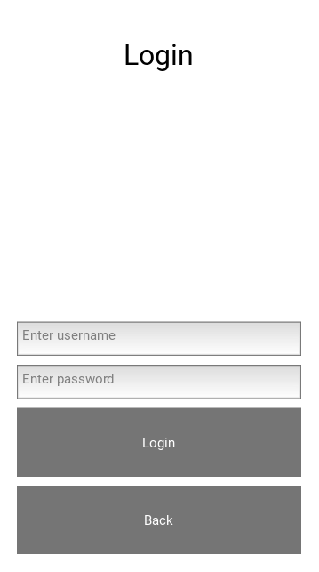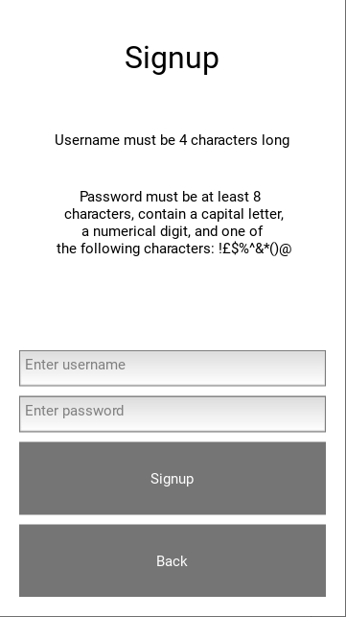

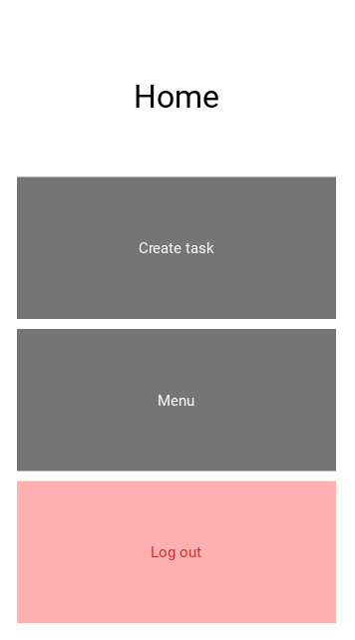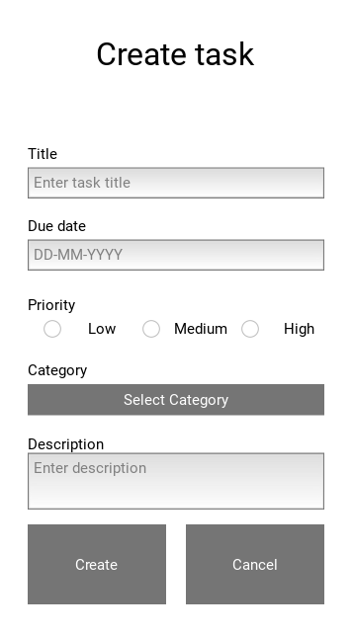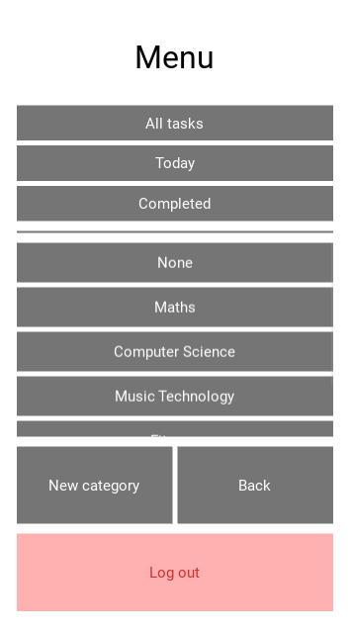-

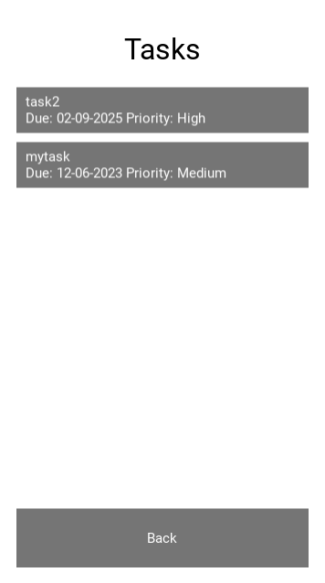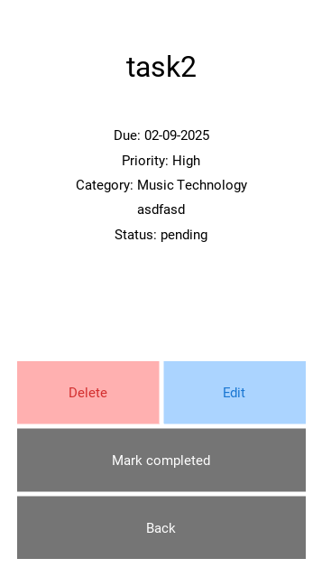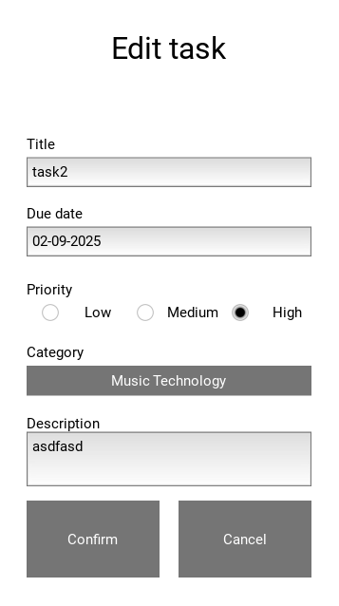

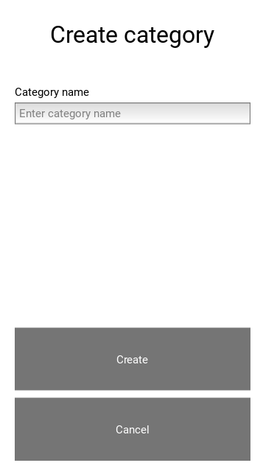

### Due date notifications

The final feature that I will need for this prototype is notifications. These will be sent to a user when a task is:

* Due in 3 days
* Due tomorrow
* Due today

And I will be using the “Plyer” library for this. This will also use the timedelta() function from the datetime library, to check the intervals between the date that a task is due and today’s date.

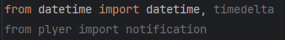

Next, I will define a function that gets today’s date and formats it in DD-MM-YYYY format.

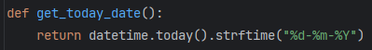

Next, I will define a function that calculates the date that is any number of days away from today.

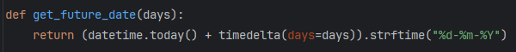

Here, the timedelta() function is used, to add the number of days that has been passed into the method to the current date.

Finally, I need a function that will find any tasks due today, tomorrow or in 3 days, then send a notification with a relevant message.

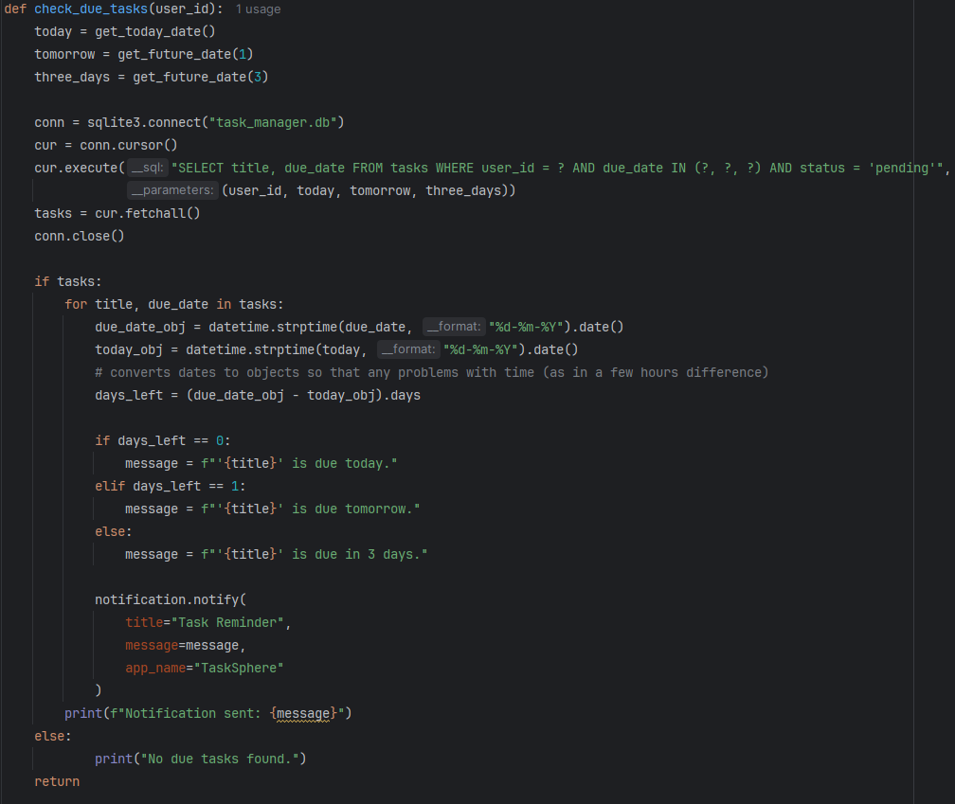

Firstly, this code creates 3 variables: “today”, “tomorrow”, “three_days”, which store the values from the get_future_date() and get_today_date() functions. It then queries my database for tasks with due dates that match these dates, and the user ID of the user that is logged in, storing them in the “tasks” variable. Then, if there are tasks present, date objects are created for both the due date and todays date (this is so that they can be subtracted from each other without worrying about times by the hour) and todays date is subtracted from the due date to find how many days are left. Based on the number of days, the relevant message is created, and a notification is sent. If there are no due tasks, this is printed to the run window so that I can see that it is working properly.

Now that these functions have been created, I will make sure they are called the moment the application is called, and I will do this within the build method for my app.

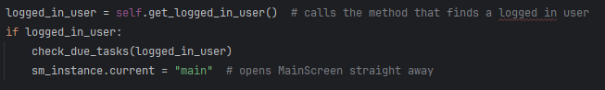  
Now, if there is a user logged in, they receive notifications about tasks that are due soon. I can now test this module.

#### Notification testing

For my test, I will create 3 tasks, one with due date in 3 days, one with due date tomorrow, and one with due date today. For reference, today’s date is 07/03/2025.

|  |  |  |  |
| --- | --- | --- | --- |
| What is being tested | Test data | Expected outcome | Actual outcome |
| If the program sends a notification when there is a task due in 3 days | Due date: 10-03-2025 | Notification sent to computer | “Category name cannot be empty” |
| If the program sends a notification when there is a task due in 1 day | Due date: 08-03-2025 | Notification sent to computer | “Category name must be less than 20 characters” |
| If the program sends a notification when there is a task due today | Due date: 07-03-2025 | Notification sent to computer | Expected outcome occurred |
| If the program sends no notification when there is no task due soon | N/A | No notification sent | Expected outcome occurred |

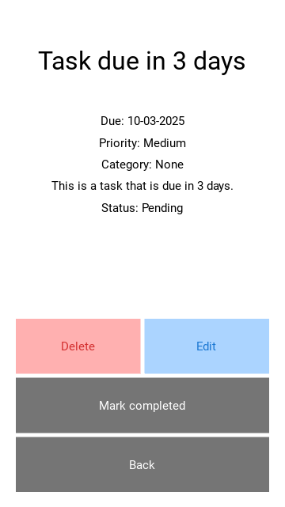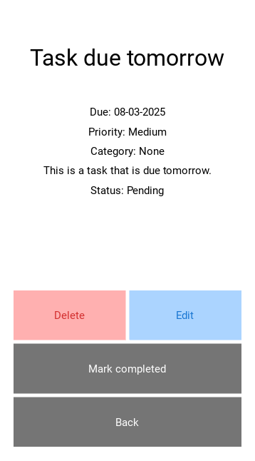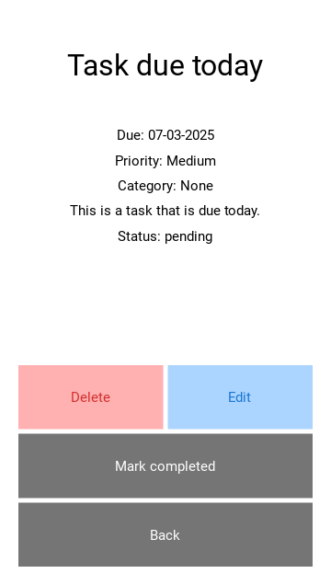

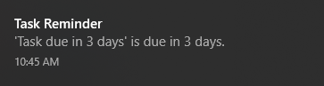 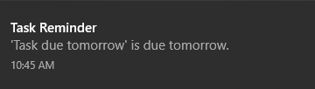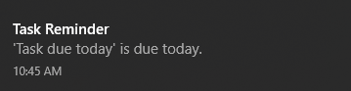

As you can see, the 3 tasks that I created ended up sending 3 notifications to my computer. Obviously, where this to be on an android device, the notification would be sent as an android notification following the format of the device that has been used. When there was no notification, this was outputted:



My notifications section is now finished.

### Sorting by priority

At this stage in development, it is clear to me that I will not be able to fully implement a task sorting feature for my Task List screens. While this is frustrating, there is still one thing that I can do to have a sort of task sorting feature, even if it is not a comprehensive one: I will make sure tasks are automatically sorted by priority, from high to low. To do this, all I have to do is change my SQL queries for when tasks are fetched from the Tasks table.

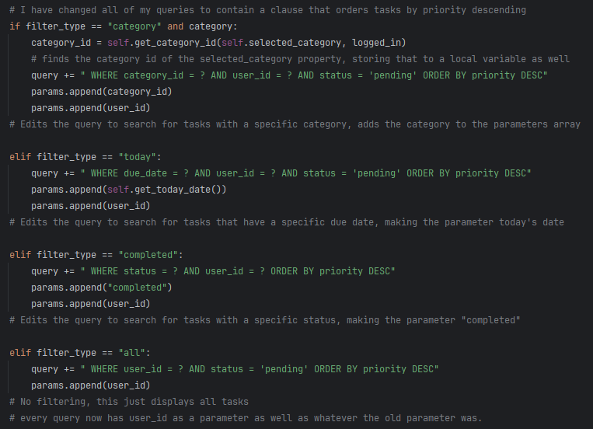

As you can see, whenever I append a query, the new query that is created always orders tasks by priority. This can be viewed in the Task List screen:

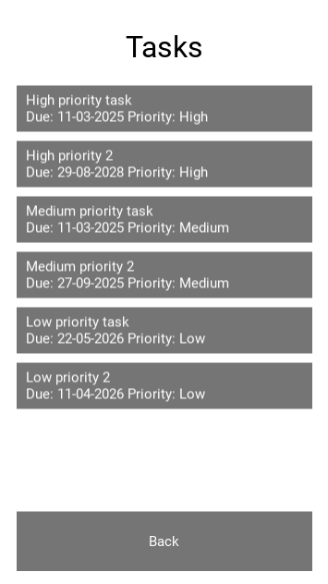

As you can see, these tasks are all ordered by priority, allowing the user to focus on what I highest in priority to them.

I have now completed every single module, with each one fully tested and working, and I will now submit this prototype for testing by stakeholders.

## Prototype 2 review

My second prototype, which represents the final solution to my problem, is now fully functional (with the exception of task sorting) and runs perfectly as a task management application. My target users would be able to use my application with ease and little guidance, and it would help them stay organised with all of their daily tasks. This prototype also has amazing scalability potential, with room for many more features to be seamlessly integrated into the application, such as recurring tasks, personalised priority ratings, and an online server that would allow users to manage tasks from multiple devices on the same account.

While I could have created another prototype afterwards, to truly iron out details and features that I missed from my “Could Achieve” section, I believe that this prototype offers a comprehensive solution to the problem that works as it is to provide great functionality to my users. Given the time frame that I had to complete this project, two prototypes worked perfectly for me, and I achieved all of the “Should achieve” goals that I worked together with my stakeholders to outline. My solution also fulfils all of the success criteria that I set out to achieve, bar the task sorting feature, and I do regret that I could not achieve this, but I ran out of time, and my app is not rendered unusable just because of the absence of this feature. I have still added a dumbed down version of this feature, which means that the success criteria is not completely failed.

In conclusion, this second prototype was successful in meeting my stakeholders’ needs, as well as fulfilling the functionality and usability features that I set out to create before development. I will perform my final post development testing.

Note – after my first prototype, I compared it against my success criteria. However, because this is my final product, I will compare it to my success criteria in evaluation to prove that I have been successful in the development of this final prototype.

# D. Evaluation

## Post development testing - functionality

Throughout the development of my final prototype, I performed numerous whitebox tests on the functionality of my program to make sure it works as intended. Now that the program is done, I will have one of my stakeholders, Ethan, perform a number of tests to prove that my program works completely, as a whole, from start to finish, with video evidence. I will be doing this module by module. In order to prove that it works from the start, I have deleted the database to start fresh, with all new data. This testing will be a mix between whitebox and blackbox testing – Ethan does not understand how the code works, but I am going to be present for the tests to ensure that he carries out a comprehensive test, with all possible input values.

The justification for why each test is necessary can be found in Post Development Test Plan, in Design.

Note – I have tested all of these using my windows device because in order to create a .apk file from my code, I would have to use a Linux-based operating system, which I do not have access to. However, because I have followed the rules of the Kivy language, my code would work perfectly on an android device as well.

### User account management

#### Choose signup or login

Evidence for this test can be found in: [Choose Screen Final](https://greenheadcollege-my.sharepoint.com/personal/s231199_greenhead_ac_uk/Documents/COMPUTER%20SCIENCE/NEA/Video%20Testing%20Evidence/Choose%20Screen%20Final.mkv)

|  |  |  |  |  |  |
| --- | --- | --- | --- | --- | --- |
| Test name | Test data | Expected outcome | Actual outcome | Success | Timestamp |
| Testing login button functionality | Login button pressed | On click, login screen opened | Expected outcome occurred | Successful | 0:03 |
| Testing signup button functionality | Signup button pressed | On click, signup screen opened | Expected outcome occurred | Successful | 0:06 |

#### Signup screen

Evidence for this test can be found in: [Signup Screen Final](https://greenheadcollege-my.sharepoint.com/personal/s231199_greenhead_ac_uk/Documents/COMPUTER%20SCIENCE/NEA/Video%20Testing%20Evidence/Signup%20Screen%20Final.mkv)

|  |  |  |  |  |  |
| --- | --- | --- | --- | --- | --- |
| Test name | Test data | Expected outcome | Actual outcome | Success | Timestamp |
| Testing signup if no details are entered | Username: “”  Password: “” | Error message: “All fields must be present” | Error message: “Username must be 4+ characters” | Partially successful – user was not allowed to sign up, but the same error message did not appear. This can be added in later development | 0:05 |
| Testing signup if username is not entered | Username: “”  Password: “P@55word” | Error message: “All fields must be present” | Expected outcome occurred | Partially successful – user was not allowed to sign up, but the same error message did not appear. This can be added in later development | 0:10 |
| Testing signup if password is not entered | Username: “Ethan”  Password: “” | Error message: “All fields must be present” | Expected outcome occurred | Partially successful – user was not allowed to sign up, but the same error message did not appear. This can be added in later development | 0:19 |
| Testing signup if username is too short | Username: “Eth”  Password: “P@55word” | Error message:  “Username must be at least 4 characters long” | Expected outcome occurred | Successful | 0:24 |
| Testing signup if password is too short | Username: “Ethan”  Password: “pass” | Error message:  “Password must be at least 8 characters long” | Expected outcome occurred | Successful | 0:33 |
| Testing signup if password does not contain a capital letter | Username: “Ethan”  Password: “p@55word” | Error message:  “Password must contain at least one uppercase character” | Expected outcome occurred | Successful | 0:40 |
| Testing signup if password does not contain a numerical digit | Username: “Ethan”  Password: “P@ssword” | Error message:  “Password must contain at least one digit” | Expected outcome occurred | Successful | 0:46 |
| Testing signup if password does not contain a special character | Username: “Ethan”  Password: “Pa55word” | Error message:  “Password must contain at least special character” | Expected outcome occurred | Successful | 0:52 |
| Testing signup if login details are valid | Username: “Ethan”  Password: “P@55word” | User account is created and they are taken to login screen. | Expected outcome occurred | Successful | 1:02 |
| Testing back button functionality | Back button pressed | On click, user taken back to choose signup/login page. | Expected outcome occurred | Successful | 1:07 |

#### Login screen

Evidence for this test can be found in: [Login Screen Final](https://greenheadcollege-my.sharepoint.com/personal/s231199_greenhead_ac_uk/Documents/COMPUTER%20SCIENCE/NEA/Video%20Testing%20Evidence/Login%20Screen%20Final.mkv)

|  |  |  |  |  |  |
| --- | --- | --- | --- | --- | --- |
| Test name | Test data | Expected outcome | Actual outcome | Success | Timestamp |
| Testing login if no details are entered | Username: “”  Password: “” | Error message: “Invalid username or password” | Expected outcome occurred | Successful | 0:02 |
| Testing login if invalid username is entered | Username: “Tobi”  Password: “P@55word” | Error message: “Invalid username or password” | Expected outcome occurred | Successful | 0:05 |
| Testing login if invalid password is entered | Username: “Ethan”  Password: “password” | Error message: “Invalid username or password” | Expected outcome occurred | Successful | 0:16 |
| Testing login if valid details are entered. | Username: “Ethan”  Password: “P@55word” | On press, user granted access to main screen | Expected outcome occurred | Successful | 0:22 |
| Testing back button functionality | Back button pressed | On press, taken back to choose signup/login page. | Expected outcome occurred | Successful | 0:27 |
| Testing if user is saved as logged in | App opened | On opening, user is automatically taken to the Home screen rather than having to log in again. | Expected outcome occurred | Successful | n/a |

### Task creation

#### create task screen

Evidence for this test can be found in: [Create Screen Final](https://greenheadcollege-my.sharepoint.com/personal/s231199_greenhead_ac_uk/Documents/COMPUTER%20SCIENCE/NEA/Video%20Testing%20Evidence/Create%20Screen%20Final.mkv)

|  |  |  |  |  |  |
| --- | --- | --- | --- | --- | --- |
| Test name | Test data | Expected outcome | Actual outcome | Success | Timestamp |
| Testing task creation if title is blank | Title: “”  Due date: “11-03-2025”  Priority: “Medium”  Category: “None”  Description: “This is a task I am using for testing” | Error message: “Title cannot be empty” | Expected outcome occurred | Successful | 0:01 |
| Testing task creation if due date is blank | Title: “Testing task”  Due date:"”  Priority: “Medium”  Category: “None”  Description: “This is a task I am using for testing” | Error message: “Due date cannot be empty” | Error message: “Due date must be in format DD-MM-YY” | Partially successful – user was not allowed to sign up, but the same error message did not appear. This can be added in later development | 0:20 |
| Testing task creation if priority is blank | Title: “Testing task”  Due date: “11-03-2025”  Priority: “”  Category: “None”  Description: “This is a task I am using for testing” | Error message: “Please select a priority” | Expected outcome occurred | Successful | 0:23 |
| Testing task creation if title is longer than 30 characters | Title: “Testing task with title that is too long”  Due date: “11-03-2025”  Priority: “Medium”  Category: “None”  Description: “This is a task I am using for testing” | Error message: “Title must be less than 30 characters” | Expected outcome occurred | Successful | 0:33 |
| Testing task creation if date is invalid but still contains numbers | Title: “Testing task”  Due date: “32-13-2025”  Priority: “Medium”  Category: “None”  Description: “This is a task I am using for testing” | Error message: “Please enter a valid date” | Error message: “Due date must be in format DD-MM-YY” | Partially successful – user was not allowed to sign up, but the same error message did not appear. This can be added in later development | 0:48 |
| Testing task creation if date is invalid containing wrong characters | Title: “Testing task”  Due date: “11/03/2025”  Priority: “Medium”  Category: “None”  Description: “This is a task I am using for testing” | Error message: “Date must be in format DD-MM-YY” | Expected outcome occurred | Successful | 0:54 |
| Testing task creation if description is longer than 200 characters. | Title: “Testing task”  Due date: “32-13-2025”  Priority: “Medium”  Category: “”  Description: “This description is way too long” x 10 | Error message: “Description must be less than 200 characters” | Expected outcome occurred | Successful | 1:08 |
| Testing task creation if all details are valid | Title: “Testing task”  Due date: “11-03-2025”  Priority: “Medium”  Category: “None”  Description: “This is a task I am using for testing” | Task is created and user is taken to the View Task screen for that task | Expected outcome occurred | Successful | 1:38 |
| Testing cancel button functionality | Cancel button pressed | On press, user taken back to Home screen | Expected outcome occurred | Successful | 1:50 |
| Testing that created task shows up in correct category in Task List screen | “Testing task” searched for in None category | Task can be found and opened | Expected outcome occurred | Successful | 1:54 |

### List display

#### Create category screen

Evidence for this test can be found in: [Category Screen Final](https://greenheadcollege-my.sharepoint.com/personal/s231199_greenhead_ac_uk/Documents/COMPUTER%20SCIENCE/NEA/Video%20Testing%20Evidence/Category%20Screen%20Final.mkv)

|  |  |  |  |  |  |
| --- | --- | --- | --- | --- | --- |
| Test name | Test data | Expected outcome | Actual outcome | Success | Timestamp |
| Testing category creation if category name is blank | Category name: “” | Error message: “Category name cannot be empty” | Expected outcome occurred | Successful | 0:03 |
| Testing category creation if category name is longer than 20 characters | Category name: “Category whose name is longer than 20 characters” | Error message: “Category name must be less than 20 characters” | Expected outcome occurred | Successful | 0:06 |
| Testing category creation if category name is valid | “My new category” | Category is created and user is taken back to home page | Expected outcome occurred | Successful | 0:24 |
| Testing that created category shows up in navigation menu | “My new category” searched for in navigation menu | Category is shown and can be opened | Expected outcome occurred | Successful | 0:31 |
| Testing cancel button functionality | Cancel button pressed | On press, user taken back to menu | Expected outcome occurred | Successful | 0:40 |

#### Navigation menu

Before this test, I had Ethan add 3 categories based on the subjects he chose, Maths, Physics and Computer Science. I also had him create a number of tasks for these categories.

Evidence for this test can be found in: [Navigation Menu Final](https://greenheadcollege-my.sharepoint.com/personal/s231199_greenhead_ac_uk/Documents/COMPUTER%20SCIENCE/NEA/Video%20Testing%20Evidence/Navigation%20Menu%20Final.mkv)

|  |  |  |  |  |  |
| --- | --- | --- | --- | --- | --- |
| Test name | Test data | Expected outcome | Actual outcome | Success | Timestamp |
| Testing All tasks button functionality | All tasks button pressed | On press, all tasks relating to user are displayed on screen | Expected outcome occurred | Successful | 0:03 |
| Testing Today button functionality | Today button pressed | On press, all tasks that are due today are displayed on screen | Expected outcome occurred | Successful | 0:09 |
| Testing Completed button functionality | Completed button pressed | On press, all tasks that have been completed are displayed on screen | Expected outcome occurred | Successful | 0:30 |
| Testing a category button functionality | “Maths” button pressed | On press, all tasks that have been created for a given category are displayed on screen | Expected outcome occurred | Successful | 0:36 |
| Testing New category button functionality | New category button pressed | On press, Create Category screen is opened | Expected outcome occurred | Successful | 0:42 |
| Testing back button functionality | Back button pressed | On press, user taken back to Home screen | Expected outcome occurred | Successful | 0:46 |
| Log out button functionality | Log out button pressed | On press, user taken back to Choose Signup/Login page | Expected outcome occurred | Successful | 0:47 |

#### Task list screen

Evidence for this test can be found in: [Task List Screen Final](https://greenheadcollege-my.sharepoint.com/personal/s231199_greenhead_ac_uk/Documents/COMPUTER%20SCIENCE/NEA/Video%20Testing%20Evidence/Task%20List%20Screen%20Final.mkv)

|  |  |  |  |  |  |
| --- | --- | --- | --- | --- | --- |
| Test name | Test data | Expected outcome | Actual outcome | Success | Timestamp |
| Testing if tasks can be sorted by different parameters | Task sorting parameter changed | When a parameter is pressed, tasks on screen are automatically sorted to fit that parameter | Tasks are sorted automatically by priority now, user has no say in how tasks are sorted | Fail | N/A |
| Testing task button functionality | Task button pressed from within a task list. | On press, the View Task screen for that task is displayed | Expected outcome occurred | Successful | 0:03 |
| Testing back button functionality | Back button pressed | On press, user taken back to menu | Expected outcome occurred | Successful | 0:10 |

### Task manipulation

#### View task screen

Evidence for this test can be found in: [View Task Screen Final](https://greenheadcollege-my.sharepoint.com/personal/s231199_greenhead_ac_uk/Documents/COMPUTER%20SCIENCE/NEA/Video%20Testing%20Evidence/View%20Task%20Screen%20Final.mkv)

|  |  |  |  |  |  |
| --- | --- | --- | --- | --- | --- |
| Test name | Test data | Expected outcome | Actual outcome | Success | Timestamp |
| Testing if all task data is displayed correctly on screen | Task opened | All the task data is displayed correctly on screen | Expected outcome occurred | Successful | 0:02 |
| Testing Edit button functionality | Edit button pressed | On press, Edit Task screen for that task is opened with all its data already in fields | Expected outcome occurred | Successful | 0:07 |
| Testing Mark Completed button functionality | Mark completed button pressed | On press, user is taken back to menu and task can only be found in the Completed list | Expected outcome occurred | Successful | 0:10 |
| Testing Back button functionality | Back button pressed | On press, user is taken back to menu | Expected outcome occurred | Successful | 0:24 |
| Testing delete button functionality | Delete button pressed | On press, user is taken back to menu, and the task can no longer be found in any list | Expected outcome occurred | Successful | 0:27 |

#### Edit task screen

This screen employs all of the same logic as the Create Task screen, meaning it works the exact same. I will not be re-testing all of the validation as that would be a waste of time. Instead, I am only going to test if the screen’s functionality works.

Evidence for this test can be found in: [Edit Task Screen Final](https://greenheadcollege-my.sharepoint.com/personal/s231199_greenhead_ac_uk/Documents/COMPUTER%20SCIENCE/NEA/Video%20Testing%20Evidence/Edit%20Task%20Screen%20Final.mkv)

|  |  |  |  |  |  |
| --- | --- | --- | --- | --- | --- |
| Test name | Test data | Expected outcome | Actual outcome | Success | Timestamp |
| Testing if all task data is already in fields to be edited | Task opened | All task data is displayed correctly already in fields | Expected outcome occurred | Successful | 0:08 |
| Testing confirm button functionality | Confirm button pressed | On press, user is taken back to the View Task screen for that task, and the details have been changed | Expected outcome occurred | Successful | 0:17 |
| Testing cancel button functionality | Cancel button pressed | On press, user is taken back to View Task screen for that task, and the details are unchanged | Expected outcome occurred | Successful | 0:23 |

### Other necessary tests

#### Notifications

Evidence for this test can be found in: [Notifications Final](https://greenheadcollege-my.sharepoint.com/personal/s231199_greenhead_ac_uk/Documents/COMPUTER%20SCIENCE/NEA/Video%20Testing%20Evidence/Navigation%20Menu%20Final.mkv)

In the evidence, the test is done on a windows device, however if this application was converted into a .apk file, plyer would automatically send the notification to the Android device.

|  |  |  |  |  |  |
| --- | --- | --- | --- | --- | --- |
| Test name | Test data | Expected outcome | Actual outcome | Success | Timestamp |
| Testing if notifications are sent for tasks due today | Title: “Task due today”  Due date: 14-03-2025 (today)  Priority: “Medium”  Category: “None”  Description: “” | Notification is sent to device upon opening app | Expected outcome occurred | Successful | All notifications shown at once in the video. |
| Testing if notifications are sent for tasks due tomorrow | Title: “Task due tomorrow”  Due date: 15-03-2025 (tomorrow)  Priority: “Medium”  Category: “None”  Description: “” | Notification is sent to device upon opening app | Expected outcome occurred | Successful |  |
| Testing if notifications are sent for tasks due in 3 days | Title: “Task due in 3 days”  Due date: 17-03-2025 (3 days’ time)  Priority: “Medium”  Category: “None”  Description: “” | Notification is sent to device upon opening app | Expected outcome occurred | Successful |  |

## Post development testing – usability

For the final testing of the functionality of my application, I used the testing table that I designed at the end of Design. However, for usability, I will be testing it against all of the features, for each screen, that I said I would achieve in the Usability Features section of design. For any usability features that I was unsuccessful/partially successful in, I have described how I would fix them in later iterations in the **Usability Features Evaluation** section,

Evidence for these tests can be found in the screenshots at the end of the document.

### General usability

|  |  |  |
| --- | --- | --- |
| Feature | Success | Justification |
| Title at the top of every screen | Successful | Every screen in my application has a title at the top, telling the user what screen this is. The only other thing that I would add would be that task lists for categories would have that category’s name on the top. |
| Back buttons on every screen that is not the main screen | Successful | Every screen in my application has a back button to return to the last screen, except for the Home and Choose Signup & Login screens, which need no back button as they are the place from which all other screens are accessed. |
| Consistent colour scheme | Successful | Every button, label, background etc. has the same colour throughout my app, except for the delete, log out and edit buttons, which are different for reasons I specified earlier. |
| All form entry points will have the same format | Successful | All of my form entry points are identical. |

### User account management

#### Choose signup & login

|  |  |  |
| --- | --- | --- |
| Feature | Success | Justification |
| The buttons will have both names (login, signup) and text above them | Successful | The buttons in my Choose Signup & Login screens are labelled inside, with names, and outside, with instructions for the user above them, showing that I have been successful with this feature. |

#### Signup screen

|  |  |  |
| --- | --- | --- |
| Feature | Success | Justification |
| Labelled fields, with the words “username” and “password” inside the field into which the user inputs text. These will disappear once the user starts typing | Successful | My username and password fields say “Enter username” and “Enter password” inside them to show the user what to do. Like I described, this text disappears once the user begins typing, showing that I have achieved this feature. |
| Clearly labelled back button so that the user can get back to choose to login instead | Successful | It is obvious that this has been achieved, as the back button has been tested in Functionality testing. |

#### Login screen

|  |  |  |
| --- | --- | --- |
| Feature | Success | Justification |
| Labelled fields, with the words “username” and “password” inside the field into which the user inputs text. These will disappear once the user starts typing. | Successful | My username and password fields say “Enter username” and “Enter password” inside them to show the user what to do. Like I described, this text disappears once the user begins typing, showing that I have achieved this feature. |
| Clearly labelled back button so that the user can get back to choose to signup instead | Successful | It is obvious that this has been achieved, as the back button has been tested in Functionality testing. |
| Once the user has logged in, the app will store them as “logged in” and they will not have to log in next time they open it. | Successful | This has been achieved, as was displayed in Functionality testing. |

### Task creation

#### Create task screen

|  |  |  |
| --- | --- | --- |
| Feature | Success | Justification |
| Radio buttons for priority | Successful | When selecting a priority for a task, users use radio buttons rather than typing |
| Drop down menu from which the user can select a category for their task | Successful | When selecting a category for a task, users use a drop-down menu, Kivy’s “Spinner” widget, to do this. |
| “Create” button which will cause the task info that the user has inputted to be validated using the Created task validationalgorithm | Successful | This has been achieved, as was displayed in Functionality testing. |
| “Cancel” button – if a user has decided they do not want to create a task, or they accidentally clicked to create one, a cancel button is necessary so that they can return without having to create a task then delete it. | Successful | This has been achieved, as was displayed in Functionality testing. |

### List display

#### Task list screen

|  |  |  |
| --- | --- | --- |
| Feature | Success | Justification |
| Priorities are displayed using exclamation marks | Partially successful | While they are not exclamation marks, my priorities are still displayed as text in the task list screen – I deemed this usability feature to be a waste of time because the text does not really take up much space on screen, however it could still be added in later development iterations. |
| Pressing on a task brings up the View Task screen for that specific task | Successful | This has been achieved, as was displayed in Functionality testing. |
| Drop down menu for sorting tasks | Unsuccessful | I described why this feature was not completed in the Prototype 2 Review. |
| If there are more tasks than can fit on the screen, the user will be able to scroll to view the rest. | Successful | This has been achieved, as was displayed in Functionality testing. |

#### Navigation menu screen

|  |  |  |
| --- | --- | --- |
| Feature | Success | Justification |
| There is a separator line between the categories that are automatically there and the categories that the user has created. | Successful | There is a separator line whenever the user opens the navigation line, which separates the “automatically there” lists, and the user created list. This is evident even when there are no categories, because the None category is already there. |
| New Category and Back buttons are the standard dark grey colour, whereas the Log Out is red to differentiate it as a more uncommon button. | Successful | This has been achieved, as was displayed in Functionality testing. |
| When logout is pressed, a message will pop up saying “Are you sure you want to log out?” with buttons Yes and No. | Unsuccessful | Unfortunately, I was unable to achieve this because the time it took to perfect functionality meant I had to skimp out on usability in some places. However, this should not be too difficult to add in later iterations. |

### Task manipulation

#### Edit task screen

|  |  |  |
| --- | --- | --- |
| Feature | Success | Justification |
| The fields will already be filled in with the information currently saved for that task, and the user will be able to edit these. | Successful | When users open the edit task screen, every field already has data in it. |
| The “Create” button will be replaced by a “Save Changes” button. | Successful | This has been achieved, however I changed the text to “Confirm” rather than “Save changes”. |

#### View task screen

|  |  |  |
| --- | --- | --- |
| Feature | Success | Justification |
| Coloured Edit and Delete buttons – blue for edit and red for delete. | Successful | This has been achieved, as was displayed in Functionality testing. |
| The Mark completed and Back buttons are both the standard dark grey, | Successful | This has been achieved, as was displayed in Functionality testing. |
| When the user presses delete, a message will pop up asking them to confirm | Unsuccessful | Similar to the log out button, I was unable to achieve this because I was focusing more on functionality. |

Now that my application is fully tested for functionality and usability, I can move onto the final evaluation of my product.

## Usability Features Evaluation

During usability testing, I evaluated each usability feature that I had described during Desing. Now, I am going to evaluate usability module by module alongside my stakeholders, Ethan, James and Sam. Please note: each feature and its justification/how I could have done it better is done in more detail during Usability Testing, so please refer to there for more detail. This is just an overall, module my module approach to evaluation.

### User account management

|  |  |  |
| --- | --- | --- |
| Stakeholder | Judgement | Reason |
| Ethan | Perfect | Every usability feature that was judged necessary during development has been fulfilled to a high standard. |
| James | Perfect | ^ |
| Sam | Perfect | ^ |
| Myself | Perfect | ^ |

### Task creation

|  |  |  |
| --- | --- | --- |
| Stakeholder | Judgement | Reason |
| Ethan | Perfect | Every usability feature that was judged necessary during development has been fulfilled to a high standard. |
| James | Perfect | ^ |
| Sam | Perfect | ^ |
| Myself | Perfect | ^ |

### List display

|  |  |  |
| --- | --- | --- |
| Stakeholder | Judgement | Reason |
| Ethan | Mostly successful | The module works well and is easy to use, despite the lack of particular usability features. |
| James | Mostly successful | ^ |
| Sam | Unsuccessful | The lack of a task sorting feature to me makes the Task List screen nowhere near as functional as it could be. |
| Myself | Mostly successful | I agree with Ethan and James, my List Display module is mostly successful and easy to use, however Sam is correct in that my Task List screen would be greatly improved with a task sorting feature. |

### Task manipulation

|  |  |  |
| --- | --- | --- |
| Stakeholder | Judgement | Reason |
| Ethan | Near perfect | This module works perfectly and is easy for users to use, however because I missed the message that says “Are you sure you want to delete”, me and my stakeholders believe that this module is only nearly complete. |
| James | Near perfect | ^ |
| Sam | Near perfect | ^ |
| Myself | Near perfect | ^ |

Overall, my stakeholders believe that the usability of my application is extremely good considering my limitations, and they are happy with how the app is right now. They are confident that any features that are lacking can be incorporated in later development iterations.

### Future scalability and issue fixes

There are 3 main things that a new iteration would include when it comes to usability features:

* Task sorting by parameters in Task List screen
  + This was originally one of my success criteria, and it would be great to see this as a feature in my application. I would do this by creating a Kivy Spinner widget, that would prompt an SQL query to be enacted that would order the tasks by the parameter chosen by the user.
* Confirmation messages to make sure Log Out and Delete are intentional
  + This would add an extra layer of protection to these actions, as they do carry consequences that would be annoying to my users if they happened by accident. This would be quite simple, using Kivy to cause a message to pop up with two buttons, yes and no.
* Forgot password button in Login Screen
  + Users would have their emails linked to the account, and an email would be sent with a link to reset passwords. This would be useful because it would ensure that my users are never locked out of their accounts.

These would all be achievable and easily integrated using Kivy’s GUI features.

## Success criteria evaluation

### User account management

|  |  |  |  |
| --- | --- | --- | --- |
| **#** | Feature | Completion | Justification |
| **1** | Signup/login form | Fully completed | My forms have full functionality with working buttons and a fluid design |
| **2** | Signup validation | Fully completed | My signup validation works perfectly, as demonstrated in the white box testing of prototype 1. Any invalid input data is handled effectively, and users are not allowed to sign up. |
| **3** | Login validation | Fully completed | My login validation also works perfectly, and users that try login with incorrect login details are refused entry and given an error message. |
| **4** | Password hashing | Fully completed | My passwords are hashed securely with the SHA-256 hashing algorithm and stored as hashes rather than actual passwords. |

### Task management system

|  |  |  |  |
| --- | --- | --- | --- |
| **#** | Feature | Completion | Justification |
| **1** | Relational database | Fully completed | My database contains all of the fields that I described, and works fully when queried, |
| **2** | Task creation system | Fully completed | My task creation system works completely, with both good functionality and good usability. Users can create tasks with all of the necessary fields, and each of these fields contributes to the functionality of my app, for example the category feature integrates seamlessly with my List Display module. |
| **3** | Task edit system | Fully completed | My edit task screen is identical to my create task screen, making it easier for the user, and the validation is the exact same for this screen as well. When a task is manipulated, the database is updated correctly with no errors. |
| **4** | Task sorting functionality | Partially completed | I was unfortunately unable to complete this criterion because I ran out of time, and it is the only success criterion that I didn’t get the chance to fulfil. However, I did still manage to make sure that tasks were always sorted by priority when they were viewed, so I did not completely fail to achieve this. |
| **5** | Task viewing | Fully completed | Firstly, my task viewing system allows the user to view all of a task’s details, including the description. This was the main feature that I required for this success criteria. Additionally, my users can delete tasks, mark tasks as completed and access the task edit system all from this screen, which really rounds off both the functionality and usability of this screen. |
| **6** | Navigation menu | Fully completed | From my navigation menu, users are able to access all of their tasks, including all tasks at once, those due today, those completed, and also those that are relevant to one of their categories that they created themselves. This menu acts as a hub for the user to access all of their tasks, create new categories, and log out. |

### Other success criteria

|  |  |  |  |
| --- | --- | --- | --- |
| **#** | Feature | Completion | Justification |
| **1** | Notifications | Fully completed with notes for future advancement | Upon opening the app, users are greeted with notifications for any tasks that are due in 3 days, 1 day or tomorrow. This fulfils both the aim of this success criterion, and one of my stakeholders’ necessary features as well. However, while plyer is great for notifications, push notifications that alert users even when the application is not open would be even better, however this would involve the use of APIs which is beyond my current skill level. |
| **2** | Simple and intuitive UI | Fully completed | Finally, my UI is simple and easy to navigate. Every button has full functionality, and the user is taken back to the main screen or the menu after almost every action (aside from creating and editing tasks, which takes them to the task screen). The user does not have to spend much, or possibly even any, time learning how to use the app, everything is laid out before them. |

## Limitations & Improvements

While my solution is comprehensive and works very well, some things have been brought to light during development and testing.

|  |  |  |
| --- | --- | --- |
| Limitation | Description | Future plans |
| Performance limitations due to Kivy | Kivy applications can often have problems with low performance mobile phones because the python has to be interpreted. Furthermore, Kivy does not use Android’s UI toolkit for UI elements, instead it renders them all, which can cause high CPU and GPU usage. | If I were to continue with the development of this app in future, I would use the features I planned alongside the knowledge that I gained during development to rewrite the program in Java or Kotlin to better integrate with Android systems. The reason I did not begin with this is that it would have involved learning a whole new programming language, whereas my approach only required me to learn how to use Kivy and a couple of other basic libraries – I already knew python. |
| Database limitations due to SQLite3 | While SQLIte3 is great for lightweight, simple applications (which is what my solution currently is), however when it comes to larger data sets with more complex queries (which is what my application could become) it becomes inefficient and unable to handle it. Furthermore, if I wanted my application to be available to users across multiple devices, I would not be able to use SQLite3, I would have to use a cloud-based DBMS. | In future, I would switch from using SQLite3 to a more powerful, cloud-based DBMS such as Firebase Firestore, which would allow my users to access their data from any device as long as they were logged in. |
| Push notifications | While I do have notifications as a part of my application, they are only sent when the application is opened, rather than at any time. This is because of the limitations of the plyer library. | In future, I would not use plyer for notifications. Instead, I would use the Firebase Cloud Messaging API, which would be able to send notifications (by way of the internet) even when the app wasn’t open. |
| User authentication | My user authentication system is good for what it does, however it has limited security, and users have no way to reset their passwords if they are forgotten. | In future, I would make sure that my users had to enter their email when signing up, so that when logging in, an email verification link could be sent, and also, if a user forgot their password, they would be able to reset it via their email. |
| Performance issues do to reused methods/functions | There are certain methods within my code that could have been defined with a global scope so that they could have been used repeatedly. Instead, I opted to recreate them for every screen because I did not realise that I would have to reuse them so much. | In future, I would remove all of these methods from my screen classes, and define them as global functions that can be used by any screen class at any time. This would improve performance, helping my users. |

## Maintenance

In order to keep my solution up to date and relevant, I will have to continue adding both functionality and usability features to improve both my users’ quality of life and their satisfaction with the depth of what my product can achieve. This will also keep my users from moving to other systems, as my constant updating and adding of new features would keep their attention on my app.

In addition to usability and functionality, I will also have to be constantly addressing feedback from my users in order to iron out any bugs or details that I may have missed during development. This will involve sending out surveys regularly to my users to receive feedback, as well as monitoring app store reviews meticulously.

Furthermore, I will need to keep myself up to date on changes to any libraries that I have used in my code, as if they were to change drastically, my application would no longer work because I will have been using the old version of the library.

Finally, I will need to maintain my database and possibly upgrade to a more powerful DBMS that works with the cloud to allow users to use the application across different devices. While I cannot control how the DBMS works, I can monitor the data to ensure that the database works efficiently, preventing unnecessary performance issues for my users.

## GUI Evidence

### Choose signup & login

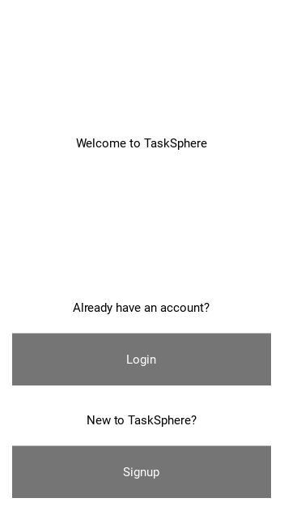

### signup

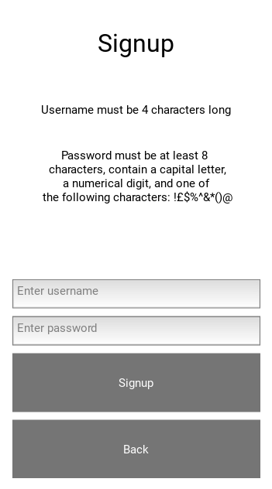

### login

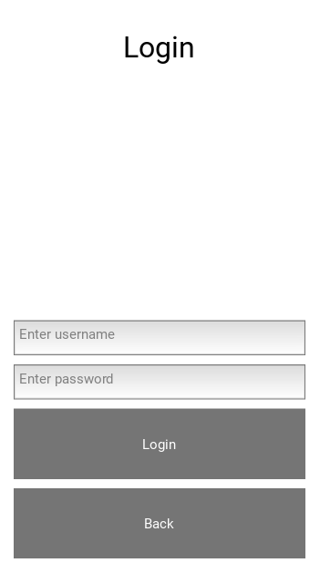

### home

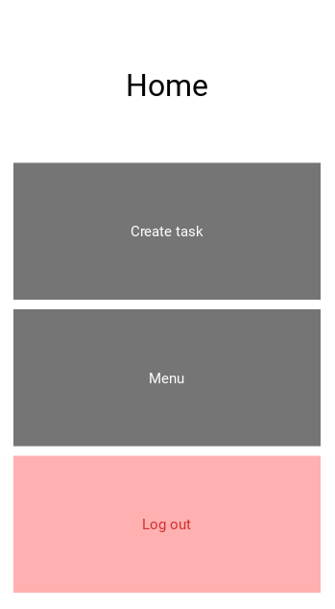

### create task

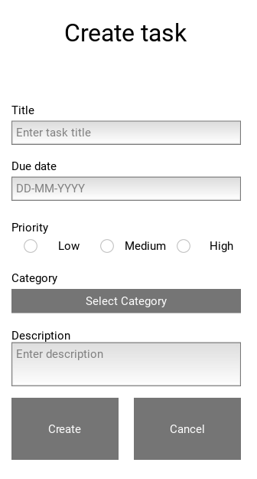

### navigation menu

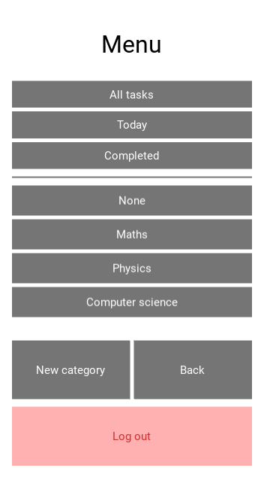

### Task list

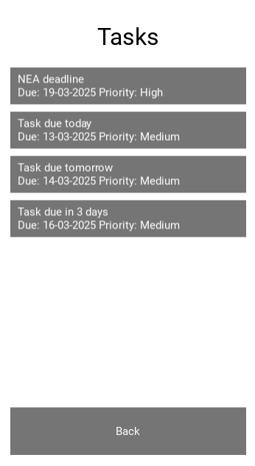

### View task

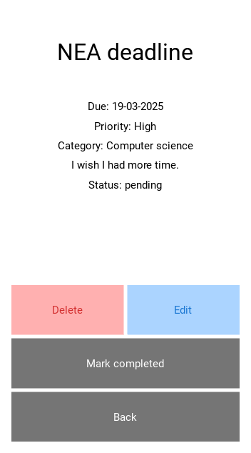

### Edit task

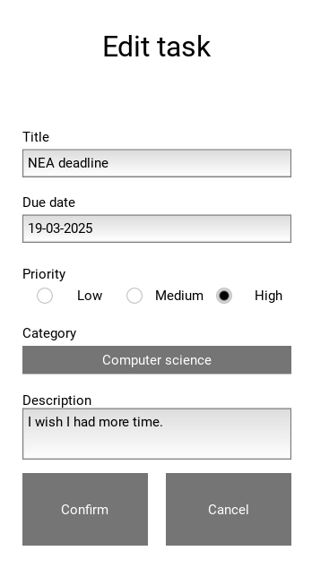

### New category

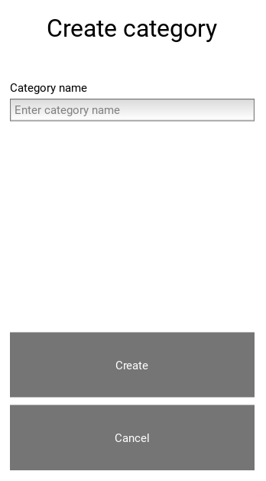

## Complete code evidence

I will only be displaying python code in this section, because I screenshotted my entire .kv file during prototype 2 and it has not changed since then.

### Libraries

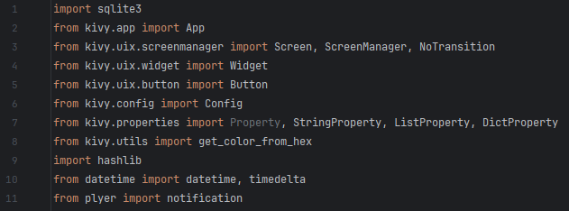

### nOTIFICATION functions

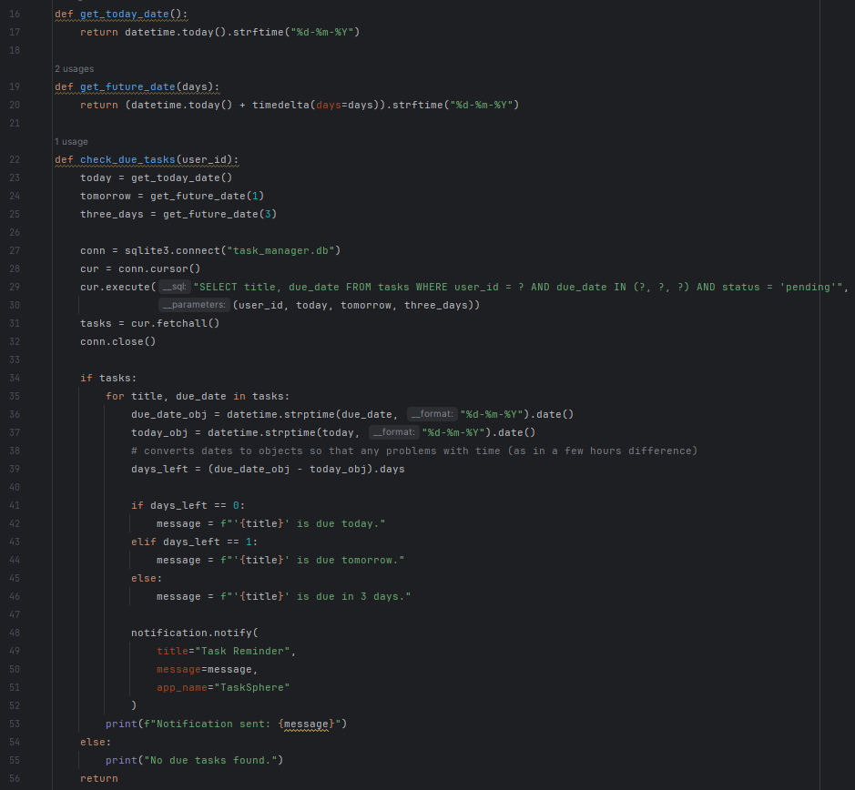

### tHEME widget class

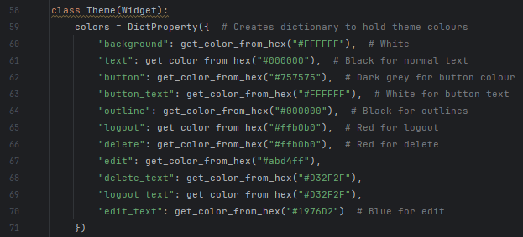

### dATABASE INITIALISATION

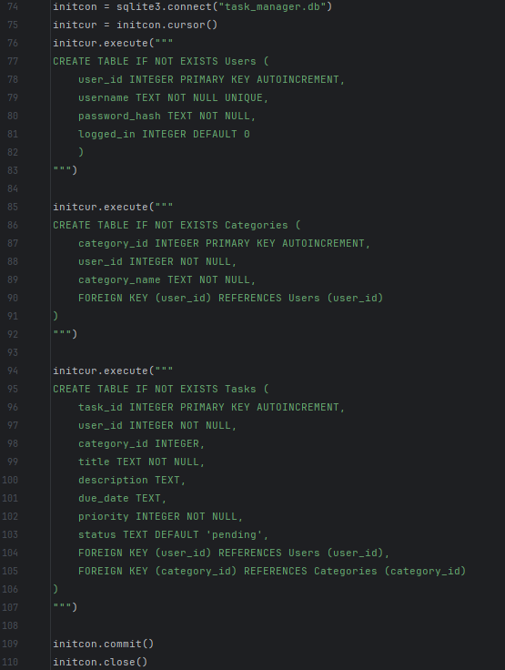

### sCREENS classes WITH NO METHODS

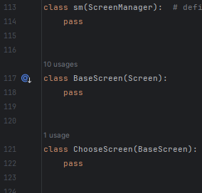

### lOGIN SCREEN class

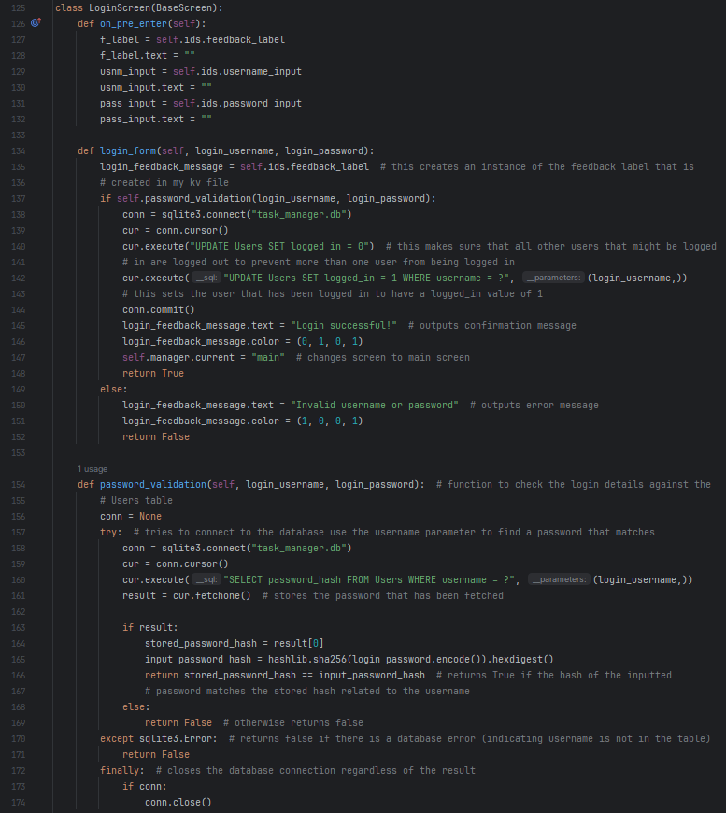

### Signup screen class

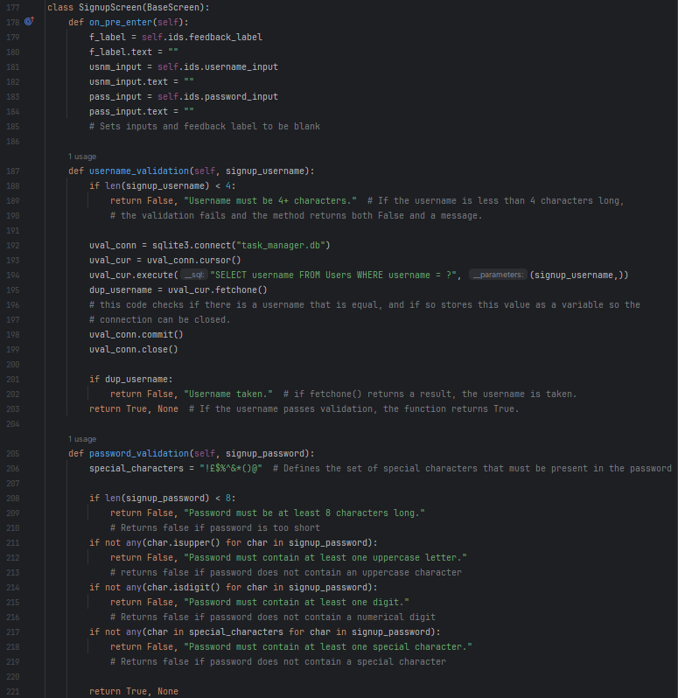

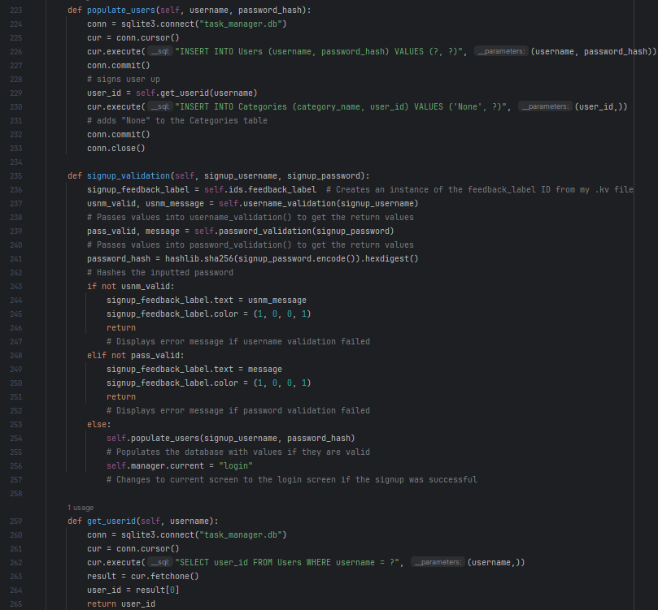

### Home screen class

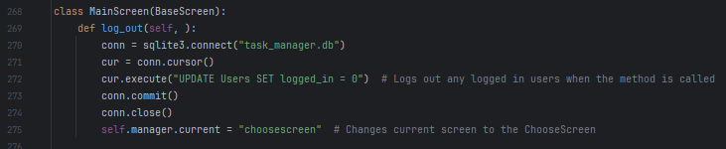

### Create task screen class

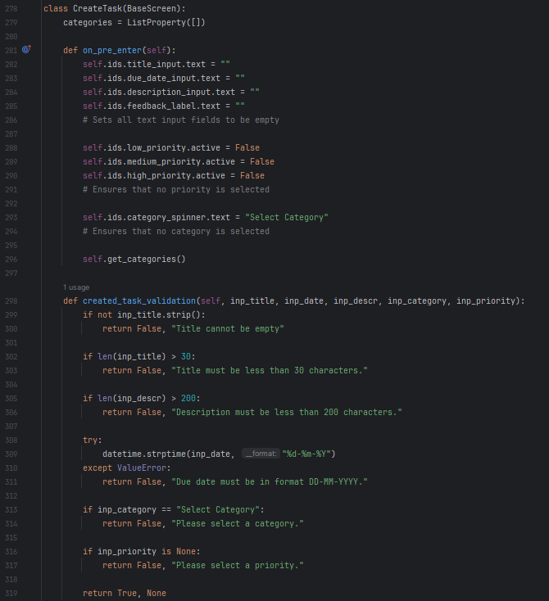

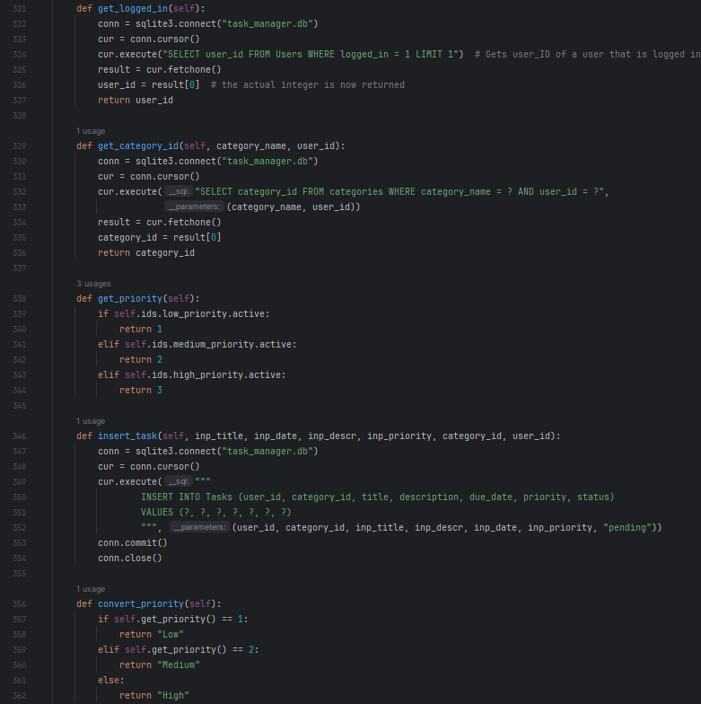

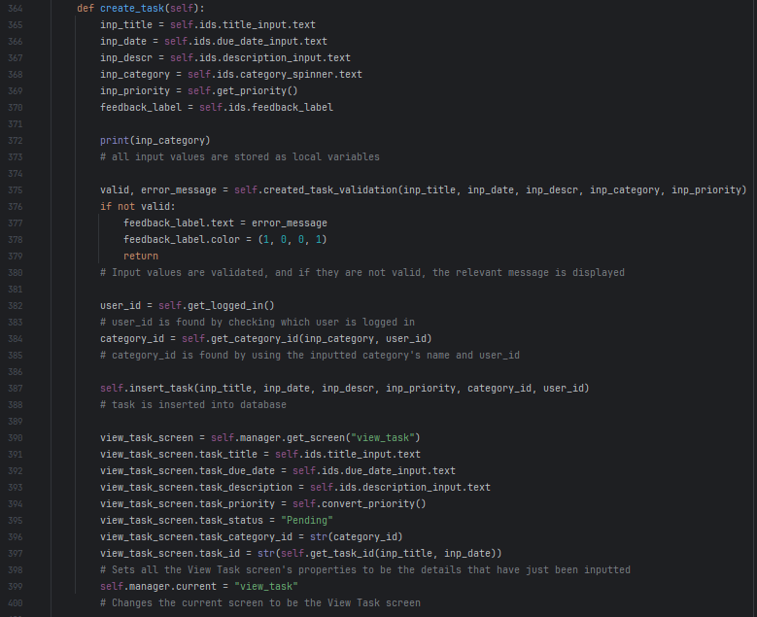

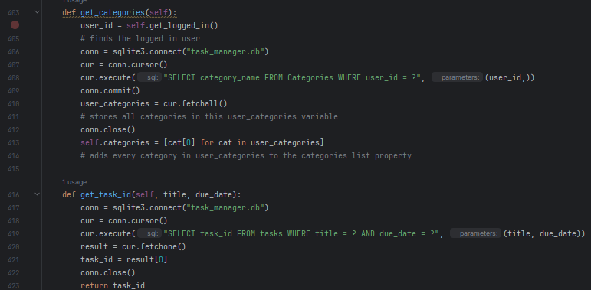

### Navigation menu screen class

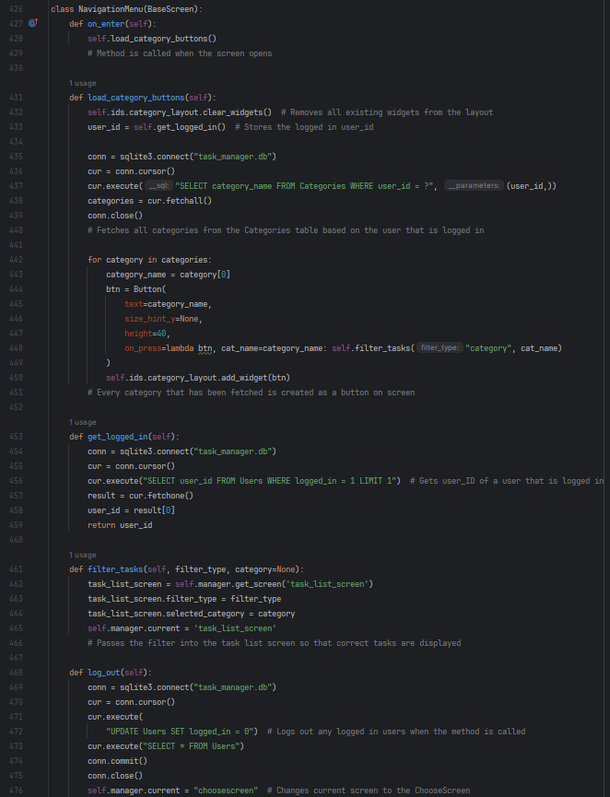

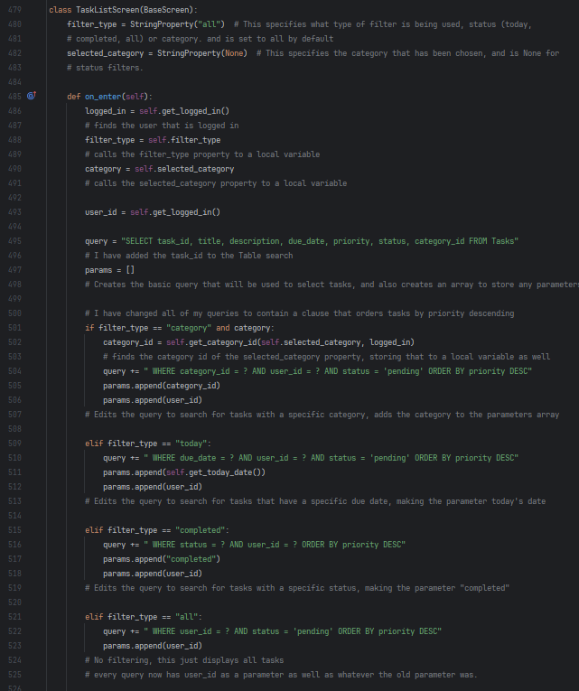

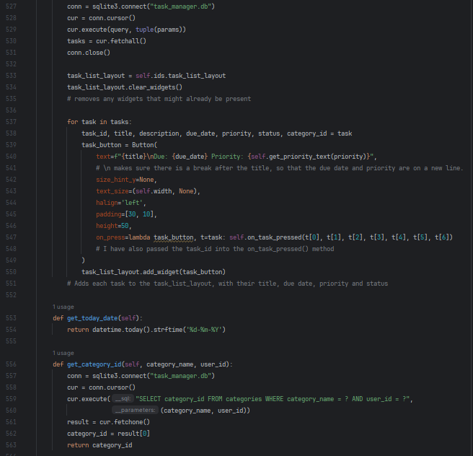

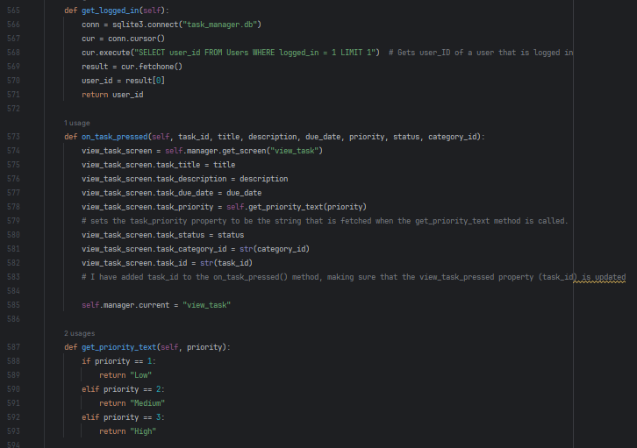

### View task screen class

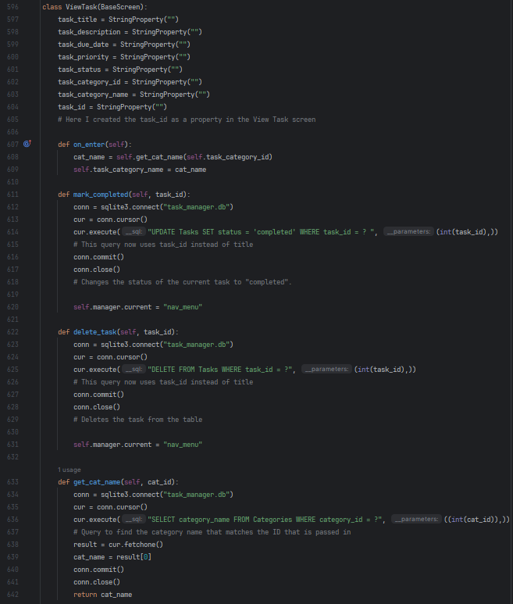

### Edit task screen class

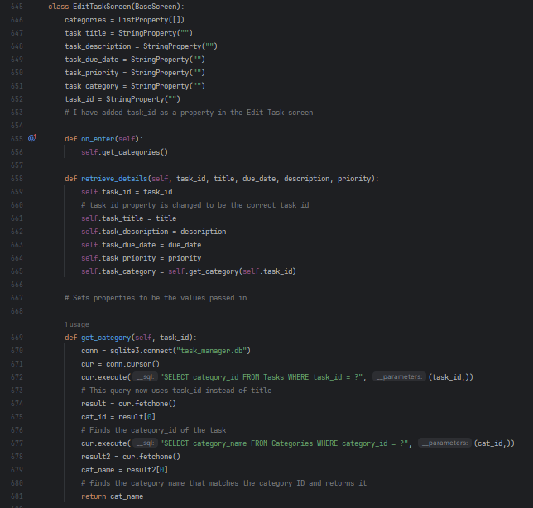

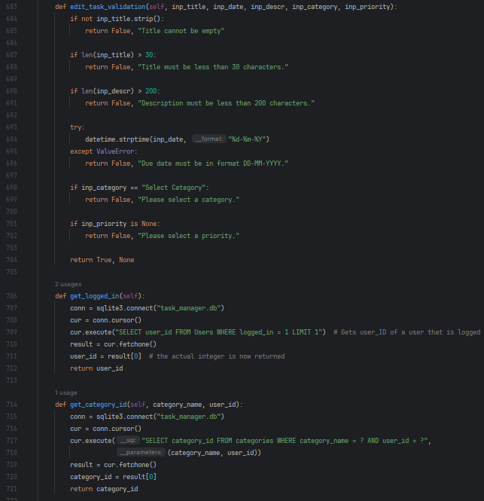

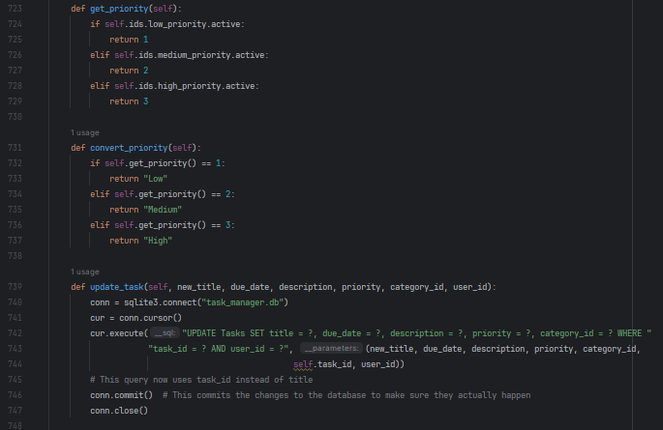

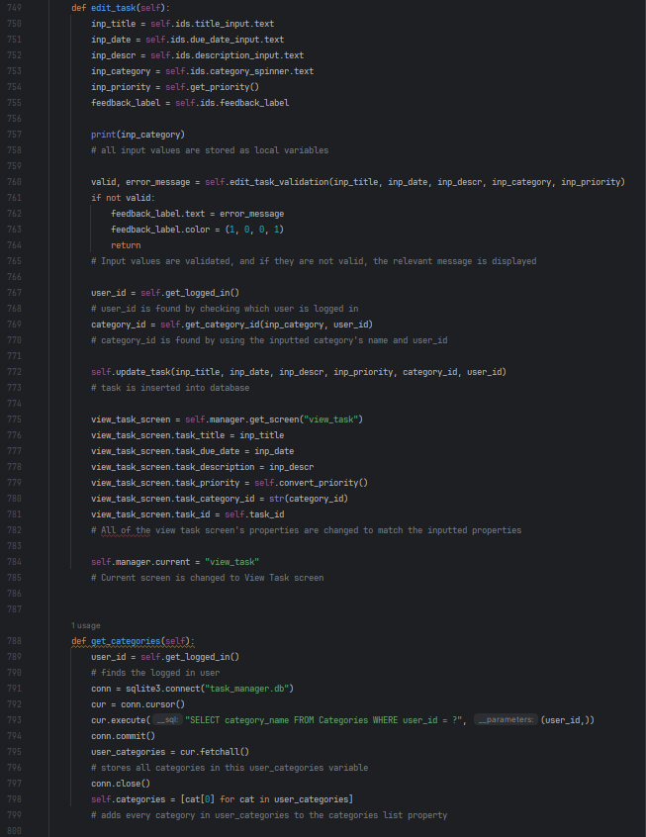

### Create category screen class

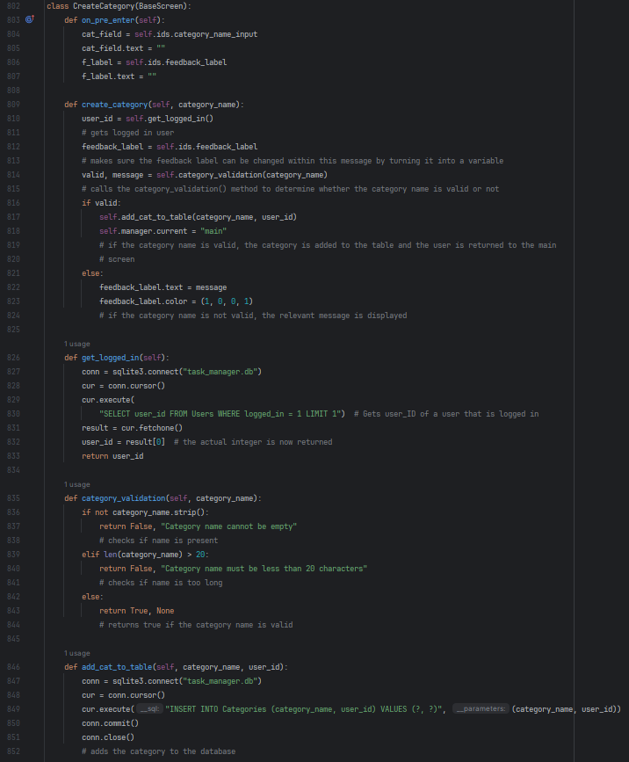

### App class

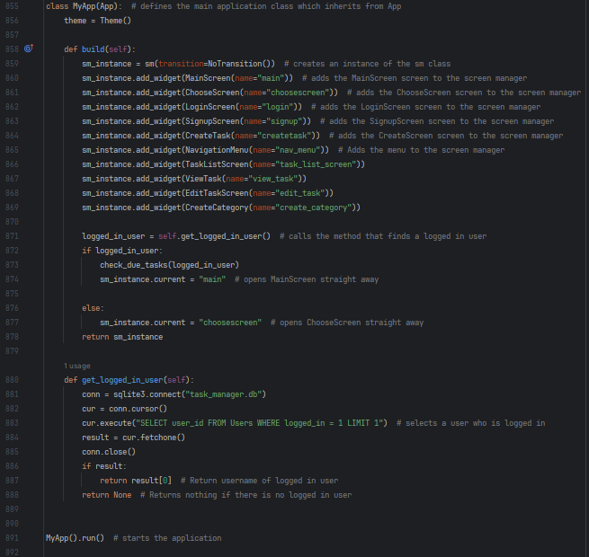

1.